Volume with Whole Number Edges — Homework
Lesson 10-1-flagship • Standard 6.G.2
Name: ______________________ Period: ______ Date: ____________

Today's Goals
Content: I can find the volume of a rectangular prism with whole-number edges using length × width × height.
Language: I can explain my work using the words volume, rectangular prism, cubic units, and edge.

Key Words

Volume (Volumen) — How much space is inside a solid shape.
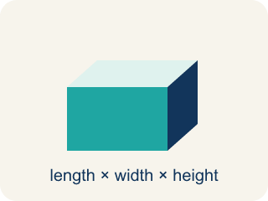
Rectangular prism (Prisma rectangular) — A solid box shape with six flat rectangle sides.

Cubic units (Unidades cúbicas) — The units used to measure space inside, like cubic inches.
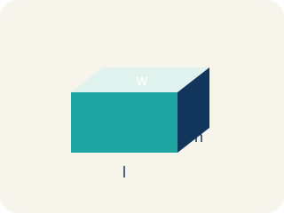
Length, width, height (Largo, ancho, altura) — How long, how wide, and how tall a box is.

Net (Plantilla (desarrollo plano)) — A flat shape that folds up into a solid.

Edge (Arista) — The line where two flat sides of a solid meet.

Practice
Show your work. Use the blank space under each problem.
1. What is the volume of a rectangular prism with l = 7 in, w = 3 in, h = 4 in?
A. 84 in³
B. 14 in³
C. 84 in²
D. 42 in³
______________________________________________________________________
2. A time capsule box has a volume of 120 cm³. Its length is 10 cm and width is 4 cm. What is its height?
A. 3 cm
B. 6 cm
C. 4 cm
D. 12 cm
______________________________________________________________________
3. Complete the table. Find the missing dimension or volume for each time capsule.
Capsule | Length | Width | Height | Volume
Capsule X | 9 in | 5 in | 2 in
Capsule Y | 6 ft | 4 ft |  | 168 ft³
Capsule Z | 12 cm |  | 5 cm | 360 cm³
______________________________________________________________________
4. Two storage bins: Bin A is 8 × 6 × 5 inches. Bin B is 9 × 4 × 7 inches. Which holds more and by how much?
A. Bin B by 12 in³
B. Bin A by 12 in³
C. Bin B by 24 in³
D. They hold the same
______________________________________________________________________
5. Sort each item into the correct group.
• undefined → __________________
• undefined → __________________
• undefined → __________________
• undefined → __________________
• undefined → __________________
______________________________________________________________________

Answer Key (Teacher)
1. A. 84 in³
V = l × w × h = 7 × 3 × 4 = 84 cubic inches.
2. A. 3 cm
V = l × w × h → 120 = 10 × 4 × h → 120 = 40h → h = 3 cm.
3. Complete the table. Find the missing dimension or volume for each time capsule.
Capsule X — Volume: 90 in³
Capsule Y — Height: 7 ft
Capsule Z — Width: 6 cm

4. A. Bin B by 12 in³
Bin A: 8 × 6 × 5 = 240 in³. Bin B: 9 × 4 × 7 = 252 in³. Bin B holds 12 in³ more.
5. Correct groups:
undefined → undefined
undefined → undefined
undefined → undefined
undefined → undefined
undefined → undefined

