Interpret Division of Fractions — Homework
Lesson 2-1 • Standard 6.NS.1
Name: ______________________ Period: ______ Date: ____________

Today's Goals
Content: I can use models to interpret what it means to divide by a fraction.
Language: I can explain a fraction division using the words dividend, divisor, quotient, reciprocal, and unit fraction.

Key Words
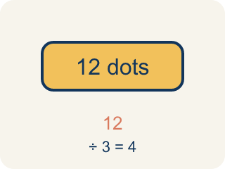
Dividend (Dividendo) — The number you are splitting up in a division problem.
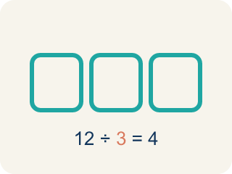
Divisor (Divisor) — The number you split by in a division problem.
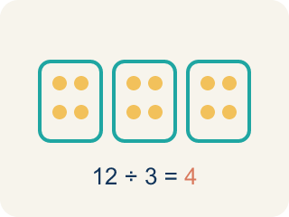
Quotient (Cociente) — The answer when you divide.
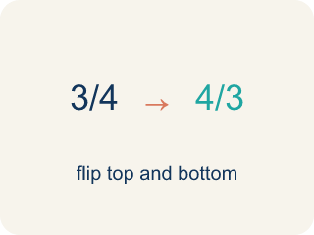
Reciprocal (Recíproco) — A fraction turned upside down.
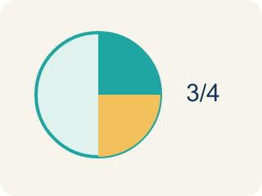
Unit fraction (Fracción unitaria) — A fraction with 1 on top, like 1/4.

Practice
Show your work. Use the blank space under each problem.
1. What does 3 ÷ 1/4 mean?
A. How many 1/4-size pieces fit into 3
B. 3 groups of 1/4
C. 3 minus 1/4
D. 1/4 of 3
______________________________________________________________________
2. Which expression means 'how many 1/3-size pieces are in 2'?
A. 2 ÷ 1/3
B. 2 × 1/3
C. 1/3 ÷ 2
D. 2 + 1/3
______________________________________________________________________
3. Match each division expression to its quotient.
Item | Answer choices
____ 5 ÷ 1/2 | F. 14
____ 6 ÷ 1/3 | E. 15
____ 2 ÷ 1/6 | D. 16
____ 4 ÷ 1/4 | C. 12
____ 3 ÷ 1/5 | B. 18
____ 7 ÷ 1/2 | A. 10
______________________________________________________________________
4. A shelf is 5 feet long. Books are each 1/4 foot wide. How many books fit on the shelf? Which expression represents this?
A. 5 ÷ 1/4 = 20 books
B. 5 × 1/4 = 1 1/4 books
C. 1/4 ÷ 5 = 1/20 book
D. 5 + 1/4 = 5 1/4 books
______________________________________________________________________
5. What does 6 ÷ (1/3) mean?
A. How many thirds are in 6
B. One third of 6
C. 6 minus a third
D. 6 times 3 then minus
______________________________________________________________________
6. A teacher has 4 cups of juice and pours 1/2 cup per serving. How many servings?
A. 8
B. 2
C. 4
D. 6
______________________________________________________________________
7. Which division does this picture show: a length of 3 split into 1/4-size pieces?
A. 3 ÷ (1/4) = 12
B. 3 ÷ 4 = 3/4
C. 1/4 ÷ 3
D. 3 × 4 = 7
______________________________________________________________________
8. How many 2/3-cup scoops are in 4 cups?
A. 6
B. 8
C. 3
D. 2
______________________________________________________________________

Answer Key (Teacher)
1. A. How many 1/4-size pieces fit into 3
3 ÷ 1/4 asks: how many 1/4-size pieces fit into 3? The answer is 12, because each whole has 4 fourths, and 3 × 4 = 12.
2. A. 2 ÷ 1/3
Finding how many 1/3-size pieces fit into 2 is represented by 2 ÷ 1/3. The answer is 6.
3. Matches:
5 ÷ 1/2 → 10
6 ÷ 1/3 → 18
2 ÷ 1/6 → 12
4 ÷ 1/4 → 16
3 ÷ 1/5 → 15
7 ÷ 1/2 → 14

4. A. 5 ÷ 1/4 = 20 books
You are finding how many 1/4-foot pieces fit into 5 feet, which is 5 ÷ 1/4 = 5 × 4 = 20 books.
5. A. How many thirds are in 6
Dividing by 1/3 asks how many one-third pieces fit into 6. The answer is 18.
6. A. 8
4 ÷ (1/2) = 4 × 2 = 8 servings.
7. A. 3 ÷ (1/4) = 12
Each whole holds 4 fourths, so 3 wholes hold 12 fourths.
8. A. 6
4 ÷ (2/3) = 4 × (3/2) = 12/2 = 6 scoops.

