Divide Whole Numbers by Fractions — Homework
Lesson 2-2 • Standard 6.NS.1
Name: ______________________ Period: ______ Date: ____________

Today's Goals
Content: I can divide a whole number by a fraction by multiplying by the reciprocal.
Language: I can explain my steps using the words fraction, reciprocal, quotient, and Keep, Change, Flip.

Key Words
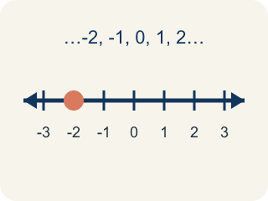
Whole Number (Número entero) — A counting number with no fraction or decimal, like 0, 1, 2, 3.
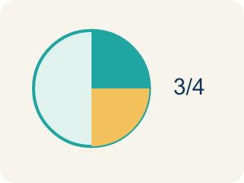
Fraction (Fracción) — A number that shows part of a whole, like 3/4.
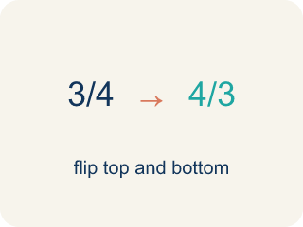
Reciprocal (Recíproco) — A fraction turned upside down.

Keep, Change, Flip (Mantener, cambiar, invertir) — A way to divide fractions: keep the first, change ÷ to ×, flip the second.
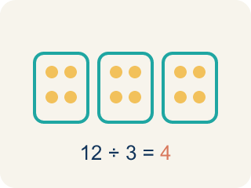
Quotient (Cociente) — The answer when you divide.

Practice
Show your work. Use the blank space under each problem.
1. What is 6 ÷ 1/3?
A. 18
B. 2
C. 6/3
D. 3
______________________________________________________________________
2. What is 3 ÷ 1/5?
A. 15
B. 3/5
C. 5/3
D. 8
______________________________________________________________________
3. Complete the table: Whole Number ÷ Fraction. Use Keep, Change, Flip.
Expression | Rewrite as Multiplication | Quotient
5 ÷ 1/4 | 5 × 4/1 | 20
8 ÷ 1/2 | 8 × 2/1 | 16
3 ÷ 1/6 | 3 × 6/1 | 18
7 ÷ 1/3 | 7 × 3/1 | 21
______________________________________________________________________
4. Match each division expression to its quotient.
Item | Answer choices
____ 4 ÷ 1/3 | F. 30
____ 7 ÷ 1/2 | E. 36
____ 5 ÷ 1/6 | D. 16
____ 2 ÷ 1/8 | C. 30
____ 9 ÷ 1/4 | B. 14
____ 6 ÷ 1/5 | A. 12
______________________________________________________________________
5. What is 6 ÷ 2/3?
A. 9
B. 4
C. 12
D. 2/18
______________________________________________________________________
6. What is 5 ÷ (1/4)?
A. 20
B. 5/4
C. 1.25
D. 9
______________________________________________________________________
7. What is 8 ÷ (2/3)?
A. 12
B. 16/3
C. 5
D. 6
______________________________________________________________________
8. A 6-foot board is cut into 3/4-foot pieces. How many pieces?
A. 8
B. 4
C. 9
D. 18
______________________________________________________________________
9. What is 10 ÷ (5/6)?
A. 12
B. 2
C. 60
D. 8
______________________________________________________________________

Answer Key (Teacher)
1. A. 18
6 ÷ 1/3 = 6 × 3/1 = 18. There are 18 thirds in 6 wholes.
2. A. 15
3 ÷ 1/5 = 3 × 5/1 = 15. There are 15 fifths in 3 wholes.
3. Complete the table: Whole Number ÷ Fraction. Use Keep, Change, Flip.
(See completed table.)

4. Matches:
4 ÷ 1/3 → 12
7 ÷ 1/2 → 14
5 ÷ 1/6 → 30
2 ÷ 1/8 → 16
9 ÷ 1/4 → 36
6 ÷ 1/5 → 30

5. A. 9
6 ÷ 2/3 = 6 × 3/2 = 18/2 = 9. Keep 6, change ÷ to ×, flip 2/3 to 3/2.
6. A. 20
Dividing by 1/4 means multiplying by 4: 5 × 4 = 20.
7. A. 12
8 ÷ (2/3) = 8 × (3/2) = 24/2 = 12.
8. A. 8
6 ÷ (3/4) = 6 × (4/3) = 24/3 = 8 pieces.
9. A. 12
10 ÷ (5/6) = 10 × (6/5) = 60/5 = 12.

