Divide Fractions — Homework
Lesson 2-3 • Standard 6.NS.1
Name: ______________________ Period: ______ Date: ____________

Today's Goals
Content: I can divide a fraction by a fraction by multiplying by the reciprocal and simplifying.
Language: I can explain my steps using the words dividend, divisor, reciprocal, quotient, and simplify.

Key Words
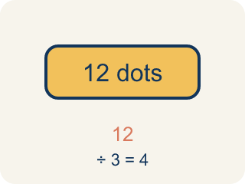
Dividend (Dividendo) — The number you are splitting up in a division problem.
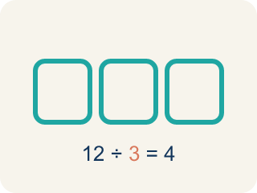
Divisor (Divisor) — The number you split by in a division problem.
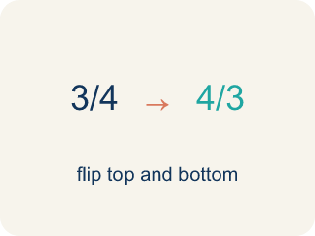
Reciprocal (Recíproco) — A fraction turned upside down.
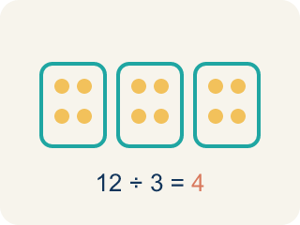
Quotient (Cociente) — The answer when you divide.
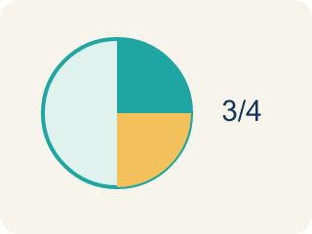
Simplify (Simplificar) — To make a fraction smaller using the same parts, like 2/4 = 1/2.

Practice
Show your work. Use the blank space under each problem.
1. What is the reciprocal of 3/5?
A. 5/3
B. 3/5
C. 5/5
D. 1/3
______________________________________________________________________
2. What is 1/2 ÷ 1/4?
A. 2
B. 1/8
C. 4
D. 1/2
______________________________________________________________________
3. Divide each pair of fractions using Keep, Change, Flip.
Problem | Keep, Change, Flip | Quotient
1/2 ÷ 1/6 | 1/2 × 6/1 = 6/2
3/4 ÷ 1/4 | 3/4 × 4/1 = 12/4
2/3 ÷ 1/3 | 2/3 × 3/1 = 6/3
5/8 ÷ 1/4 | 5/8 × 4/1 = 20/8
______________________________________________________________________
4. Match each fraction division to its quotient.
Item | Answer choices
____ 4/5 ÷ 2/5 | F. 2/3
____ 3/4 ÷ 3/8 | E. 3 1/2
____ 5/6 ÷ 1/3 | D. 4
____ 2/3 ÷ 1/6 | C. 2 1/2
____ 7/8 ÷ 1/4 | B. 2
____ 1/2 ÷ 3/4 | A. 2
______________________________________________________________________
5. A recipe needs 2/3 cup of sugar. You only have a 1/6-cup scoop. How many scoops do you need?
A. 4 scoops
B. 3 scoops
C. 6 scoops
D. 2 scoops
______________________________________________________________________
6. What is (3/4) ÷ (1/2)?
A. 3/2
B. 3/8
C. 1/2
D. 2/3
______________________________________________________________________
7. What is (2/3) ÷ (4/9)?
A. 3/2
B. 8/27
C. 2/3
D. 9/4
______________________________________________________________________
8. What is (5/6) ÷ (5/12)?
A. 2
B. 1/2
C. 25/72
D. 12/5
______________________________________________________________________
9. What is (7/8) ÷ (1/4)?
A. 7/2
B. 7/32
C. 1/2
D. 4/7
______________________________________________________________________

Answer Key (Teacher)
1. A. 5/3
To find the reciprocal, flip the fraction. The reciprocal of 3/5 is 5/3.
2. A. 2
1/2 ÷ 1/4 = 1/2 × 4/1 = 4/2 = 2. Two 1/4-size pieces fit into 1/2.
3. Divide each pair of fractions using Keep, Change, Flip.
1/2 ÷ 1/6 → 3
3/4 ÷ 1/4 → 3
2/3 ÷ 1/3 → 2
5/8 ÷ 1/4 → 2 1/2

4. Matches:
4/5 ÷ 2/5 → 2
3/4 ÷ 3/8 → 2
5/6 ÷ 1/3 → 2 1/2
2/3 ÷ 1/6 → 4
7/8 ÷ 1/4 → 3 1/2
1/2 ÷ 3/4 → 2/3

5. A. 4 scoops
2/3 ÷ 1/6 = 2/3 × 6/1 = 12/3 = 4 scoops.
6. A. 3/2
(3/4) ÷ (1/2) = (3/4) × (2/1) = 6/4 = 3/2.
7. A. 3/2
(2/3) × (9/4) = 18/12 = 3/2.
8. A. 2
(5/6) × (12/5) = 60/30 = 2.
9. A. 7/2
(7/8) × (4/1) = 28/8 = 7/2.

