Divide Mixed Numbers — Homework
Lesson 2-4 • Standard 6.NS.1
Name: ______________________ Period: ______ Date: ____________

Today's Goals
Content: I can divide mixed numbers by first changing them to improper fractions.
Language: I can explain my steps using the words mixed number, improper fraction, convert, reciprocal, and simplify.

Key Words
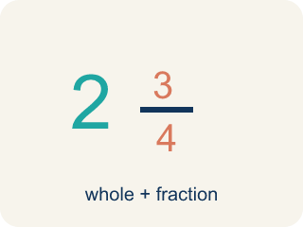
Mixed Number (Número mixto) — A whole number plus a fraction, like 2 1/2.
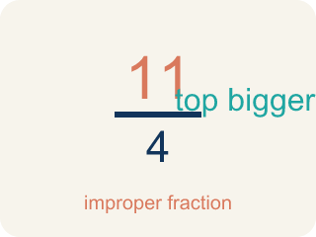
Improper Fraction (Fracción impropia) — A fraction where the top is bigger than or equal to the bottom, like 7/4.
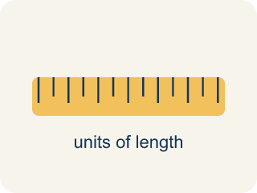
Convert (Convertir) — To change a number to a new form but keep the same value.
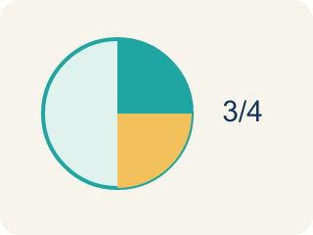
Simplify (Simplificar) — To make a fraction smaller using the same parts, like 2/4 = 1/2.
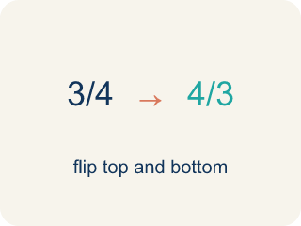
Reciprocal (Recíproco) — A fraction turned upside down. You use it in keep-change-flip.

Practice
Show your work. Use the blank space under each problem.
1. What is 1 1/2 ÷ 3/4?
A. 2
B. 1 1/8
C. 3/4
D. 9/8
______________________________________________________________________
2. Convert 3 2/5 to an improper fraction.
A. 17/5
B. 15/5
C. 6/5
D. 32/5
______________________________________________________________________
3. Convert each mixed number to an improper fraction, then divide.
Problem | Convert to Improper | Keep-Change-Flip | Quotient
3 1/2 ÷ 1/4 | 7/2 ÷ 1/4 | 7/2 × 4/1 = 28/2
1 3/4 ÷ 1/2 | 7/4 ÷ 1/2 | 7/4 × 2/1 = 14/4
2 1/3 ÷ 7/6 | 7/3 ÷ 7/6 | 7/3 × 6/7 = 42/21
4 1/5 ÷ 3/5 | 21/5 ÷ 3/5 | 21/5 × 5/3 = 105/15
______________________________________________________________________
4. Match each mixed number division to its quotient.
Item | Answer choices
____ 2 1/4 ÷ 3/4 | F. 6
____ 4 1/2 ÷ 3/2 | E. 3
____ 1 2/3 ÷ 5/6 | D. 5
____ 3 1/3 ÷ 2/3 | C. 2
____ 2 1/2 ÷ 5/6 | B. 3
____ 1 1/2 ÷ 1/4 | A. 3
______________________________________________________________________
5. A recipe makes 2 1/4 batches of cookies. Each batch uses 3/4 cup of butter. How many cups of butter are needed in total?
A. 3 cups
B. 1 1/2 cups
C. 2 cups
D. 6 cups
______________________________________________________________________
6. What is 2½ ÷ ½?
A. 5
B. 1¼
C. 1¼ doubled
D. 2
______________________________________________________________________
7. What is 3¾ ÷ 1¼?
A. 3
B. 2
C. 4¾
D. 5
______________________________________________________________________
8. A recipe needs 1½ cups of flour. How many full recipes can you make with 6 cups?
A. 4
B. 3
C. 5
D. 9
______________________________________________________________________
9. What is 2⅓ ÷ ⅔?
A. 3½
B. 1⅔
C. 2
D. 3
______________________________________________________________________

Answer Key (Teacher)
1. A. 2
1 1/2 = 3/2. Then 3/2 ÷ 3/4 = 3/2 × 4/3 = 12/6 = 2.
2. A. 17/5
3 × 5 = 15, then 15 + 2 = 17. So 3 2/5 = 17/5.
3. Convert each mixed number to an improper fraction, then divide.
→ 14
→ 3 1/2
→ 2
→ 7

4. Matches:
2 1/4 ÷ 3/4 → 3
4 1/2 ÷ 3/2 → 3
1 2/3 ÷ 5/6 → 2
3 1/3 ÷ 2/3 → 5
2 1/2 ÷ 5/6 → 3
1 1/2 ÷ 1/4 → 6

5. A. 3 cups
This is multiplication: 2 1/4 × 3/4 = 9/4 × 3/4 = 27/16. Wait — re-read: we need 2 1/4 batches at 3/4 cup each, but the question for division practice should be: if you have 2 1/4 cups and each batch needs 3/4 cup, how many batches? 2 1/4 ÷ 3/4 = 9/4 × 4/3 = 36/12 = 3.
6. A. 5
2½ = 5/2. (5/2) ÷ (1/2) = (5/2) × (2/1) = 5.
7. A. 3
15/4 ÷ 5/4 = 15/4 × 4/5 = 60/20 = 3.
8. A. 4
6 ÷ (3/2) = 6 × (2/3) = 12/3 = 4 recipes.
9. A. 3½
7/3 ÷ 2/3 = 7/3 × 3/2 = 21/6 = 7/2 = 3½.

