Fraction Division Problem Solving — Homework
Lesson 2-5 • Standard 6.NS.1
Name: ______________________ Period: ______ Date: ____________

Today's Goals
Content: I can solve real-world problems by writing and solving fraction division equations.
Language: I can explain my reasoning using the words model, equation, solution, and reasonableness.

Key Words
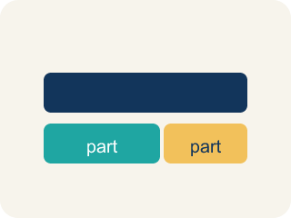
Model (Modelo) — A picture or math way to show a problem so you can solve it.
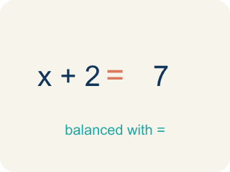
Equation (Ecuación) — A math sentence with an equal sign showing both sides are the same.

Solution (Solución) — The answer to an equation or problem.
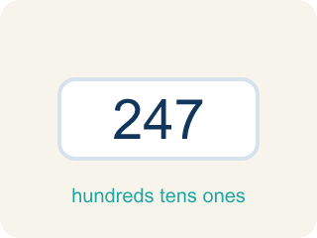
Reasonableness (Razonabilidad) — Checking if your answer makes sense.

Inverse operations (Operaciones inversas) — Two math actions that undo each other, like × and ÷.

Practice
Show your work. Use the blank space under each problem.
1. A ribbon is 4/5 of a yard long. Each bow uses 1/10 of a yard. Which equation finds how many bows can be made?
A. 4/5 ÷ 1/10
B. 1/10 ÷ 4/5
C. 4/5 × 1/10
D. 4/5 + 1/10
______________________________________________________________________
2. A detective has 1/2 gallon of solution. Each test uses 1/8 gallon. How many tests can be run?
A. 4
B. 1/16
C. 16
D. 1/4
______________________________________________________________________
3. Solve each word problem by writing and solving an equation.
Problem | Equation | Solution
A board is 7/8 foot long. Each shelf bracket needs 1/4 foot. How many brackets fit? | 7/8 ÷ 1/4 | 3 1/2
A jug holds 5/6 liter. Each cup holds 1/3 liter. How many cups can be filled? | 5/6 ÷ 1/3 | 2 1/2
A path is 3/4 mile long. A runner does laps of 3/8 mile. How many laps fit? | 3/4 ÷ 3/8 | 2
______________________________________________________________________
4. Sort: is the equation and solution CORRECT, or is there an error?
Groups: Correct Equation and Solution | Incorrect Equation or Solution
• A tank has 5/6 gallon. Each bucket holds 1/3 gallon. → 5/6 ÷ 1/3 = 2 1/2 buckets → __________________
• A pipe is 2/3 foot long. Each piece is 1/6 foot. → 2/3 ÷ 1/6 = 4 pieces → __________________
• A bag has 3/4 lb. Each scoop is 1/8 lb. → 3/4 ÷ 1/8 = 6 scoops → __________________
• A rope is 1/2 yard. Each section is 1/4 yard. → 1/4 ÷ 1/2 = 1/2 section → __________________
• A jug has 4/5 liter. Each cup is 2/5 liter. → 4/5 × 2/5 = 8/25 cups → __________________
• A shelf is 7/8 foot. Each book is 1/4 foot. → 7/8 ÷ 1/4 = 7/32 books → __________________
______________________________________________________________________
5. Marcus solved 2/3 ÷ 1/4 and got 8/3 = 2 2/3. He says 'That can't be right because I started with less than 1.' Is Marcus's math correct? Is his reasoning correct?
A. His math is correct (2 2/3), but his reasoning is wrong — dividing by a small fraction gives a larger result
B. His math and reasoning are both correct — the answer should be less than 1
C. His math is wrong — the answer should be 1/6
D. His math is wrong — the answer should be 8/12
______________________________________________________________________
6. A 3/4-liter bottle fills cups that hold 1/8 liter. How many cups can it fill?
A. 6
B. 4
C. 8
D. 3
______________________________________________________________________
7. Tom has 4½ yards of rope and cuts ¾-yard pieces. How many pieces?
A. 6
B. 5
C. 7
D. 9
______________________________________________________________________
8. A trail is 7½ miles. A hiker rests every 1¼ miles. How many rest stops (not counting the start)?
A. 6
B. 5
C. 7
D. 8
______________________________________________________________________
9. You have 2/3 of a pizza and split it into 1/6-pizza slices. How many slices?
A. 4
B. 3
C. 6
D. 2
______________________________________________________________________

Answer Key (Teacher)
1. A. 4/5 ÷ 1/10
The total (4/5 yard) is divided into groups of 1/10 yard each. The equation is 4/5 ÷ 1/10 = 4/5 × 10/1 = 40/5 = 8 bows.
2. A. 4
1/2 ÷ 1/8 = 1/2 × 8/1 = 8/2 = 4 tests.
3. Solve each word problem by writing and solving an equation.
(See completed table.)

4. Correct groups:
A tank has 5/6 gallon. Each bucket holds 1/3 gallon. → 5/6 ÷ 1/3 = 2 1/2 buckets → Correct Equation and Solution
A pipe is 2/3 foot long. Each piece is 1/6 foot. → 2/3 ÷ 1/6 = 4 pieces → Correct Equation and Solution
A bag has 3/4 lb. Each scoop is 1/8 lb. → 3/4 ÷ 1/8 = 6 scoops → Correct Equation and Solution
A rope is 1/2 yard. Each section is 1/4 yard. → 1/4 ÷ 1/2 = 1/2 section → Incorrect Equation or Solution
A jug has 4/5 liter. Each cup is 2/5 liter. → 4/5 × 2/5 = 8/25 cups → Incorrect Equation or Solution
A shelf is 7/8 foot. Each book is 1/4 foot. → 7/8 ÷ 1/4 = 7/32 books → Incorrect Equation or Solution

5. A. His math is correct (2 2/3), but his reasoning is wrong — dividing by a small fraction gives a larger result
2/3 ÷ 1/4 = 2/3 × 4/1 = 8/3 = 2 2/3. This IS correct. When you divide by a number less than 1, the quotient is greater than the dividend.
6. A. 6
(3/4) ÷ (1/8) = (3/4) × 8 = 24/4 = 6 cups.
7. A. 6
(9/2) ÷ (3/4) = (9/2) × (4/3) = 36/6 = 6 pieces.
8. A. 6
(15/2) ÷ (5/4) = (15/2) × (4/5) = 60/10 = 6 rest stops.
9. A. 4
(2/3) ÷ (1/6) = (2/3) × 6 = 12/3 = 4 slices.

