Ratio Tables — Homework
Lesson 3-2 • Standard 6.RP.3a
Name: ______________________ Period: ______ Date: ____________

Today's Goals
Content: I can use a ratio table to find equivalent ratios.
Language: I can explain my table using the words ratio table, equivalent ratio, scale factor, and pattern.

Key Words
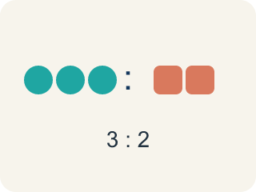
Ratio table (Tabla de razones) — A table of equal ratios that shows a pattern.
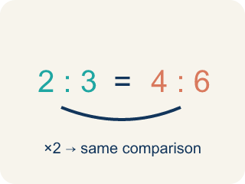
Equivalent ratio (Razón equivalente) — Two ratios that mean the same thing, like 1:2 and 2:4.
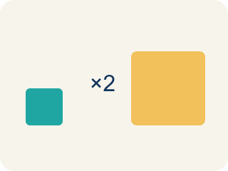
Scale factor (Factor de escala) — The number you multiply both parts of a ratio by to get an equal ratio.
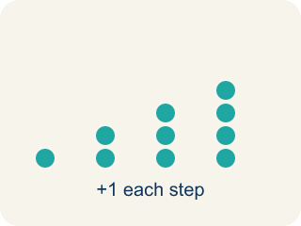
Pattern (Patrón) — A rule that numbers follow again and again.

Additive pattern (Patrón aditivo) — Adding the same amount to both parts of a ratio table to make new rows.

Practice
Show your work. Use the blank space under each problem.
1. A recipe uses 3 eggs for every 5 cups of flour. How many eggs are needed for 15 cups of flour?
A. 9
B. 6
C. 10
D. 12
______________________________________________________________________
2. Which row does NOT belong in a ratio table for 4:5?
A. 6:10
B. 8:10
C. 12:15
D. 16:20
______________________________________________________________________
3. Complete the ratio table for lemon juice to water in Chef Reyes's lemonade recipe (1 cup lemon juice for every 4 cups water).
Pitchers | Lemon Juice (cups) | Water (cups)
1 | 1 | 4
2
5
10
______________________________________________________________________
4. In a ratio table, the ratio of sugar to butter is 3:2. If you use 12 cups of sugar, how many cups of butter do you need?
A. 8
B. 6
C. 10
D. 9
______________________________________________________________________
5. Which rows belong in a ratio table for 3:4? Sort them into correct and incorrect.
Groups: Belongs in 3:4 Table | Does NOT Belong
• 6:8 → __________________
• 9:12 → __________________
• 15:20 → __________________
• 6:10 → __________________
• 12:14 → __________________
• 9:16 → __________________
______________________________________________________________________
6. A ratio table shows 5:8, 10:16, 15:24. What scale factor was used from the first row to the third row?
A. 3
B. 2
C. 5
D. 8
______________________________________________________________________
7. Complete the ratio table. The ratio of cups of flour to cups of sugar is 2 : 1.
Flour (cups) | Sugar (cups)
2
6
10
14
______________________________________________________________________
8. A ratio table shows 3 tickets cost $12. How much do 7 tickets cost?
A. $28
B. $24
C. $21
D. $36
______________________________________________________________________
9. In a ratio table, 4 maps to 10. What does 12 map to?
A. 30
B. 24
C. 36
D. 18
______________________________________________________________________
10. A ratio table keeps the ratio 5:8. If one row is 15, what is its partner value?
A. 24
B. 20
C. 23
D. 40
______________________________________________________________________

Answer Key (Teacher)
1. A. 9
The scale factor is 15 ÷ 5 = 3. Multiply the eggs by 3: 3 × 3 = 9 eggs.
2. A. 6:10
6:10 simplifies to 3:5, not 4:5. The other ratios (8:10, 12:15, 16:20) all simplify to 4:5.
3. Complete the ratio table for lemon juice to water in Chef Reyes's lemonade recipe (1 cup lemon juice for every 4 cups water).
2 — Lemon Juice (cups): 2
2 — Water (cups): 8
5 — Lemon Juice (cups): 5
5 — Water (cups): 20
10 — Lemon Juice (cups): 10
10 — Water (cups): 40

4. A. 8
Scale factor: 12 ÷ 3 = 4. Multiply butter by 4: 2 × 4 = 8 cups of butter.
5. Correct groups:
6:8 → Belongs in 3:4 Table
9:12 → Belongs in 3:4 Table
15:20 → Belongs in 3:4 Table
6:10 → Does NOT Belong
12:14 → Does NOT Belong
9:16 → Does NOT Belong

6. A. 3
From 5 to 15: 15 ÷ 5 = 3. From 8 to 24: 24 ÷ 8 = 3. The scale factor is 3.
7. Complete the ratio table. The ratio of cups of flour to cups of sugar is 2 : 1.
2 — Sugar (cups): 1
6 — Sugar (cups): 3
10 — Sugar (cups): 5
14 — Sugar (cups): 7

8. A. $28
Each ticket costs $12 ÷ 3 = $4, so 7 tickets cost 7 × $4 = $28.
9. A. 30
12 is 3 times 4, so multiply 10 by 3 to get 30.
10. A. 24
15 is 3 times 5, so the partner is 3 times 8 = 24.

