Graph Ratio Tables — Homework
Lesson 3-3 • Standard 6.RP.3a
Name: ______________________ Period: ______ Date: ____________

Today's Goals
Content: I can graph the values from a ratio table as points on the coordinate plane.
Language: I can explain my graph using the words coordinate plane, ordered pair, origin, and proportional.

Key Words
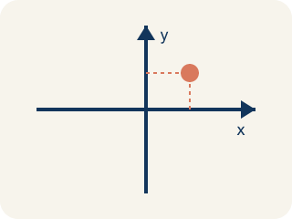
Coordinate plane (Plano cartesiano) — A grid with a line going across and a line going up to plot points.
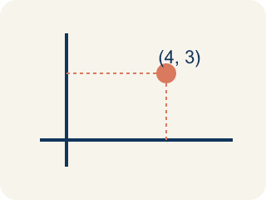
Ordered pair (Par ordenado) — Two numbers (x, y) that tell where a point is on a grid.
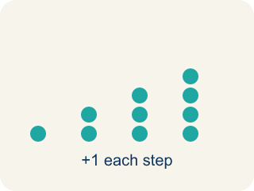
Linear pattern (Patrón lineal) — Points that make a straight line on a grid.
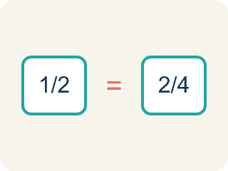
Proportional (Proporcional) — Two amounts that grow together at the same rate.
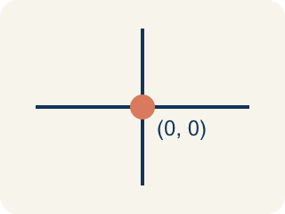
Origin (Origen) — The point (0, 0) where the two grid lines cross.

Practice
Show your work. Use the blank space under each problem.
1. A ratio table shows (2, 6), (4, 12), and (6, 18). Which ordered pair comes next if the pattern continues?
A. (8, 24)
B. (7, 20)
C. (8, 22)
D. (10, 24)
______________________________________________________________________
2. When you graph equivalent ratios, the points will always form what shape?
A. A straight line through the origin
B. A curved line
C. A zigzag
D. A circle
______________________________________________________________________
3. Points from a ratio table are plotted at (1, 4), (2, 8), and (3, 12). What is the ratio of y to x for each point?
A. 4:1
B. 1:4
C. 2:8
D. 3:4
______________________________________________________________________
4. Use the graph pattern y = 5x to complete the ratio table, then identify what the ordered pairs would be.
x | y | Ordered Pair
1 | 5 | (1, 5)
2
4
6
______________________________________________________________________
5. Two students graph ratio tables. Student A plots (1,2), (2,4), (3,6). Student B plots (1,3), (2,6), (3,9). Whose line is steeper?
A. Student B
B. Student A
C. Same steepness
D. Cannot tell
______________________________________________________________________
6. A graph of a ratio passes through (0,0) and (2,6). What point also lies on the line?
A. (4, 12)
B. (4, 8)
C. (3, 6)
D. (6, 2)
______________________________________________________________________
7. On a ratio graph each apple costs $2. Which point shows 5 apples?
A. (5, 10)
B. (5, 5)
C. (10, 5)
D. (2, 5)
______________________________________________________________________
8. A line through the origin contains (3, 9). What is the unit rate (y per 1 x)?
A. 3
B. 1/3
C. 6
D. 9
______________________________________________________________________
9. Why do graphs of equivalent ratios start at the origin (0,0)?
A. Because 0 of one quantity pairs with 0 of the other
B. Because every line starts at zero
C. Because ratios are always negative
D. Because the y-axis is longer
______________________________________________________________________

Answer Key (Teacher)
1. A. (8, 24)
The pattern adds 2 to x and 6 to y each time. After (6, 18): x = 6+2 = 8, y = 18+6 = 24. The next point is (8, 24).
2. A. A straight line through the origin
Equivalent ratios are proportional, so their graph is always a straight line that passes through the origin (0, 0).
3. A. 4:1
For each point: 4÷1 = 4, 8÷2 = 4, 12÷3 = 4. The ratio of y to x is always 4:1.
4. Use the graph pattern y = 5x to complete the ratio table, then identify what the ordered pairs would be.
2 — y: 10
2 — Ordered Pair: (2, 10)
4 — y: 20
4 — Ordered Pair: (4, 20)
6 — y: 30
6 — Ordered Pair: (6, 30)

5. A. Student B
Student A's ratio is 1:2 (y goes up 2 for each 1 in x). Student B's ratio is 1:3 (y goes up 3 for each 1 in x). A higher rate of change means a steeper line, so Student B's is steeper.
6. A. (4, 12)
The ratio is 6 to 2 = 3 to 1, so (4, 12) follows the same pattern.
7. A. (5, 10)
5 apples at $2 each is $10, so the point is (5, 10).
8. A. 3
9 ÷ 3 = 3, so y increases by 3 for each 1 unit of x.
9. A. Because 0 of one quantity pairs with 0 of the other
When you have 0 of one amount you have 0 of the other, so the line passes through (0,0).

