Equivalent Ratios — Homework
Lesson 3-4 • Standard 6.RP.3
Name: ______________________ Period: ______ Date: ____________

Today's Goals
Content: I can find and check equivalent ratios using multiplication and division.
Language: I can explain my reasoning using the words equivalent ratios, rate, proportion, and simplify.

Key Words
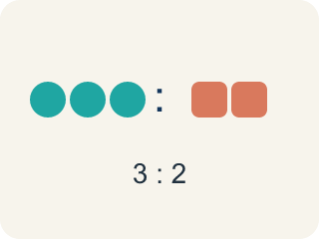
Ratio (Razón) — A way to compare two amounts.
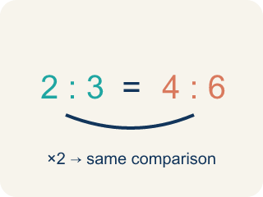
Equivalent ratios (Razones equivalentes) — Two ratios that mean the same thing.
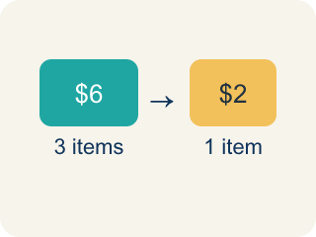
Rate (Tasa) — A ratio comparing two amounts with different units, like miles per hour.
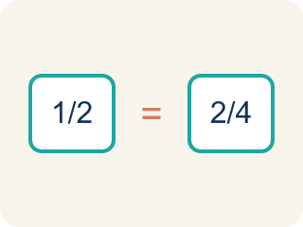
Proportion (Proporción) — A math sentence saying two ratios are equal.
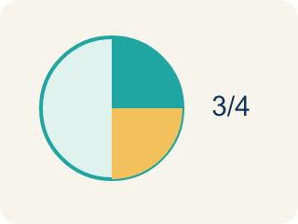
Simplify (Simplificar) — To make a ratio smaller while keeping the same comparison.

Practice
Show your work. Use the blank space under each problem.
1. Which ratio is equivalent to 2:5?
A. 4:10
B. 3:6
C. 2:10
D. 5:2
______________________________________________________________________
2. A recipe uses 4 eggs for every 6 cups of flour. Which ratio is equivalent?
A. 2:3
B. 8:10
C. 4:3
D. 6:4
______________________________________________________________________
3. Sort these ratios — which are equivalent to 3:4 and which are not?
Groups: Equivalent to 3:4 | NOT Equivalent to 3:4
• 6:8 → __________________
• 9:12 → __________________
• 15:20 → __________________
• 3:5 → __________________
• 4:3 → __________________
• 6:12 → __________________
______________________________________________________________________
4. Marcus earns $45 for every 3 hours of work. How much does he earn in 8 hours?
A. $120
B. $90
C. $135
D. $105
______________________________________________________________________
5. Find the missing value that makes each pair of ratios equivalent.
Ratio 1 | Ratio 2 | Missing Value
3:7 | 9:?
5:8 | ?:24
4:6 | ?:3
______________________________________________________________________
6. Which ratio is equivalent to 3:4?
A. 9:12
B. 4:3
C. 3:8
D. 6:7
______________________________________________________________________
7. Which ratio is NOT equivalent to 2:5?
A. 4:9
B. 4:10
C. 6:15
D. 8:20
______________________________________________________________________
8. If 12:18 is written in simplest form, what is it?
A. 2:3
B. 6:9
C. 3:2
D. 4:6
______________________________________________________________________
9. A paint mix uses 3:5 blue to white. To keep the same color with 15 parts white, how much blue?
A. 9
B. 12
C. 5
D. 8
______________________________________________________________________

Answer Key (Teacher)
1. A. 4:10
Multiply both parts by 2: 2×2 = 4 and 5×2 = 10, so 4:10 is equivalent to 2:5.
2. A. 2:3
Divide both by 2: 4÷2 = 2 and 6÷2 = 3. The ratio 2:3 is equivalent to 4:6.
3. Correct groups:
6:8 → Equivalent to 3:4
9:12 → Equivalent to 3:4
15:20 → Equivalent to 3:4
3:5 → NOT Equivalent to 3:4
4:3 → NOT Equivalent to 3:4
6:12 → NOT Equivalent to 3:4

4. A. $120
Unit rate: $45 ÷ 3 = $15/hour. In 8 hours: $15 × 8 = $120.
5. Find the missing value that makes each pair of ratios equivalent.
3:7 — Missing Value: 21
5:8 — Missing Value: 15
4:6 — Missing Value: 2

6. A. 9:12
Multiply both parts of 3:4 by 3 to get 9:12.
7. A. 4:9
4:9 is not 2:5 doubled (that would be 4:10). The others all reduce to 2:5.
8. A. 2:3
12:18 divides by 6 to give 2:3.
9. A. 9
15 white is 3 times 5, so blue is 3 times 3 = 9.

