Compare Ratios — Homework
Lesson 3-5 • Standard 6.RP.3
Name: ______________________ Period: ______ Date: ____________

Today's Goals
Content: I can compare ratios by finding unit rates or using equivalent ratios.
Language: I can explain my comparison using the words unit rate, equivalent ratio, compare, and common denominator.

Key Words
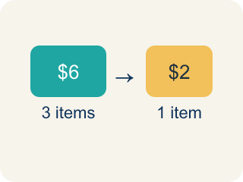
Unit rate (Tasa unitaria) — A rate for just 1 of something, like cost for 1 item.
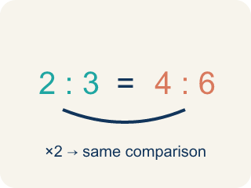
Equivalent ratio (Razón equivalente) — Two ratios that mean the same thing.
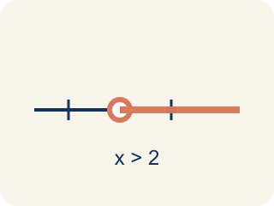
Compare (Comparar) — To look at ratios and see which is bigger, smaller, or equal.
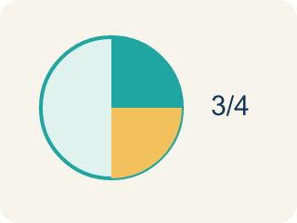
Simplify (Simplificar) — To make a ratio as small as possible while keeping the same comparison.

Common denominator (Denominador común) — A bottom number that two fractions can share so you can compare them.

Practice
Show your work. Use the blank space under each problem.
1. Chef A uses 2 cups of cheese for every 8 crackers. Chef B uses 3 cups of cheese for every 9 crackers. Who uses more cheese per cracker?
A. Chef B
B. Chef A
C. They use the same amount
D. Cannot determine
______________________________________________________________________
2. Which ratio is greater: 3:4 or 5:8?
A. 3:4
B. 5:8
C. They are equal
D. Cannot determine
______________________________________________________________________
3. Match each scenario to the correct answer: Which ratio is greater?
Groups: Correct Comparison | Incorrect Comparison
• 5:6 vs. 7:9 → 5:6 is greater → __________________
• 2:3 vs. 4:6 → they are equal → __________________
• 1:4 vs. 2:5 → 2:5 is greater → __________________
• 3:7 vs. 2:5 → 3:7 is greater → __________________
• 4:5 vs. 3:4 → 3:4 is greater → __________________
• 1:2 vs. 3:4 → they are equal → __________________
______________________________________________________________________
4. Store A sells 3 mangoes for $6. Store B sells 5 mangoes for $9. Which store offers a better price per mango?
A. Store B
B. Store A
C. Same price
D. Cannot determine
______________________________________________________________________
5. Two paint recipes both make green. Recipe A: 3 parts blue to 5 parts yellow. Recipe B: 4 parts blue to 7 parts yellow. Scale both to a common amount of yellow to compare which recipe is more blue.
Recipe | Blue Parts | Yellow Parts
Recipe A | 3 | 5
Recipe B | 4 | 7
Recipe A (scaled to 35) |  | 35
Recipe B (scaled to 35) |  | 35
______________________________________________________________________
6. Store A sells 3 pens for $6. Store B sells 5 pens for $9. Which is the better buy?
A. Store B
B. Store A
C. They are equal
D. Cannot tell
______________________________________________________________________
7. Which ratio is greater: 4:5 or 7:10?
A. 4:5
B. 7:10
C. They are equal
D. Cannot compare
______________________________________________________________________
8. Recipe X uses 2 cups sugar per 8 cookies. Recipe Y uses 3 cups per 10 cookies. Which is sweeter per cookie?
A. Recipe Y
B. Recipe X
C. Same sweetness
D. Cannot tell
______________________________________________________________________
9. Team A won 6 of 10 games. Team B won 9 of 15 games. Which team has the better win ratio?
A. They are equal
B. Team A
C. Team B
D. Cannot tell
______________________________________________________________________

Answer Key (Teacher)
1. A. Chef B
Chef A: 2÷8 = 0.25 cups per cracker. Chef B: 3÷9 ≈ 0.33 cups per cracker. Chef B uses more cheese per cracker.
2. A. 3:4
Convert to the same denominator: 3:4 = 6:8. Since 6:8 > 5:8, the ratio 3:4 is greater.
3. Correct groups:
5:6 vs. 7:9 → 5:6 is greater → Correct Comparison
2:3 vs. 4:6 → they are equal → Correct Comparison
1:4 vs. 2:5 → 2:5 is greater → Correct Comparison
3:7 vs. 2:5 → 3:7 is greater → Incorrect Comparison
4:5 vs. 3:4 → 3:4 is greater → Incorrect Comparison
1:2 vs. 3:4 → they are equal → Incorrect Comparison

4. A. Store B
Store A: $6÷3 = $2.00 per mango. Store B: $9÷5 = $1.80 per mango. Store B has the better (lower) price per mango.
5. Two paint recipes both make green. Recipe A: 3 parts blue to 5 parts yellow. Recipe B: 4 parts blue to 7 parts yellow. Scale both to a common amount of yellow to compare which recipe is more blue.
Recipe A (scaled to 35) — Blue Parts: 21
Recipe B (scaled to 35) — Blue Parts: 20

6. A. Store B
Store A is $2 per pen; Store B is $1.80 per pen. Store B is cheaper.
7. A. 4:5
4:5 = 8:10, which is greater than 7:10.
8. A. Recipe Y
X = 0.25 cup/cookie; Y = 0.30 cup/cookie. Y has more sugar per cookie.
9. A. They are equal
6:10 = 3:5 and 9:15 = 3:5, so the win ratios are equal.

