UNIT 3 · LESSON 6 STANDARD 6.RP.3

Use Ratio Reasoning
Student Notes Packet
Name: ______________________ Date: ____________ Period: ________

Today's Goals
Content: I can use ratio reasoning to solve problems with proportions and scaling.
Language: I can explain my reasoning using the words proportion, scale, equivalent, and unit rate.

Key Vocabulary
Look at the picture, read the word, then read what it means.
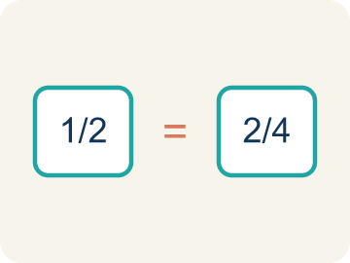 | Proportion Proporción  A math sentence saying two ratios are equal.  Example: 2/3 = 8/12
 | Cross-multiply Multiplicación cruzada  Multiplying across two ratios to check if they are equal.  Example: 2/3 = 8/12 → 2×12 = 24 and 3×8 = 24 ✓
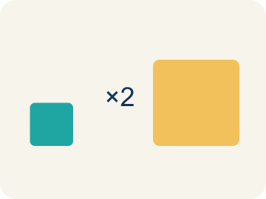 | Scale Escalar  To multiply or divide both parts of a ratio by the same number.  Example: 5:8 × 3 → 15:24
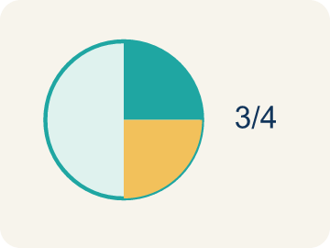 | Equivalent Equivalente  Having the same value.  Example: 1/2 and 3/6 and 5/10 all equal the same amount — half
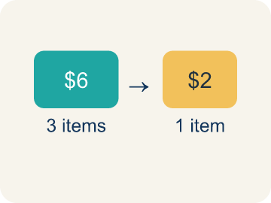 | Unit rate Tasa unitaria  A rate for just 1 of something. You find it by dividing.  Example: 60 miles in 3 hours → 20 miles per 1 hour

Worked Example

Watch & Read I Do — follow along with your teacher
Chef Academy received a huge catering order — a banquet for 120 guests! Chef Reyes's original appetizer recipe serves 8 people and calls for 5 cups of diced tomatoes and 3 cups of mozzarella. The students need to use ratio reasoning to scale the recipe so every guest gets the same delicious flavor.

Think about:
• How many times bigger is 120 compared to 8?
• What operation would help you scale both ingredients?
• What stays the same about the recipe even when the amounts change?
• What if we had a different number of guests — like 60 or 200?
• Could cross-multiplying help us check if our scaled recipe is correct?

Solved Example I Do — watch each step
Problem: A recipe uses 4 cups of broth for every 10 servings. How many cups of broth are needed for 30 servings?
A) 12
B) 8
C) 14
D) 40
Step 1: Scale factor: 30 ÷ 10 = 3.
Step 2: Multiply broth by 3: 4 × 3 = 12 cups.
Answer: A. 12

Guided Practice

Solve Together We Do — work with your class
Problem: Are the ratios 6:9 and 2:3 equivalent?
A) Yes, both simplify to 2:3
B) No, 6 ≠ 2
C) Yes, because 6 + 9 = 15
D) No, because 9 - 6 ≠ 3 - 2
Step 1:

Step 2:

Answer:

A school garden grows tomatoes. The gardeners know that 4 tomato plants produce about 20 tomatoes. The school wants to grow 100 tomatoes for a salsa-making event. They need to use ratio reasoning to determine how many plants to grow.

Sentence frame: This is like our ratio reasoning work because ___ and ___ are related by ___.

Turn & Talk discuss with a partner
1. [Launch] Chef Reyes's recipe serves 8 people, but the banquet has 120 guests. How many times bigger is 120 than 8, and how does that scale factor help you adjust the tomatoes and mozzarella?
Start with: 120 guests is ___ times bigger than 8 because 120 divided by 8 equals ___.
120 invitados es ___ veces más que 8 porque 120 entre 8 es ___.
Word bank: proportion, scale, equivalent, unit rate, ratio
2. [Explore] You sorted ratio pairs into equivalent and not equivalent. How does ratio reasoning, like cross-multiplying, prove that 4:7 and 12:21 are equivalent?
Start with: I reasoned that 4:7 and 12:21 are ___ because ___.
Razoné que 4:7 y 12:21 son ___ porque ___.
Word bank: proportion, equivalent, scale, cross-multiply, ratio
3. [Connect] Where might ratio reasoning help you make a smart choice in real life, like shopping or cooking?
Start with: Ratio reasoning helps me when ___.
El razonamiento con razones me ayuda cuando ___.
Word bank: proportion, scale, equivalent, unit rate, ratio

Independent Practice

On Your Own You Do — show your work
Solve each problem. Show your thinking in the work box.
1. If 3 pounds of apples cost $6, how much do 7 pounds cost?
A) $14
B) $13
C) $10
D) $21

2. Solve the proportion: 2/5 = x/20. What is x?
A) 8
B) 10
C) 4
D) 12

3. A chef uses the proportion 3/7 = x/28 to scale a recipe. What is x?
A) 12
B) 14
C) 9
D) 21

4. A recipe serves 6 people and uses 4 cups of rice. You need to serve 15 people. Show two different methods to find how much rice you need: (1) using a scale factor and (2) using a unit rate.

Write About the Math

Build Strong Sentences The Writing Revolution
I can explain my reasoning using the words proportion, scale, equivalent, and unit rate.

1. Kernel Sentence subject + verb
Model: Scale is to multiply or divide both parts of a ratio by the same number.

Write a kernel sentence about scale. Use a subject and a verb.
Escribe una oración base sobre escalar. Usa un sujeto y un verbo.

2. Sentence Expansion because · but · so
Kernel: Scale matters in math
because Scale matters in math because ___.
Escalar importa en matemáticas porque ___.

but Scale matters in math, but ___.
Escalar importa en matemáticas, pero ___.

so Scale matters in math, so ___.
Escalar importa en matemáticas, entonces ___.

3. Explain Your Reasoning use a sentence starter
120 guests is ___ times bigger than 8 because 120 divided by 8 equals ___.
120 invitados es ___ veces más que 8 porque 120 entre 8 es ___.
So I scale by ___, which keeps the recipe in ___.
Entonces escalo por ___, lo que mantiene la receta en ___.
I reasoned that 4:7 and 12:21 are ___ because ___.
Razoné que 4:7 y 12:21 son ___ porque ___.

Exit Ticket
Answer on your own. This shows what you learned today.
★ A recipe calls for 6 cups of flour for every 15 cookies. How many cups of flour are needed to make 45 cookies?
A) 18
B) 12
C) 24
D) 21

Answer Key & Teacher Guide
Teacher reference — remove or fold back before distributing to students.

Worked Notes (I Do / We Do)
I Do: A. 12
We Do: A. Yes, both simplify to 2:3

Independent Practice
1. A) $14 — Unit rate: $6 ÷ 3 = $2 per pound. For 7 pounds: $2 × 7 = $14.
2. A) 8 — Scale factor: 20 ÷ 5 = 4. Multiply: 2 × 4 = 8. So x = 8.
3. A) 12 — Scale factor: 28 ÷ 7 = 4. Multiply: 3 × 4 = 12. So x = 12.
4. Method 1 (scale factor): 15 ÷ 6 = 2.5. Multiply rice by 2.5: 4 × 2.5 = 10 cups. Method 2 (unit rate): 4 ÷ 6 = 2/3 cup per person. For 15 people: 2/3 × 15 = 10 cups. Both methods give 10 cups of rice.

Exit Ticket
A) 18 — Scale factor: 45 ÷ 15 = 3. Multiply flour by 3: 6 × 3 = 18 cups of flour.

Writing (TWR) — what to look for
Kernel sentence: a complete sentence needs a subject and a verb. Example: Scale is to multiply or divide both parts of a ratio by the same number.
Expansion: because = reason, but = contrast/exception, so = result. Answers vary; each must keep the kernel idea.

Turn & Talk — listen for
1. Students find the scale factor of 15 and explain that multiplying both ingredients by 15 keeps the recipe proportional (5 cups tomatoes becomes 75, 3 cups mozzarella becomes 45).
2. Students show 4 × 21 = 84 and 7 × 12 = 84 (or that 4:7 scales by 3 to 12:21), proving the ratios are equivalent.
3. Students name a real use (scaling a recipe, comparing deals, mixing paint or fuel) and explain how keeping the ratio equivalent guides the decision.

