Use Ratio Reasoning — Homework
Lesson 3-6 • Standard 6.RP.3
Name: ______________________ Period: ______ Date: ____________

Today's Goals
Content: I can use ratio reasoning to solve problems with proportions and scaling.
Language: I can explain my reasoning using the words proportion, scale, equivalent, and unit rate.

Key Words
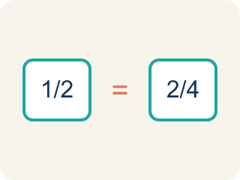
Proportion (Proporción) — A math sentence saying two ratios are equal.

Cross-multiply (Multiplicación cruzada) — Multiplying across two ratios to check if they are equal.
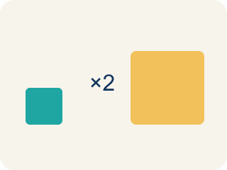
Scale (Escalar) — To multiply or divide both parts of a ratio by the same number.
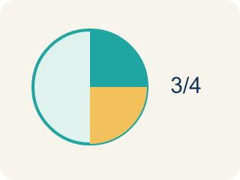
Equivalent (Equivalente) — Having the same value.
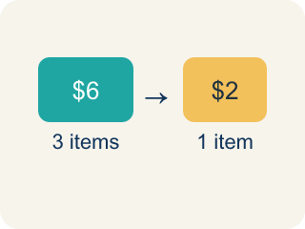
Unit rate (Tasa unitaria) — A rate for just 1 of something. You find it by dividing.

Practice
Show your work. Use the blank space under each problem.
1. A recipe uses 4 cups of broth for every 10 servings. How many cups of broth are needed for 30 servings?
A. 12
B. 8
C. 14
D. 40
______________________________________________________________________
2. Are the ratios 6:9 and 2:3 equivalent?
A. Yes, both simplify to 2:3
B. No, 6 ≠ 2
C. Yes, because 6 + 9 = 15
D. No, because 9 - 6 ≠ 3 - 2
______________________________________________________________________
3. Chef Reyes's appetizer uses 5 cups of tomatoes for every 3 cups of mozzarella. Scale the recipe for different group sizes.
Servings | Tomatoes (cups) | Mozzarella (cups)
8 | 5 | 3
16
40
120
______________________________________________________________________
4. A chef uses the proportion 3/7 = x/28 to scale a recipe. What is x?
A. 12
B. 14
C. 9
D. 21
______________________________________________________________________
5. For each proportion, sort whether it is set up correctly or incorrectly to solve '4 cups for 6 servings = ? cups for 18 servings'.
Groups: Correct Setup | Incorrect Setup
• 4/6 = x/18 → __________________
• 6/4 = 18/x → __________________
• 4/18 = x/6 → __________________
• 6/18 = x/4 → __________________
______________________________________________________________________
6. A car travels 150 miles using 5 gallons. At this rate, how far on 8 gallons?
A. 240 miles
B. 210 miles
C. 30 miles
D. 300 miles
______________________________________________________________________
7. If 4 workers build a wall in the same time pattern, and 4 workers lay 20 bricks per minute, how many bricks do 10 workers lay per minute at the same rate?
A. 50
B. 40
C. 30
D. 25
______________________________________________________________________
8. A map scale is 1 inch = 25 miles. Two cities are 4.5 inches apart. How far apart in real life?
A. 112.5 miles
B. 100 miles
C. 125 miles
D. 29.5 miles
______________________________________________________________________
9. A printer prints 24 pages in 3 minutes. How many pages in 7 minutes?
A. 56
B. 48
C. 63
D. 21
______________________________________________________________________

Answer Key (Teacher)
1. A. 12
Scale factor: 30 ÷ 10 = 3. Multiply broth by 3: 4 × 3 = 12 cups.
2. A. Yes, both simplify to 2:3
Divide 6:9 by 3 to get 2:3. Since both ratios simplify to 2:3, they are equivalent.
3. Chef Reyes's appetizer uses 5 cups of tomatoes for every 3 cups of mozzarella. Scale the recipe for different group sizes.
16 — Tomatoes (cups): 10
16 — Mozzarella (cups): 6
40 — Tomatoes (cups): 25
40 — Mozzarella (cups): 15
120 — Tomatoes (cups): 75
120 — Mozzarella (cups): 45

4. A. 12
Scale factor: 28 ÷ 7 = 4. Multiply: 3 × 4 = 12. So x = 12.
5. Correct groups:
4/6 = x/18 → Correct Setup
6/4 = 18/x → Correct Setup
4/18 = x/6 → Incorrect Setup
6/18 = x/4 → Incorrect Setup

6. A. 240 miles
150 ÷ 5 = 30 miles per gallon; 30 × 8 = 240 miles.
7. A. 50
20 ÷ 4 = 5 bricks per worker; 5 × 10 = 50 bricks per minute.
8. A. 112.5 miles
4.5 × 25 = 112.5 miles.
9. A. 56
24 ÷ 3 = 8 pages per minute; 8 × 7 = 56 pages.

