UNIT 3 · LESSON 7 STANDARD 6.RP.3

Ratio and Rate Problem Solving
Student Notes Packet
Name: ______________________ Date: ____________ Period: ________

Today's Goals
Content: I can solve real-world rate problems by finding and using unit rates.
Language: I can explain my solution using the words rate, unit rate, per, and proportion.

Key Vocabulary
Look at the picture, read the word, then read what it means.
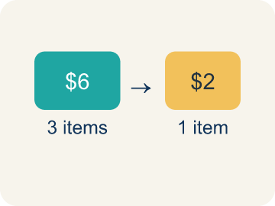 | Rate Tasa  A ratio comparing two amounts with different units, like miles per hour.  Example: $12 for 4 pounds → dollars per pound
 | Unit rate Tasa unitaria  A rate for just 1 of something, like cost for 1 item.  Example: $12 ÷ 4 = $3 per 1 pound
 | Per Por  For each one. Example: 5 dollars per book.  Example: 60 miles per hour, $5 per ticket
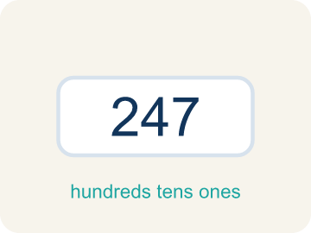 | Problem solving Resolución de problemas  Using ratios and rates to find a missing amount.  Example: Set up → Plan → Solve → Check
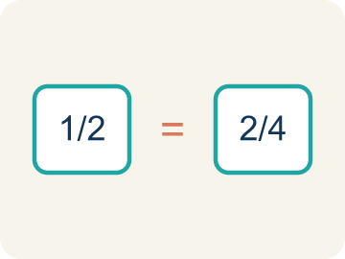 | Proportion Proporción  A math sentence saying two ratios are equal. It helps find a missing number.  Example: 3/5 = x/20 → x = 12

Worked Example

Watch & Read I Do — follow along with your teacher
It's the final day of Chef Academy — the Culinary Competition! Teams must solve ratio and rate problems to earn ingredients for their dishes. Team 1 needs to figure out how much chicken costs if 3 pounds cost $18. Team 2 must calculate how many cupcakes they can frost if they decorate 5 cupcakes every 4 minutes. The clock is ticking!

Think about:
• What two quantities with different units are being compared?
• How could you find the cost of just 1 pound of chicken?
• How could you find the number of cupcakes frosted in 1 minute?
• Which strategy is fastest — unit rates, ratio tables, or proportions?
• What if the rate is not a whole number — can you still solve the problem?

Solved Example I Do — watch each step
Problem: A bakery makes 24 cookies in 3 batches. What is the unit rate of cookies per batch?
A) 8 cookies per batch
B) 3 cookies per batch
C) 24 cookies per batch
D) 6 cookies per batch
Step 1: Unit rate: 24 cookies ÷ 3 batches = 8 cookies per batch.
Answer: A. 8 cookies per batch

Guided Practice

Solve Together We Do — work with your class
Problem: Apples cost $5 for 4 pounds. What is the cost per pound?
A) $1.25
B) $0.80
C) $1.50
D) $4.00
Step 1:

Step 2:

Answer:

A runner trains for a 5K race. During practice, she runs 3 miles in 27 minutes. She wants to know her pace (minutes per mile) and predict how long the full 5K (3.1 miles) will take at the same rate.

Sentence frame: This is like our rate problem-solving work because ___ and ___ are related by ___.

Turn & Talk discuss with a partner
1. [Launch] Team 1 knows 3 pounds of chicken cost $18. What was your plan to find the cost of just 1 pound, and why is that unit rate useful?
Start with: My plan was to divide ___ by ___ to get the cost per ___.
Mi plan fue dividir ___ entre ___ para hallar el costo por ___.
Word bank: rate, unit rate, per, proportion, divide
2. [Explore] Team 2 frosts 5 cupcakes every 4 minutes. How did you set up a rate or proportion to find how many cupcakes they frost in a longer time?
Start with: The rate is ___ cupcakes per ___ minutes.
La tasa es ___ cupcakes por ___ minutos.
Word bank: rate, unit rate, per, proportion, scale
3. [Connect] Tell about a real situation where rates matter, like speed, pay, or price, and explain how the unit rate helps you.
Start with: Rates matter when ___, like ___ per ___.
Las tasas importan cuando ___, como ___ por ___.
Word bank: rate, unit rate, per, proportion, compare

Independent Practice

On Your Own You Do — show your work
Solve each problem. Show your thinking in the work box.
1. A cyclist rides 36 miles in 3 hours. At the same rate, how far will she ride in 5 hours?
A) 60 miles
B) 48 miles
C) 72 miles
D) 45 miles

2. A printer prints 45 pages in 9 minutes. How many pages does it print per minute?
A) 5 pages per minute
B) 9 pages per minute
C) 4 pages per minute
D) 45 pages per minute

3. A car travels 150 miles in 3 hours. A bus travels 200 miles in 5 hours. Which vehicle is faster?
A) The car
B) The bus
C) Same speed
D) Cannot determine

4. A factory makes 240 widgets in 8 hours. Another factory makes 200 widgets in 5 hours. Which factory is faster? If both factories work together for 10 hours, how many total widgets would they produce?

Write About the Math

Build Strong Sentences The Writing Revolution
I can explain my solution using the words rate, unit rate, per, and proportion.

1. Kernel Sentence subject + verb
Model: Rate is a ratio comparing two amounts with different units, like miles per hour.

Write a kernel sentence about rate. Use a subject and a verb.
Escribe una oración base sobre tasa. Usa un sujeto y un verbo.

2. Sentence Expansion because · but · so
Kernel: Rate matters in math
because Rate matters in math because ___.
Tasa importa en matemáticas porque ___.

but Rate matters in math, but ___.
Tasa importa en matemáticas, pero ___.

so Rate matters in math, so ___.
Tasa importa en matemáticas, entonces ___.

3. Explain Your Reasoning use a sentence starter
My plan was to divide ___ by ___ to get the cost per ___.
Mi plan fue dividir ___ entre ___ para hallar el costo por ___.
The unit rate is ___ per pound, which is useful because ___.
La tasa unitaria es ___ por libra, lo cual es útil porque ___.
The rate is ___ cupcakes per ___ minutes.
La tasa es ___ cupcakes por ___ minutos.

Exit Ticket
Answer on your own. This shows what you learned today.
★ A printer prints 30 pages in 5 minutes. At this rate, how many pages will it print in 12 minutes?
A) 72
B) 60
C) 36
D) 42

Answer Key & Teacher Guide
Teacher reference — remove or fold back before distributing to students.

Worked Notes (I Do / We Do)
I Do: A. 8 cookies per batch
We Do: A. $1.25

Independent Practice
1. A) 60 miles — Unit rate: 36 ÷ 3 = 12 miles per hour. In 5 hours: 12 × 5 = 60 miles.
2. A) 5 pages per minute — Unit rate: 45 ÷ 9 = 5 pages per minute.
3. A) The car — Car: 150÷3 = 50 mph. Bus: 200÷5 = 40 mph. The car travels faster at 50 mph vs. 40 mph.
4. Factory A: 240 ÷ 8 = 30 widgets/hour. Factory B: 200 ÷ 5 = 40 widgets/hour. Factory B is faster. Together: (30 + 40) × 10 = 70 × 10 = 700 widgets in 10 hours.

Exit Ticket
A) 72 — Unit rate: 30 ÷ 5 = 6 pages per minute. In 12 minutes: 6 × 12 = 72 pages.

Writing (TWR) — what to look for
Kernel sentence: a complete sentence needs a subject and a verb. Example: Rate is a ratio comparing two amounts with different units, like miles per hour.
Expansion: because = reason, but = contrast/exception, so = result. Answers vary; each must keep the kernel idea.

Turn & Talk — listen for
1. Students divide $18 by 3 to get $6 per pound and explain the unit rate lets them find the cost of any number of pounds.
2. Students state the rate (5 cupcakes per 4 minutes) and set up a proportion or unit rate (1.25 cupcakes/min) to scale to the needed time.
3. Students give a real rate (speed, hourly pay, price per item) and explain how the unit rate lets them predict or compare.

