Ratio and Rate Problem Solving — Homework
Lesson 3-7 • Standard 6.RP.3
Name: ______________________ Period: ______ Date: ____________

Today's Goals
Content: I can solve real-world rate problems by finding and using unit rates.
Language: I can explain my solution using the words rate, unit rate, per, and proportion.

Key Words
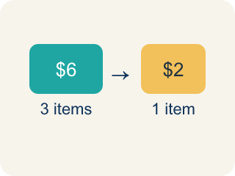
Rate (Tasa) — A ratio comparing two amounts with different units, like miles per hour.

Unit rate (Tasa unitaria) — A rate for just 1 of something, like cost for 1 item.

Per (Por) — For each one. Example: 5 dollars per book.
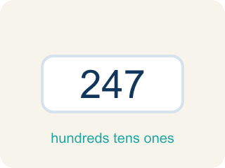
Problem solving (Resolución de problemas) — Using ratios and rates to find a missing amount.
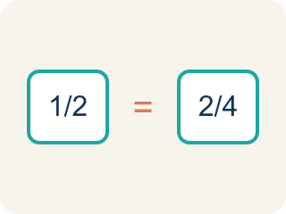
Proportion (Proporción) — A math sentence saying two ratios are equal. It helps find a missing number.

Practice
Show your work. Use the blank space under each problem.
1. A bakery makes 24 cookies in 3 batches. What is the unit rate of cookies per batch?
A. 8 cookies per batch
B. 3 cookies per batch
C. 24 cookies per batch
D. 6 cookies per batch
______________________________________________________________________
2. Apples cost $5 for 4 pounds. What is the cost per pound?
A. $1.25
B. $0.80
C. $1.50
D. $4.00
______________________________________________________________________
3. Team 2 frosts 5 cupcakes every 4 minutes. Complete the ratio table to find how many cupcakes they can frost in different times.
Minutes | Cupcakes Frosted
4 | 5
8
12
20
______________________________________________________________________
4. A car travels 150 miles in 3 hours. A bus travels 200 miles in 5 hours. Which vehicle is faster?
A. The car
B. The bus
C. Same speed
D. Cannot determine
______________________________________________________________________
5. Sort each rate problem by the strategy that works BEST to solve it.
Groups: Use Unit Rate | Use Ratio Table / Proportion
• Find cost per pound when 5 lb costs $12 → __________________
• If 3 shirts cost $24, find cost of 9 shirts → __________________
• A car goes 55 mph — how far in 4 hours? → __________________
• Scale a recipe from 4 servings to 20 servings → __________________
______________________________________________________________________
6. A store sells 3 shirts for $36. How much would 5 shirts cost at the same rate?
A. $60
B. $48
C. $72
D. $54
______________________________________________________________________
7. A recipe for 4 people uses 6 eggs. How many eggs for 10 people?
A. 15
B. 12
C. 18
D. 20
______________________________________________________________________
8. A runner covers 12 km in 4 hours. How long to cover 21 km at the same speed?
A. 7 hours
B. 6 hours
C. 8 hours
D. 5 hours
______________________________________________________________________
9. 5 notebooks cost $7.50. What is the cost of 12 notebooks?
A. $18.00
B. $15.00
C. $20.00
D. $16.50
______________________________________________________________________

Answer Key (Teacher)
1. A. 8 cookies per batch
Unit rate: 24 cookies ÷ 3 batches = 8 cookies per batch.
2. A. $1.25
Unit rate: $5 ÷ 4 pounds = $1.25 per pound.
3. Team 2 frosts 5 cupcakes every 4 minutes. Complete the ratio table to find how many cupcakes they can frost in different times.
8 — Cupcakes Frosted: 10
12 — Cupcakes Frosted: 15
20 — Cupcakes Frosted: 25

4. A. The car
Car: 150÷3 = 50 mph. Bus: 200÷5 = 40 mph. The car travels faster at 50 mph vs. 40 mph.
5. Correct groups:
Find cost per pound when 5 lb costs $12 → Use Unit Rate
If 3 shirts cost $24, find cost of 9 shirts → Use Ratio Table / Proportion
A car goes 55 mph — how far in 4 hours? → Use Unit Rate
Scale a recipe from 4 servings to 20 servings → Use Ratio Table / Proportion

6. A. $60
Each shirt is $12, so 5 shirts cost $60.
7. A. 15
6 ÷ 4 = 1.5 eggs per person; 1.5 × 10 = 15 eggs.
8. A. 7 hours
Speed is 3 km/h; 21 ÷ 3 = 7 hours.
9. A. $18.00
Each notebook is $1.50; 12 × $1.50 = $18.00.

