Rates and Unit Rates — Homework
Lesson 4-1 • Standard 6.RP.2
Name: ______________________ Period: ______ Date: ____________

Today's Goals
Content: I can find a unit rate to compare prices and decide the better buy.
Language: I can explain my choice using the words rate, unit rate, per, and better buy.

Key Words
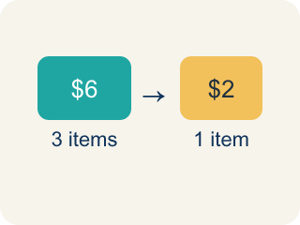
Rate (Tasa) — A ratio comparing two amounts with different units, like miles per hour.

Unit Rate (Tasa unitaria) — A rate for just 1 of something, like cost for 1 item.

Per (Por) — For each one. Example: 5 dollars per book.
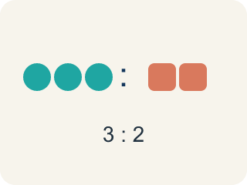
Ratio (Razón) — A way to compare two amounts.

Better Buy (Mejor compra) — The choice that costs less for each item.
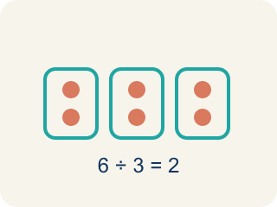
Divide (Dividir) — Splitting a total into equal groups.

Practice
Show your work. Use the blank space under each problem.
1. A booth charges $4.50 for 9 games. What is the unit rate?
A. $0.50 per game
B. $0.45 per game
C. $2.00 per game
D. $4.50 per game
______________________________________________________________________
2. A car travels 180 miles using 6 gallons of gas. What is the unit rate in miles per gallon?
A. 30 miles per gallon
B. 6 miles per gallon
C. 180 miles per gallon
D. 36 miles per gallon
______________________________________________________________________
3. Complete the table to find unit rates and determine the best deal.
Deal | Quantity | Cost | Unit Rate
Tokens Pack A | 20 tokens | $5.00
Tokens Pack B | 35 tokens | $7.00
Tokens Pack C | 50 tokens | $12.50
______________________________________________________________________
4. Which token pack from the table above is the best deal?
A. Pack A
B. Pack B
C. Pack C
D. They are all the same
______________________________________________________________________
5. Sort each situation by whether the unit rate is 'per item' or 'per time'.
Groups: Rate Per Item | Rate Per Time
• $3 per pound of apples → __________________
• 60 miles per hour → __________________
• $0.25 per token → __________________
• 15 pages per minute → __________________
• $1.50 per bottle → __________________
• 8 laps per hour → __________________
______________________________________________________________________
6. Runner A completes 4 laps in 12 minutes. Runner B completes 5 laps in 14 minutes. Who runs more laps per minute?
A. Runner B
B. Runner A
C. Same rate
D. Cannot determine
______________________________________________________________________
7. A car drives 180 miles in 3 hours. What is the unit rate?
A. 60 miles per hour
B. 540 miles per hour
C. 3 miles per hour
D. 60 hours per mile
______________________________________________________________________
8. 12 oranges cost $4.80. What is the unit price per orange?
A. $0.40
B. $0.48
C. $4.00
D. $0.04
______________________________________________________________________
9. Which is the better unit rate for typing speed: 240 words in 4 minutes or 300 words in 6 minutes?
A. 240 words in 4 minutes
B. 300 words in 6 minutes
C. They are equal
D. Cannot tell
______________________________________________________________________
10. A faucet fills 15 liters in 5 minutes. How many liters per minute?
A. 3
B. 75
C. 5
D. 10
______________________________________________________________________

Answer Key (Teacher)
1. A. $0.50 per game
$4.50 ÷ 9 = $0.50 per game.
2. A. 30 miles per gallon
180 miles ÷ 6 gallons = 30 miles per gallon.
3. Complete the table to find unit rates and determine the best deal.
Tokens Pack A — Unit Rate: $0.25 per token
Tokens Pack B — Unit Rate: $0.20 per token
Tokens Pack C — Unit Rate: $0.25 per token

4. B. Pack B
Pack B has a unit rate of $0.20 per token, which is the lowest cost per token.
5. Correct groups:
$3 per pound of apples → Rate Per Item
60 miles per hour → Rate Per Time
$0.25 per token → Rate Per Item
15 pages per minute → Rate Per Time
$1.50 per bottle → Rate Per Item
8 laps per hour → Rate Per Time

6. A. Runner B
Runner A: 4÷12 ≈ 0.33 laps/min. Runner B: 5÷14 ≈ 0.36 laps/min. Runner B runs slightly more laps per minute.
7. A. 60 miles per hour
180 ÷ 3 = 60 miles per hour.
8. A. $0.40
4.80 ÷ 12 = 0.40 per orange.
9. A. 240 words in 4 minutes
60 words/min vs 50 words/min; 240 in 4 minutes is faster.
10. A. 3
15 ÷ 5 = 3 liters per minute.

