UNIT 4 · LESSON 2 STANDARD 6.RP.3C

Relate Fractions, Decimals, and Percents
Student Notes Packet
Name: ______________________ Date: ____________ Period: ________

Today's Goals
Content: I can write equivalent fractions, decimals, and percents for the same value.
Language: I can explain my conversions using the words percent, decimal, equivalent, and benchmark.

Key Vocabulary
Look at the picture, read the word, then read what it means.
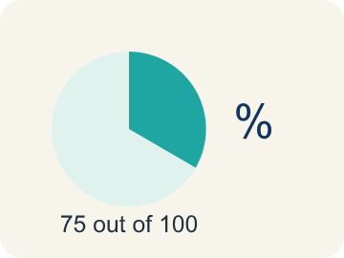 | Percent Porcentaje  A way to compare a number to 100, shown with the % sign.  Example: 25% means 25 out of 100
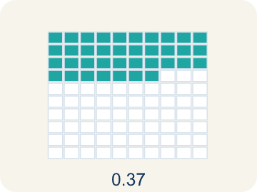 | Decimal Decimal  A number with a dot, like 0.5, that shows a part.  Example: 0.75 means seventy-five hundredths
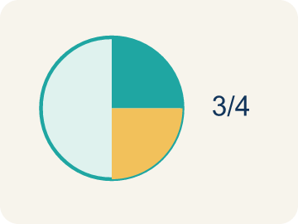 | Equivalent Equivalente  Having the same value, just written a different way.  Example: 1/2 = 0.5 = 50%
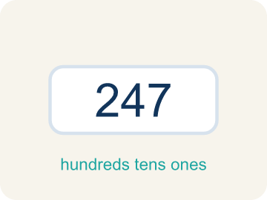 | Benchmark Referencia  A familiar number you use to guess, like 50% or 1/2.  Example: Common benchmarks: 25%, 50%, 75%
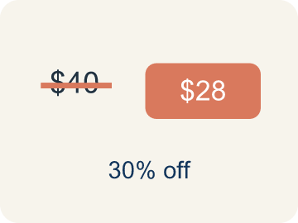 | Discount Descuento  Money taken off the first price to make it cheaper.  Example: $40 shirt at 25% off: discount = $10

Worked Example

Watch & Read I Do — follow along with your teacher
Arcade Builder Challenge
You're designing the scoring system for a new arcade game. Players earn points as fractions of the total possible score. The leaderboard shows scores as percentages, but the game engine uses decimals. You need to convert between all three forms to build the display!

Think about:
• What are three different ways to write the same number?
• If a player scored 3/4 of the points, what percent is that?
• Are some fractions easier to convert than others?
• How do you convert a fraction to a percent without a calculator?

Solved Example I Do — watch each step
Problem: Convert 3/5 to a percent.
A) 60%
B) 35%
C) 53%
D) 65%
Step 1: 3 ÷ 5 = 0.6 = 60%.
Answer: A. 60%

Guided Practice

Solve Together We Do — work with your class
Problem: Convert 7/20 to a percent.
A) 35%
B) 70%
C) 20%
D) 14%
Step 1:

Step 2:

Answer:

A store has a clearance sale: 'Everything 3/5 off!' Your friend says that means 35% off. Another friend says it's 60% off. The original price of a game is $40.
Who is correct, and how much would the game cost on sale?

Sentence frame: The friend who said ___% is correct because 3/5 = ___ = ___%. The sale price is $___.

Turn & Talk discuss with a partner
1. [Launch] A player scored 3/4 of the points. The leaderboard shows percents and the game engine uses decimals. What are three different ways to write the same score?
Start with: The fraction ___ is the same as the decimal ___ and the percent ___.
La fracción ___ es igual al decimal ___ y al porcentaje ___.
Word bank: percent, decimal, equivalent, benchmark
2. [Explore] How did you convert a fraction like 3/5 into a decimal and a percent in the table?
Start with: To change ___ to a decimal I divided ___ by ___.
Para cambiar ___ a decimal dividí ___ entre ___.
Word bank: percent, decimal, equivalent, benchmark
3. [Connect] A sale says 'Everything 3/5 off!' One friend says that is 35% off and another says 60% off. Who is right, and how do you know?
Start with: The friend who said ___% is correct because 3/5 = ___ = ___%.
El amigo que dijo ___% tiene razón porque 3/5 = ___ = ___%.
Word bank: percent, decimal, equivalent, discount

Independent Practice

On Your Own You Do — show your work
Solve each problem. Show your thinking in the work box.
1. Which decimal is equivalent to 45%?
A) 0.45
B) 4.5
C) 0.045
D) 45.0

2. What fraction is equal to 0.75?
A) 3/4
B) 7/5
C) 3/5
D) 7/10

3. A game shows your score as 7/8 complete. What percent is that?
A) 87.5%
B) 78%
C) 75%
D) 88%

4. What is 0.45 written as a percent?
A) 45%
B) 4.5%
C) 450%
D) 0.45%

Write About the Math

Build Strong Sentences The Writing Revolution
I can explain my conversions using the words percent, decimal, equivalent, and benchmark.

1. Kernel Sentence subject + verb
Model: Percent is a way to compare a number to 100, shown with the % sign.

Write a kernel sentence about percent. Use a subject and a verb.
Escribe una oración base sobre porcentaje. Usa un sujeto y un verbo.

2. Sentence Expansion because · but · so
Kernel: Percent matters in math
because Percent matters in math because ___.
Porcentaje importa en matemáticas porque ___.

but Percent matters in math, but ___.
Porcentaje importa en matemáticas, pero ___.

so Percent matters in math, so ___.
Porcentaje importa en matemáticas, entonces ___.

3. Explain Your Reasoning use a sentence starter
The fraction ___ is the same as the decimal ___ and the percent ___.
La fracción ___ es igual al decimal ___ y al porcentaje ___.
I can write the same value as a fraction, a ___, or a ___.
Puedo escribir el mismo valor como fracción, ___ o ___.
To change ___ to a decimal I divided ___ by ___.
Para cambiar ___ a decimal dividí ___ entre ___.

Exit Ticket
Answer on your own. This shows what you learned today.
★ Which shows 0.45 as a fraction and a percent?
A) 9/20 and 45%
B) 45/10 and 4.5%
C) 4/5 and 45%
D) 9/20 and 4.5%

Answer Key & Teacher Guide
Teacher reference — remove or fold back before distributing to students.

Worked Notes (I Do / We Do)
I Do: A. 60%
We Do: A. 35%

Independent Practice
1. A) 0.45 — To convert a percent to a decimal, divide by 100: 45 ÷ 100 = 0.45.
2. A) 3/4 — 0.75 = 75/100. Simplify by dividing both by 25: 75÷25 = 3 and 100÷25 = 4. So 0.75 = 3/4.
3. A) 87.5% — 7 ÷ 8 = 0.875, and 0.875 × 100 = 87.5%.
4. A) 45% — Multiply by 100: 0.45 = 45%.

Exit Ticket
A) 9/20 and 45% — 0.45 = 45/100 = 9/20 (simplified). 0.45 × 100 = 45%.

Writing (TWR) — what to look for
Kernel sentence: a complete sentence needs a subject and a verb. Example: Percent is a way to compare a number to 100, shown with the % sign.
Expansion: because = reason, but = contrast/exception, so = result. Answers vary; each must keep the kernel idea.

Turn & Talk — listen for
1. Students give 3/4 = 0.75 = 75% and recognize these are three forms of one value, not three different scores.
2. Students describe dividing numerator by denominator (3 div 5 = 0.6) and multiplying by 100 to get 60%, and call the three forms equivalent.
3. Students convert 3/5 to 0.6 and 60%, identify 60% off as correct, and can find the $40 game becomes $16.

