Relate Fractions, Decimals, and Percents — Homework
Lesson 4-2 • Standard 6.RP.3c
Name: ______________________ Period: ______ Date: ____________

Today's Goals
Content: I can write equivalent fractions, decimals, and percents for the same value.
Language: I can explain my conversions using the words percent, decimal, equivalent, and benchmark.

Key Words
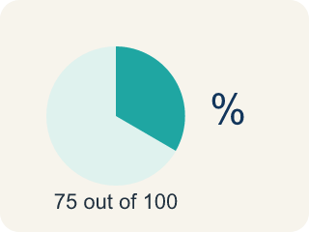
Percent (Porcentaje) — A way to compare a number to 100, shown with the % sign.
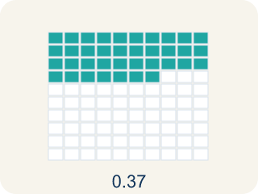
Decimal (Decimal) — A number with a dot, like 0.5, that shows a part.
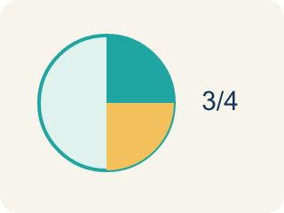
Equivalent (Equivalente) — Having the same value, just written a different way.
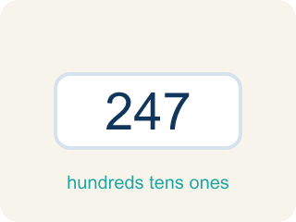
Benchmark (Referencia) — A familiar number you use to guess, like 50% or 1/2.
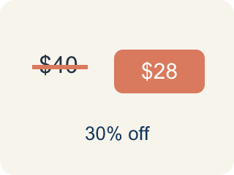
Discount (Descuento) — Money taken off the first price to make it cheaper.

Practice
Show your work. Use the blank space under each problem.
1. Sort these values — which are greater than 50% and which are less than 50%?
Groups: Greater than 50% | Less than 50%
• 3/4 → __________________
• 0.8 → __________________
• 65% → __________________
• 7/10 → __________________
• 1/3 → __________________
• 0.25 → __________________
• 40% → __________________
• 2/5 → __________________
______________________________________________________________________
2. Convert 3/5 to a percent.
A. 60%
B. 35%
C. 53%
D. 65%
______________________________________________________________________
3. A game shows your score as 7/8 complete. What percent is that?
A. 87.5%
B. 78%
C. 75%
D. 88%
______________________________________________________________________
4. Complete each row by converting to all three forms.
Fraction | Decimal | Percent
2/5
 | 0.125
 |  | 90%
5/8
______________________________________________________________________
5. Order these values from least to greatest by sorting them into the correct position.
Groups: 1st (Smallest) | 2nd | 3rd | 4th | 5th (Largest)
• 1/5 (= 0.20) → __________________
• 0.35 → __________________
• 2/5 (= 0.40) → __________________
• 55% → __________________
• 3/4 (= 0.75) → __________________
______________________________________________________________________
6. What is 0.45 written as a percent?
A. 45%
B. 4.5%
C. 450%
D. 0.45%
______________________________________________________________________
7. What is 3/5 written as a percent?
A. 60%
B. 35%
C. 53%
D. 30%
______________________________________________________________________
8. Which is the largest value?
A. 0.7
B. 65%
C. 3/5
D. 0.59
______________________________________________________________________
9. What is 25% as a fraction in simplest form?
A. 1/4
B. 25/10
C. 1/5
D. 4/1
______________________________________________________________________

Answer Key (Teacher)
1. Correct groups:
3/4 → Greater than 50%
0.8 → Greater than 50%
65% → Greater than 50%
7/10 → Greater than 50%
1/3 → Less than 50%
0.25 → Less than 50%
40% → Less than 50%
2/5 → Less than 50%

2. A. 60%
3 ÷ 5 = 0.6 = 60%.
3. A. 87.5%
7 ÷ 8 = 0.875, and 0.875 × 100 = 87.5%.
4. Complete each row by converting to all three forms.
2/5 — Decimal: 0.4
2/5 — Percent: 40%
Row 2 — Fraction: 1/8
Row 2 — Percent: 12.5%
Row 3 — Fraction: 9/10
Row 3 — Decimal: 0.9
5/8 — Decimal: 0.625
5/8 — Percent: 62.5%

5. Correct groups:
1/5 (= 0.20) → 1st (Smallest)
0.35 → 2nd
2/5 (= 0.40) → 3rd
55% → 4th
3/4 (= 0.75) → 5th (Largest)

6. A. 45%
Multiply by 100: 0.45 = 45%.
7. A. 60%
3/5 = 0.6 = 60%.
8. A. 0.7
0.7 = 70%, larger than 65%, 60% (3/5), and 59%.
9. A. 1/4
25% = 25/100 = 1/4.

