Find the Percent of a Number — Homework
Lesson 4-4 • Standard 6.RP.3c
Name: ______________________ Period: ______ Date: ____________

Today's Goals
Content: I can find the percent of a number using an equation or a model.
Language: I can explain my steps using the words percent, base, part, and equation.

Key Words
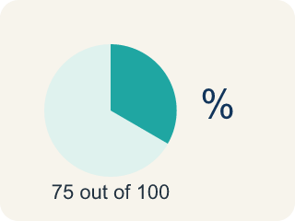
Percent (Porcentaje) — A way to compare a number to 100, shown with the % sign.
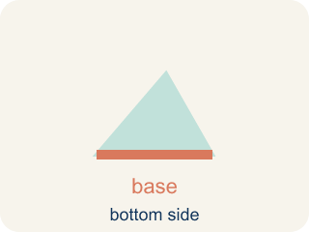
Base (Base (el todo)) — The whole amount you take a percent of.
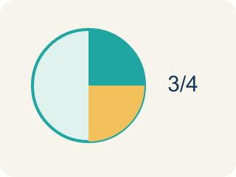
Part (Parte) — The piece you get when you take a percent of a number.
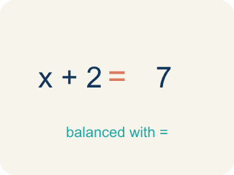
Equation (Ecuación) — A math sentence with an equal sign showing both sides are the same.
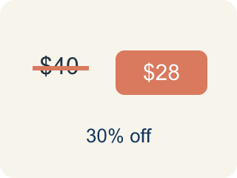
Discount (Descuento) — Money taken off the first price to make it cheaper.

Practice
Show your work. Use the blank space under each problem.
1. What is 20% of 150?
A. 30
B. 20
C. 35
D. 75
______________________________________________________________________
2. What is 50% of 84?
A. 42
B. 50
C. 34
D. 168
______________________________________________________________________
3. Complete each row to find the percent of a number.
Percent | Base | Part
10% | 250
75% | 120
35% | 200
8% | 50
______________________________________________________________________
4. An arcade prize costs 240 tickets. If you have a coupon for 15% off, how many tickets do you save?
A. 36 tickets
B. 24 tickets
C. 15 tickets
D. 204 tickets
______________________________________________________________________
5. A student scored 72 out of 90 on a test. What percent did they score?
A. 80%
B. 72%
C. 75%
D. 90%
______________________________________________________________________
6. What is 20% of 150?
A. 30
B. 15
C. 300
D. 75
______________________________________________________________________
7. What is 35% of 80?
A. 28
B. 35
C. 45
D. 24
______________________________________________________________________
8. A jacket costs $60 and is 25% off. How much is the discount?
A. $15
B. $25
C. $45
D. $20
______________________________________________________________________
9. What is 150% of 40?
A. 60
B. 45
C. 20
D. 140
______________________________________________________________________

Answer Key (Teacher)
1. A. 30
20% = 0.20. Multiply: 0.20 × 150 = 30.
2. A. 42
50% = 0.50. Multiply: 0.50 × 84 = 42. (Or simply divide by 2: 84 ÷ 2 = 42.)
3. Complete each row to find the percent of a number.
10% — Part: 25
75% — Part: 90
35% — Part: 70
8% — Part: 4

4. A. 36 tickets
15% of 240 = 0.15 × 240 = 36 tickets saved.
5. A. 80%
72 ÷ 90 = 0.80 = 80%.
6. A. 30
0.20 × 150 = 30.
7. A. 28
0.35 × 80 = 28.
8. A. $15
0.25 × 60 = $15 off.
9. A. 60
1.5 × 40 = 60.

