Use Percent to Solve Problems — Homework
Lesson 4-5 • Standard 6.RP.3c
Name: ______________________ Period: ______ Date: ____________

Today's Goals
Content: I can solve problems involving discounts, markups, tax, and tips using percents.
Language: I can explain my solution using the words discount, markup, tax, tip, and percent.

Key Words
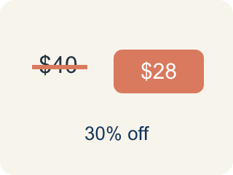
Discount (Descuento) — Money taken off the first price to make it cheaper.
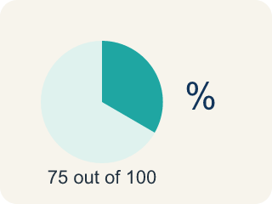
Markup (Recargo (margen)) — Money added to the cost to set the selling price.

Tax (Impuesto) — Extra money added to a price for the government.

Tip (Propina) — Extra money you give for good service.

Percent (Porcentaje) — A way to compare a number to 100, shown with the % sign.

Practice
Show your work. Use the blank space under each problem.
1. A prize costs 120 tickets and is 25% off. What is the sale price?
A. 90 tickets
B. 95 tickets
C. 100 tickets
D. 30 tickets
______________________________________________________________________
2. A meal costs $20. You leave a 15% tip. How much is the tip?
A. $3.00
B. $1.50
C. $5.00
D. $0.15
______________________________________________________________________
3. Solve each percent word problem.
Situation | Calculation | Answer
A $45 game has a 20% discount. What is the sale price? | 45 − (0.20 × 45)
A $60 controller has 8% tax. What is the total? | 60 + (0.08 × 60)
A $25 meal with 15% tip. What is the total? | 25 + (0.15 × 25)
______________________________________________________________________
4. A store marks up a $30 item by 40%, then a customer gets 10% off. What is the final price?
A. $37.80
B. $39.00
C. $42.00
D. $36.00
______________________________________________________________________
5. A restaurant bill is $35. You want to leave a 20% tip. What is the total amount you pay?
A. $42.00
B. $40.00
C. $38.50
D. $55.00
______________________________________________________________________
6. 15 is what percent of 60?
A. 25%
B. 15%
C. 45%
D. 40%
______________________________________________________________________
7. 8 is 40% of what number?
A. 20
B. 32
C. 48
D. 16
______________________________________________________________________
8. A test has 25 questions. A student gets 88% correct. How many are correct?
A. 22
B. 20
C. 23
D. 21
______________________________________________________________________
9. A shirt is $30 after a 25% discount off the original price. What was the original price?
A. $40
B. $37.50
C. $45
D. $36
______________________________________________________________________

Answer Key (Teacher)
1. A. 90 tickets
25% of 120 = 0.25 × 120 = 30. Sale price: 120 − 30 = 90 tickets.
2. A. $3.00
15% of $20 = 0.15 × 20 = $3.00.
3. Solve each percent word problem.
A $45 game has a 20% discount. What is the sale price? — Answer: $36
A $60 controller has 8% tax. What is the total? — Answer: $64.80
A $25 meal with 15% tip. What is the total? — Answer: $28.75

4. A. $37.80
Markup: $30 × 1.40 = $42. Discount: $42 × 0.10 = $4.20. Final: $42 − $4.20 = $37.80.
5. A. $42.00
Tip: 0.20 × $35 = $7.00. Total: $35 + $7 = $42.00.
6. A. 25%
15/60 = 0.25 = 25%.
7. A. 20
8 ÷ 0.40 = 20.
8. A. 22
0.88 × 25 = 22 questions.
9. A. $40
$30 is 75% of the original; 30 ÷ 0.75 = $40.

