Convert Measurement Units — Homework
Lesson 4-6 • Standard 6.RP.3d
Name: ______________________ Period: ______ Date: ____________

Today's Goals
Content: I can convert measurement units using ratios and conversion factors.
Language: I can explain my conversion using the words conversion factor, unit, equivalent, and ratio.

Key Words
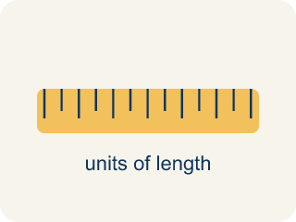
Conversion Factor (Factor de conversión) — A ratio that helps you change one unit into another.

Unit (Unidad) — A standard amount used to measure, like an inch or a liter.
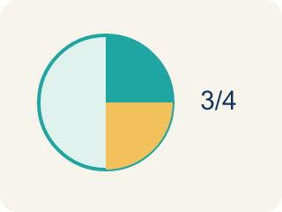
Equivalent (Equivalente) — Having the same value, just in different units.
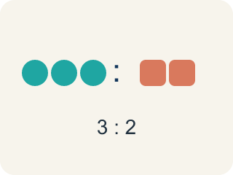
Ratio (Razón) — A way to compare two amounts.

Customary units (Unidades usuales (sistema inglés)) — The U.S. way of measuring, like inches, feet, and pounds.

Metric units (Unidades métricas) — A way of measuring by 10s, like meters, liters, and grams.

Practice
Show your work. Use the blank space under each problem.
1. How many inches are in 7 feet?
A. 84 inches
B. 72 inches
C. 70 inches
D. 96 inches
______________________________________________________________________
2. How many feet are in 3 yards?
A. 9 feet
B. 6 feet
C. 12 feet
D. 36 feet
______________________________________________________________________
3. Match each item on the left to its answer on the right.
Item | Answer choices
____ 3 yards | F. 48 ounces
____ 4 feet | E. 3 feet
____ 5 pounds | D. 72 inches
____ 2 yards | C. 80 ounces
____ 36 inches | B. 48 inches
____ 3 pounds | A. 9 feet
______________________________________________________________________
4. A shelf is 30 inches long. How many feet and inches is that?
A. 2 feet 6 inches
B. 3 feet 0 inches
C. 2 feet 8 inches
D. 1 foot 18 inches
______________________________________________________________________
5. An arcade cabinet has parts measured in different units. Convert each to the target unit.
Part | Measurement | Target Unit | Converted
Power cord | 2 yards | inches
Top panel | 54 inches | feet
Weight | 96 ounces | pounds
Side rail | 5 feet | inches
______________________________________________________________________
6. When converting, do you multiply or divide? Sort each conversion by the correct operation.
Groups: Multiply | Divide
• Feet → inches → __________________
• Yards → feet → __________________
• Pounds → ounces → __________________
• Inches → feet → __________________
• Ounces → pounds → __________________
• Feet → yards → __________________
______________________________________________________________________
7. How many inches are in 4 feet? (1 ft = 12 in)
A. 48
B. 16
C. 36
D. 40
______________________________________________________________________
8. How many centimeters are in 2.5 meters? (1 m = 100 cm)
A. 250
B. 25
C. 2,500
D. 2.5
______________________________________________________________________
9. A recipe needs 3 quarts of water. How many cups is that? (1 qt = 4 cups)
A. 12
B. 7
C. 8
D. 16
______________________________________________________________________
10. How many pounds are in 64 ounces? (1 lb = 16 oz)
A. 4
B. 8
C. 48
D. 1,024
______________________________________________________________________

Answer Key (Teacher)
1. A. 84 inches
7 × 12 = 84 inches.
2. A. 9 feet
1 yard = 3 feet. 3 × 3 = 9 feet.
3. Matches:
3 yards → 9 feet
4 feet → 48 inches
5 pounds → 80 ounces
2 yards → 72 inches
36 inches → 3 feet
3 pounds → 48 ounces

4. A. 2 feet 6 inches
30 ÷ 12 = 2 remainder 6. So 30 inches = 2 feet 6 inches.
5. An arcade cabinet has parts measured in different units. Convert each to the target unit.
Power cord — Converted: 72 inches
Top panel — Converted: 4.5 feet
Weight — Converted: 6 pounds
Side rail — Converted: 60 inches

6. Correct groups:
Feet → inches → Multiply
Yards → feet → Multiply
Pounds → ounces → Multiply
Inches → feet → Divide
Ounces → pounds → Divide
Feet → yards → Divide

7. A. 48
4 × 12 = 48 inches.
8. A. 250
2.5 × 100 = 250 cm.
9. A. 12
3 × 4 = 12 cups.
10. A. 4
64 ÷ 16 = 4 pounds.

