UNIT 4 · LESSON 7 STANDARD 6.RP.3B

Solve Problems with Unit Rates
Student Notes Packet
Name: ______________________ Date: ____________ Period: ________

Today's Goals
Content: I can solve real-world problems by using unit rates to compare options.
Language: I can explain my comparison using the words unit rate, better buy, per unit, and rate.

Key Vocabulary
Look at the picture, read the word, then read what it means.
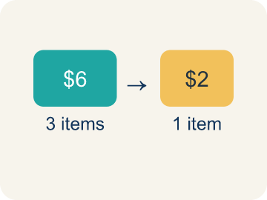 | Unit Rate Tasa unitaria  A rate for just 1 of something, like cost for 1 item.  Example: $2.50 per pound means $2.50 for every 1 pound
 | Better Buy Mejor compra  The choice that costs less for each item.  Example: $0.10 each vs $0.15 each — the $0.10 option is the better buy
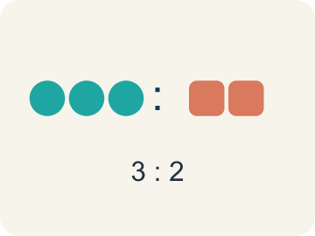 | Comparison Comparación  Looking at numbers to see which is bigger or smaller.  Example: $3 per game < $4 per game
 | Per Unit Por unidad  For each single item.  Example: $0.50 per token means each token costs $0.50
 | Rate Tasa  A ratio comparing two amounts with different units, like miles per hour.  Example: 120 miles in 3 hours is a rate (miles and hours are different units)
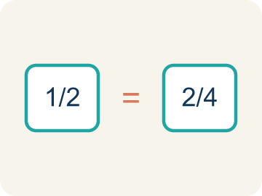 | Proportion Proporción  A math sentence saying two ratios are equal. It helps find a missing number.  Example: 5/3 = x/12 → x = 20

Worked Example

Watch & Read I Do — follow along with your teacher
Arcade Builder Challenge
You're the new supply manager for the arcade! You need to order tokens, prizes, and snacks from different suppliers. Each supplier offers a different package deal. Your job is to find the unit rate for each deal and figure out which supplier gives you the best value for every item you need to order.

Think about:
• How can you compare deals when the quantities are different?
• What operation helps you find the cost for just one item?
• Does the biggest package always give the best unit rate?
• How can unit rates help you make smart spending decisions?

Solved Example I Do — watch each step
Problem: Which is the better buy: 6 bouncy balls for $4.50 or 10 bouncy balls for $8.00?
A) 6 for $4.50 — $0.75 each
B) 10 for $8.00 — $0.80 each
C) They cost the same per ball
D) Not enough information
Step 1: $4.50 ÷ 6 = $0.75 each.
Step 2: $8.00 ÷ 10 = $0.80 each.
Step 3: $0.75 < $0.80, so 6 for $4.50 is the better buy.
Answer: A. 6 for $4.50 — $0.75 each

Guided Practice

Solve Together We Do — work with your class
Problem: A faucet drips 15 ounces of water in 5 minutes. What is the unit rate?
A) 3 ounces per minute
B) 5 ounces per minute
C) 15 ounces per minute
D) 0.33 ounces per minute
Step 1:

Step 2:

Step 3:

Answer:

The arcade needs 600 prize tickets printed. Printer A prints 150 tickets in 5 minutes. Printer B prints 200 tickets in 8 minutes. The manager wants to use the faster printer.
Which printer should the manager choose, and how long will it take to print all 600 tickets?

Sentence frame: Printer A prints ___ tickets per minute. Printer B prints ___ tickets per minute. The manager should use Printer ___ because it is faster. It will take ___ minutes to print 600 tickets.

Turn & Talk discuss with a partner
1. [Launch] As supply manager you compare token deals like 500 for $60 and 350 for $38.50. You can't compare totals directly, so what does finding the cost 'per unit' let you do?
Start with: I can't compare the totals because ___.
No puedo comparar los totales porque ___.
Word bank: unit rate, per unit, comparison, rate
2. [Explore] How did the unit rate help you decide the better buy between the two token suppliers in your table?
Start with: The unit rate for ___ is $___ per token.
La tasa unitaria de ___ es $___ por ficha.
Word bank: unit rate, better buy, per unit, comparison, rate
3. [Connect] Printer A makes 150 tickets in 5 minutes and Printer B makes 200 in 8 minutes. The manager needs 600 tickets fast. How do unit rates decide the faster printer and the time needed?
Start with: Printer A prints ___ tickets per minute and Printer B prints ___.
La impresora A imprime ___ boletos por minuto y la B imprime ___.
Word bank: unit rate, rate, per unit, comparison, proportion

Independent Practice

On Your Own You Do — show your work
Solve each problem. Show your thinking in the work box.
1. A printer prints 42 pages in 6 minutes. How many pages does it print in 15 minutes at the same rate?
A) 105 pages
B) 90 pages
C) 70 pages
D) 120 pages

2. Store A sells 5 notebooks for $8. Store B sells 3 notebooks for $5.25. Which has the lower price per notebook?
A) Store A ($1.60 each)
B) Store B ($1.75 each)
C) Same price
D) Cannot determine

3. A machine dispenses 24 tokens in 3 minutes. At this rate, how many tokens does it dispense in 10 minutes?
A) 80 tokens
B) 60 tokens
C) 72 tokens
D) 240 tokens

4. A factory produces 360 widgets in 8 hours. At the same rate, how many widgets are produced in a 12-hour shift?
A) 540 widgets
B) 480 widgets
C) 360 widgets
D) 720 widgets

Write About the Math

Build Strong Sentences The Writing Revolution
I can explain my comparison using the words unit rate, better buy, per unit, and rate.

1. Kernel Sentence subject + verb
Model: Unit Rate is a rate for just 1 of something, like cost for 1 item.

Write a kernel sentence about unit rate. Use a subject and a verb.
Escribe una oración base sobre tasa unitaria. Usa un sujeto y un verbo.

2. Sentence Expansion because · but · so
Kernel: Unit Rate matters in math
because Unit Rate matters in math because ___.
Tasa unitaria importa en matemáticas porque ___.

but Unit Rate matters in math, but ___.
Tasa unitaria importa en matemáticas, pero ___.

so Unit Rate matters in math, so ___.
Tasa unitaria importa en matemáticas, entonces ___.

3. Explain Your Reasoning use a sentence starter
I can't compare the totals because ___.
No puedo comparar los totales porque ___.
Finding the cost ___ lets me compare fairly.
Hallar el costo ___ me deja comparar de forma justa.
The unit rate for ___ is $___ per token.
La tasa unitaria de ___ es $___ por ficha.

Exit Ticket
Answer on your own. This shows what you learned today.
★ A car travels 195 miles on 6 gallons of gas. What is the unit rate in miles per gallon?
A) 32.5 miles per gallon
B) 33 miles per gallon
C) 30 miles per gallon
D) 1,170 miles per gallon

Answer Key & Teacher Guide
Teacher reference — remove or fold back before distributing to students.

Worked Notes (I Do / We Do)
I Do: A. 6 for $4.50 — $0.75 each
We Do: A. 3 ounces per minute

Independent Practice
1. A) 105 pages — Unit rate: 42 ÷ 6 = 7 pages per minute. In 15 minutes: 7 × 15 = 105 pages.
2. A) Store A ($1.60 each) — Store A: $8 ÷ 5 = $1.60. Store B: $5.25 ÷ 3 = $1.75. $1.60 < $1.75, so Store A is cheaper per notebook.
3. A) 80 tokens — Unit rate: 24 ÷ 3 = 8 tokens per minute. In 10 minutes: 8 × 10 = 80 tokens.
4. A) 540 widgets — Unit rate: 360 ÷ 8 = 45 widgets per hour. In 12 hours: 45 × 12 = 540 widgets.

Exit Ticket
A) 32.5 miles per gallon — 195 ÷ 6 = 32.5 miles per gallon.

Writing (TWR) — what to look for
Kernel sentence: a complete sentence needs a subject and a verb. Example: Unit Rate is a rate for just 1 of something, like cost for 1 item.
Expansion: because = reason, but = contrast/exception, so = result. Answers vary; each must keep the kernel idea.

Turn & Talk — listen for
1. Students explain the packages have different quantities, so the per-unit cost (unit rate) is needed to compare deals fairly.
2. Students divide price by quantity for each deal (e.g., 350 for $38.50 = $0.11 each) and choose the supplier with the lower unit rate as the better buy.
3. Students find 30 and 25 tickets/min, choose Printer A (higher rate), and divide 600 / 30 = 20 minutes.

