Solve Problems with Unit Rates — Homework
Lesson 4-7 • Standard 6.RP.3b
Name: ______________________ Period: ______ Date: ____________

Today's Goals
Content: I can solve real-world problems by using unit rates to compare options.
Language: I can explain my comparison using the words unit rate, better buy, per unit, and rate.

Key Words
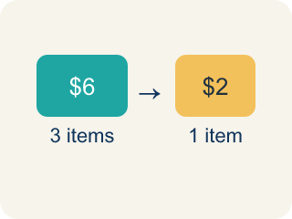
Unit Rate (Tasa unitaria) — A rate for just 1 of something, like cost for 1 item.

Better Buy (Mejor compra) — The choice that costs less for each item.
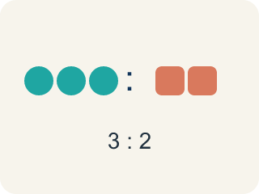
Comparison (Comparación) — Looking at numbers to see which is bigger or smaller.

Per Unit (Por unidad) — For each single item.

Rate (Tasa) — A ratio comparing two amounts with different units, like miles per hour.
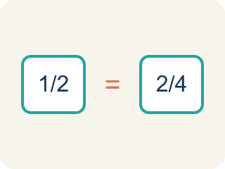
Proportion (Proporción) — A math sentence saying two ratios are equal. It helps find a missing number.

Practice
Show your work. Use the blank space under each problem.
1. Which is the better buy: 6 bouncy balls for $4.50 or 10 bouncy balls for $8.00?
A. 6 for $4.50 — $0.75 each
B. 10 for $8.00 — $0.80 each
C. They cost the same per ball
D. Not enough information
______________________________________________________________________
2. A faucet drips 15 ounces of water in 5 minutes. What is the unit rate?
A. 3 ounces per minute
B. 5 ounces per minute
C. 15 ounces per minute
D. 0.33 ounces per minute
______________________________________________________________________
3. Find the unit rate for each deal and identify the better buy.
Option | Deal | Unit Rate
Store A Batteries | 8 for $6.00
Store B Batteries | 12 for $8.40
Store A Candy | 15 for $6.75
Store B Candy | 20 for $8.00
______________________________________________________________________
4. A machine dispenses 24 tokens in 3 minutes. At this rate, how many tokens does it dispense in 10 minutes?
A. 80 tokens
B. 60 tokens
C. 72 tokens
D. 240 tokens
______________________________________________________________________
5. Three friends each walked different distances in different times. Sort them from fastest to slowest.
Groups: Fastest | Middle | Slowest
• Aiden: 6 miles in 2 hours (3 mph) → __________________
• Bella: 10 miles in 4 hours (2.5 mph) → __________________
• Carlos: 4 miles in 2 hours (2 mph) → __________________
______________________________________________________________________
6. A factory produces 360 widgets in 8 hours. At the same rate, how many widgets are produced in a 12-hour shift?
A. 540 widgets
B. 480 widgets
C. 360 widgets
D. 720 widgets
______________________________________________________________________
7. Apples cost $3 for 2 pounds. What is the price per pound?
A. $1.50
B. $6.00
C. $0.67
D. $5.00
______________________________________________________________________
8. A printer prints 90 pages in 6 minutes. How many pages per minute?
A. 15
B. 540
C. 84
D. 12
______________________________________________________________________
9. At 55 miles per hour, how far do you travel in 4 hours?
A. 220 miles
B. 59 miles
C. 14 miles
D. 200 miles
______________________________________________________________________
10. A worker earns $54 for 6 hours. At the same rate, how much for 9 hours?
A. $81
B. $72
C. $90
D. $60
______________________________________________________________________

Answer Key (Teacher)
1. A. 6 for $4.50 — $0.75 each
$4.50 ÷ 6 = $0.75 each. $8.00 ÷ 10 = $0.80 each. $0.75 < $0.80, so 6 for $4.50 is the better buy.
2. A. 3 ounces per minute
15 ÷ 5 = 3 ounces per minute.
3. Find the unit rate for each deal and identify the better buy.
Store A Batteries — Unit Rate: $0.75 each
Store B Batteries — Unit Rate: $0.70 each
Store A Candy — Unit Rate: $0.45 each
Store B Candy — Unit Rate: $0.40 each

4. A. 80 tokens
Unit rate: 24 ÷ 3 = 8 tokens per minute. In 10 minutes: 8 × 10 = 80 tokens.
5. Correct groups:
Aiden: 6 miles in 2 hours (3 mph) → Fastest
Bella: 10 miles in 4 hours (2.5 mph) → Middle
Carlos: 4 miles in 2 hours (2 mph) → Slowest

6. A. 540 widgets
Unit rate: 360 ÷ 8 = 45 widgets per hour. In 12 hours: 45 × 12 = 540 widgets.
7. A. $1.50
3 ÷ 2 = $1.50 per pound.
8. A. 15
90 ÷ 6 = 15 pages per minute.
9. A. 220 miles
55 × 4 = 220 miles.
10. A. $81
$54 ÷ 6 = $9 per hour; 9 × $9 = $81.

