UNIT 5 · LESSON 1 STANDARD 6.G.1

Area of Parallelograms
Student Notes Packet
Name: ______________________ Date: ____________ Period: ________

Today's Goals
Content: I can find the area of a parallelogram using base × height.
Language: I can explain how I found the area using the words base, height, area, and formula.

Key Vocabulary
Look at the picture, read the word, then read what it means.
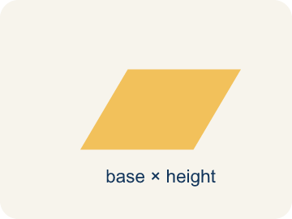 | Parallelogram Paralelogramo  A four-sided shape with two pairs of parallel sides.  Example: Think of a leaning door — the top and bottom are parallel, and the two sides are parallel, like a slanted rectangle
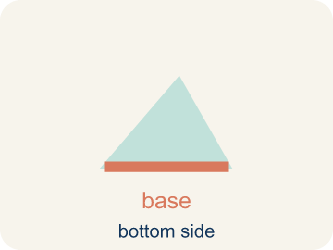 | Base Base  A side of the shape you use to find the area.  Example: If the bottom of a parallelogram is 10 cm, then b = 10 cm in the formula A = b × h
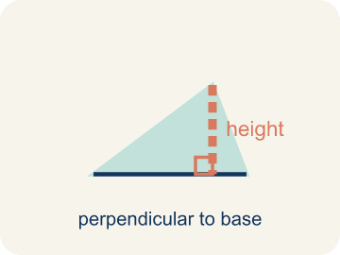 | Height Altura  The straight-up distance from the base to the top.  Example: A dashed vertical line from the top side straight down to the base, forming a 90° angle — NOT the slanted side
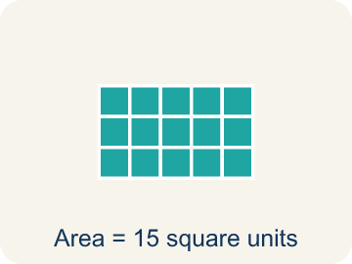 | Area Área  How much space is inside a flat shape.  Example: A 3 cm × 4 cm rectangle covers 12 square centimeters — imagine 12 tiny 1×1 squares inside it
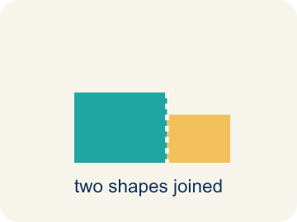 | Composite figure Figura compuesta  A shape made by putting two or more simple shapes together.  Example: An L-shaped room = a 10×8 rectangle joined to a 4×5 rectangle; total area = 80 + 20 = 100 sq ft
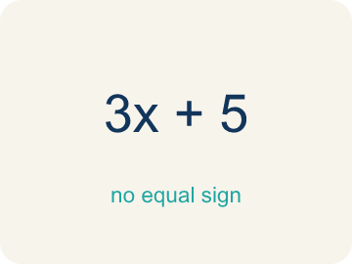 | Formula Fórmula  A math rule written with symbols.  Example: A = b × h means Area equals base times height; for a parallelogram with b = 6 and h = 4, A = 24

Worked Example

Watch & Read I Do — follow along with your teacher
Blueprint Review
Your architecture firm is designing a parallelogram-shaped patio for a client's backyard. The client needs to know how many square feet of pavers to order. The patio has a base of 14 feet and a height of 9 feet.

Think about:
• What shape is the patio?
• What measurements are given?
• How is a parallelogram different from a rectangle?
• Why do we use the height instead of the slanted side to find the area?
• Can you rearrange a parallelogram into a rectangle?

Solved Example I Do — watch each step
Problem: What is the area of a parallelogram with base 10 cm and height 7 cm?
A) 70 sq cm
B) 34 sq cm
C) 17 sq cm
D) 70 cm
Step 1: A = b × h = 10 × 7 = 70 square centimeters.
Answer: A. 70 sq cm

Guided Practice

Solve Together We Do — work with your class
Problem: A parallelogram has an area of 54 sq ft and a base of 9 ft. What is the height?
A) 6 ft
B) 45 ft
C) 63 ft
D) 27 ft
Step 1:

Step 2:

Answer:

A landscape architect is tiling a parallelogram-shaped courtyard. The courtyard has a base of 18 feet and a height of 10 feet. Each tile covers 2 square feet.
How many tiles does the architect need?

Sentence frame: The courtyard's area is ___ sq ft because A = ___ x ___ . She needs ___ tiles because ___ / 2 = ___.

Turn & Talk discuss with a partner
1. [Launch] Look at the patio blueprint with a base of 14 feet and a height of 9 feet. Why do we use the height (9 ft) and not the slanted side to find the area?
Start with: We use the height because it is ___ to the base.
Usamos la altura porque es ___ a la base.
Word bank: base, height, area, parallelogram, formula
2. [Explore] On the grid you cut a triangle off one end of the parallelogram and slid it to the other side. What shape did you make, and why does that prove the area is base x height?
Start with: When I move the triangle, I get a ___.
Cuando muevo el triángulo, obtengo un ___.
Word bank: rearrange, rectangle, base, height, area
3. [Connect] The landscape architect tiles an 18 ft by 10 ft parallelogram courtyard and each tile covers 2 sq ft. Talk through how you find the number of tiles.
Start with: First I find the area: 18 times 10 equals ___ square feet.
Primero hallo el área: 18 por 10 es ___ pies cuadrados.
Word bank: area, base, height, parallelogram, tiles

Independent Practice

On Your Own You Do — show your work
Solve each problem. Show your thinking in the work box.
1. What is the area of a parallelogram with base 9 cm and height 5 cm?
A) 45 sq cm
B) 14 sq cm
C) 22.5 sq cm
D) 90 sq cm

2. Which measurement is the height of a parallelogram?
A) The perpendicular distance between the base and the opposite side
B) The length of the slanted side
C) The perimeter divided by 4
D) The longest side

3. A parallelogram has base 9 cm and height 6 cm. What is its area?
A) 54 cm²
B) 30 cm²
C) 15 cm²
D) 27 cm²

4. A parallelogram has area 48 m² and base 8 m. What is its height?
A) 6 m
B) 40 m
C) 384 m
D) 16 m

Write About the Math

Build Strong Sentences The Writing Revolution
I can explain how I found the area using the words base, height, area, and formula.

1. Kernel Sentence subject + verb
Model: Parallelogram is a four-sided shape with two pairs of parallel sides.

Write a kernel sentence about parallelogram. Use a subject and a verb.
Escribe una oración base sobre paralelogramo. Usa un sujeto y un verbo.

2. Sentence Expansion because · but · so
Kernel: Parallelogram matters in math
because Parallelogram matters in math because ___.
Paralelogramo importa en matemáticas porque ___.

but Parallelogram matters in math, but ___.
Paralelogramo importa en matemáticas, pero ___.

so Parallelogram matters in math, so ___.
Paralelogramo importa en matemáticas, entonces ___.

3. Explain Your Reasoning use a sentence starter
We use the height because it is ___ to the base.
Usamos la altura porque es ___ a la base.
The slanted side is not the height because ___.
El lado inclinado no es la altura porque ___.
When I move the triangle, I get a ___.
Cuando muevo el triángulo, obtengo un ___.

Exit Ticket
Answer on your own. This shows what you learned today.
★ A parallelogram has a base of 13 inches and a height of 5 inches. What is its area?
A) 65 sq in
B) 36 sq in
C) 18 sq in
D) 65 in

Answer Key & Teacher Guide
Teacher reference — remove or fold back before distributing to students.

Worked Notes (I Do / We Do)
I Do: A. 70 sq cm
We Do: A. 6 ft

Independent Practice
1. A) 45 sq cm — A = b × h = 9 × 5 = 45 square centimeters.
2. A) The perpendicular distance between the base and the opposite side — The height is always the perpendicular (straight up-and-down) distance between the base and the opposite side, not the slanted side.
3. A) 54 cm² — Area = base × height = 9 × 6 = 54 cm².
4. A) 6 m — height = area ÷ base = 48 ÷ 8 = 6 m.

Exit Ticket
A) 65 sq in — A = b x h = 13 x 5 = 65 square inches.

Writing (TWR) — what to look for
Kernel sentence: a complete sentence needs a subject and a verb. Example: Parallelogram is a four-sided shape with two pairs of parallel sides.
Expansion: because = reason, but = contrast/exception, so = result. Answers vary; each must keep the kernel idea.

Turn & Talk — listen for
1. Students connect 'height' to the perpendicular (straight-up) distance from base to top, and recognize the slanted side is longer and would overstate the area.
2. A strong answer names a rectangle, states the area is 14 x 9 = 126 sq ft, and explains the rearranged rectangle has the same base and height as the parallelogram.
3. Students compute area = 180 sq ft, then divide 180 / 2 = 90 tiles, and explain why dividing by the tile size gives the count.

