Area of Parallelograms — Homework
Lesson 5-1 • Standard 6.G.1
Name: ______________________ Period: ______ Date: ____________

Today's Goals
Content: I can find the area of a parallelogram using base × height.
Language: I can explain how I found the area using the words base, height, area, and formula.

Key Words
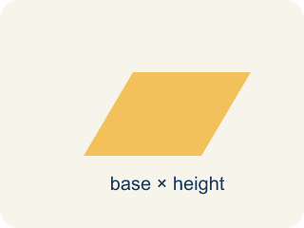
Parallelogram (Paralelogramo) — A four-sided shape with two pairs of parallel sides.
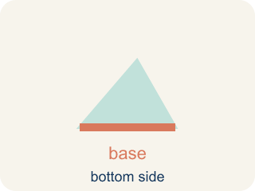
Base (Base) — A side of the shape you use to find the area.
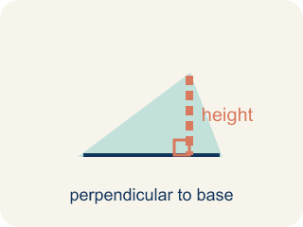
Height (Altura) — The straight-up distance from the base to the top.
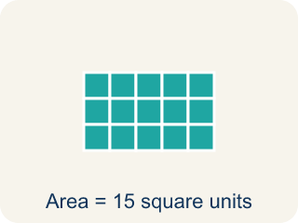
Area (Área) — How much space is inside a flat shape.
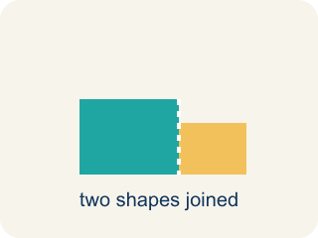
Composite figure (Figura compuesta) — A shape made by putting two or more simple shapes together.
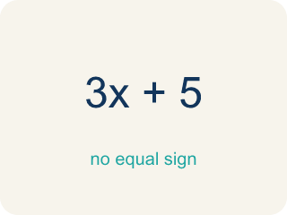
Formula (Fórmula) — A math rule written with symbols.

Practice
Show your work. Use the blank space under each problem.
1. What is the area of a parallelogram with base 10 cm and height 7 cm?
A. 70 sq cm
B. 34 sq cm
C. 17 sq cm
D. 70 cm
______________________________________________________________________
2. A parallelogram has an area of 54 sq ft and a base of 9 ft. What is the height?
A. 6 ft
B. 45 ft
C. 63 ft
D. 27 ft
______________________________________________________________________
3. Complete the table.
Parallelogram | Base | Height | Area
Patio A | 14 ft | 9 ft
Patio B | 8 ft |  | 56 sq ft
Patio C |  | 12 ft | 96 sq ft
Patio D | 15 ft | 6 ft
______________________________________________________________________
4. Match each shape to its area.
Item | Answer choices
____ Triangle 8×6 | F. 18 sq units
____ Parallelogram 5×4 | E. 36 sq units
____ Rectangle 7×3 | D. 40 sq units
____ Triangle 10×8 | C. 21 sq units
____ Square side 6 | B. 20 sq units
____ Parallelogram 9×2 | A. 24 sq units
______________________________________________________________________
5. Sort each parallelogram by whether its area is greater than 50 sq units or 50 or less.
Groups: Area > 50 sq units | Area ≤ 50 sq units
• b = 12, h = 5 → A = 60 → __________________
• b = 7, h = 6 → A = 42 → __________________
• b = 10, h = 8 → A = 80 → __________________
• b = 9, h = 4 → A = 36 → __________________
• b = 11, h = 7 → A = 77 → __________________
• b = 5, h = 10 → A = 50 → __________________
______________________________________________________________________
6. A parallelogram has base 9 cm and height 6 cm. What is its area?
A. 54 cm²
B. 30 cm²
C. 15 cm²
D. 27 cm²
______________________________________________________________________
7. A parallelogram has area 48 m² and base 8 m. What is its height?
A. 6 m
B. 40 m
C. 384 m
D. 16 m
______________________________________________________________________
8. Why is a parallelogram's area base × height and not base × slant side?
A. Height is the perpendicular distance between the bases
B. The slant side is always longer
C. Both give the same answer
D. The base is always the longest side
______________________________________________________________________
9. A parallelogram has base 12 in and height 4.5 in. What is its area?
A. 54 in²
B. 16.5 in²
C. 48 in²
D. 27 in²
______________________________________________________________________

Answer Key (Teacher)
1. A. 70 sq cm
A = b × h = 10 × 7 = 70 square centimeters.
2. A. 6 ft
A = b × h → 54 = 9 × h → h = 54 ÷ 9 = 6 ft.
3. Table
Patio A — Area: 126 sq ft
Patio B — Height: 7 ft
Patio C — Base: 8 ft
Patio D — Area: 90 sq ft

4. Matches:
Triangle 8×6 → 24 sq units
Parallelogram 5×4 → 20 sq units
Rectangle 7×3 → 21 sq units
Triangle 10×8 → 40 sq units
Square side 6 → 36 sq units
Parallelogram 9×2 → 18 sq units

5. Correct groups:
b = 12, h = 5 → A = 60 → Area > 50 sq units
b = 7, h = 6 → A = 42 → Area ≤ 50 sq units
b = 10, h = 8 → A = 80 → Area > 50 sq units
b = 9, h = 4 → A = 36 → Area ≤ 50 sq units
b = 11, h = 7 → A = 77 → Area > 50 sq units
b = 5, h = 10 → A = 50 → Area ≤ 50 sq units

6. A. 54 cm²
Area = base × height = 9 × 6 = 54 cm².
7. A. 6 m
height = area ÷ base = 48 ÷ 8 = 6 m.
8. A. Height is the perpendicular distance between the bases
Area uses the perpendicular height, not the slanted side length.
9. A. 54 in²
12 × 4.5 = 54 in².

