Area of Trapezoids — Homework
Lesson 5-2 • Standard 6.G.1
Name: ______________________ Period: ______ Date: ____________

Today's Goals
Content: I can find the area of a trapezoid using the formula A = ½(b1 + b2) × h.
Language: I can explain my steps using the words trapezoid, base, height, and area.

Key Words
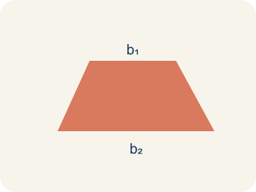
Trapezoid (Trapecio) — A four-sided shape with just one pair of parallel sides.

Base 1 (b1) (Base 1 (b1)) — One of the two parallel sides of a trapezoid.

Base 2 (b2) (Base 2 (b2)) — The other parallel side of a trapezoid.
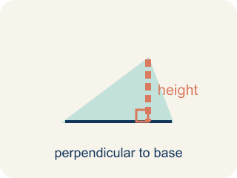
Height (Altura) — The straight-up distance between the two parallel sides.
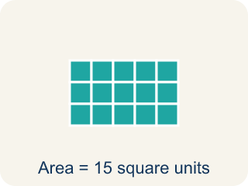
Area (Área) — How much space is inside a flat shape.

Practice
Show your work. Use the blank space under each problem.
1. What is the area of a trapezoid with bases 6 cm and 10 cm, and height 4 cm?
A. 32 sq cm
B. 64 sq cm
C. 24 sq cm
D. 40 sq cm
______________________________________________________________________
2. A trapezoid has an area of 45 sq ft, bases of 7 ft and 11 ft. What is the height?
A. 5 ft
B. 9 ft
C. 3 ft
D. 10 ft
______________________________________________________________________
3. Complete the table.
Trapezoid | Base 1 | Base 2 | Height | Area
Window A | 8 ft | 4 ft | 5 ft
Window B | 12 ft | 6 ft | 4 ft
Window C | 10 ft |  | 8 ft | 72 sq ft
Window D |  | 5 ft | 6 ft | 48 sq ft
______________________________________________________________________
4. Match each shape to its area.
Item | Answer choices
____ Trapezoid b₁=10, b₂=6, h=4 | F. 21 sq units
____ Trapezoid b₁=8, b₂=4, h=5 | E. 45 sq units
____ Trapezoid b₁=12, b₂=8, h=3 | D. 42 sq units
____ Triangle b=14, h=6 | C. 30 sq units
____ Parallelogram b=9, h=5 | B. 30 sq units
____ Rectangle 7×3 | A. 32 sq units
______________________________________________________________________
5. Calculate the area of each trapezoid, then sort by whether the area is greater than 40 sq units or not.
Groups: Area > 40 sq units | Area ≤ 40 sq units
• b₁=10, b₂=6, h=4 → A=32 → __________________
• b₁=12, b₂=8, h=5 → A=50 → __________________
• b₁=6, b₂=4, h=7 → A=35 → __________________
• b₁=9, b₂=7, h=6 → A=48 → __________________
• b₁=5, b₂=3, h=8 → A=32 → __________________
• b₁=14, b₂=6, h=5 → A=50 → __________________
______________________________________________________________________
6. A trapezoid has parallel sides 6 cm and 10 cm and height 4 cm. What is its area?
A. 32 cm²
B. 40 cm²
C. 64 cm²
D. 16 cm²
______________________________________________________________________
7. A trapezoid has bases 8 m and 12 m and height 5 m. What is its area?
A. 50 m²
B. 100 m²
C. 40 m²
D. 60 m²
______________________________________________________________________
8. A trapezoid has area 36 in² and bases 5 in and 7 in. What is its height?
A. 6 in
B. 3 in
C. 12 in
D. 18 in
______________________________________________________________________
9. Why is the trapezoid area formula ½(b1 + b2)h?
A. It averages the two bases, then multiplies by the height
B. It adds all four sides
C. It uses only the longer base
D. Trapezoids have no height
______________________________________________________________________

Answer Key (Teacher)
1. A. 32 sq cm
A = ½ × (b₁ + b₂) × h = ½ × (6 + 10) × 4 = ½ × 16 × 4 = 32 sq cm.
2. A. 5 ft
A = ½ × (b₁ + b₂) × h → 45 = ½ × 18 × h → 45 = 9h → h = 5 ft.
3. Table
Window A — Area: 30 sq ft
Window B — Area: 36 sq ft
Window C — Base 2: 8 ft
Window D — Base 1: 11 ft

4. Matches:
Trapezoid b₁=10, b₂=6, h=4 → 32 sq units
Trapezoid b₁=8, b₂=4, h=5 → 30 sq units
Trapezoid b₁=12, b₂=8, h=3 → 30 sq units
Triangle b=14, h=6 → 42 sq units
Parallelogram b=9, h=5 → 45 sq units
Rectangle 7×3 → 21 sq units

5. Correct groups:
b₁=10, b₂=6, h=4 → A=32 → Area ≤ 40 sq units
b₁=12, b₂=8, h=5 → A=50 → Area > 40 sq units
b₁=6, b₂=4, h=7 → A=35 → Area ≤ 40 sq units
b₁=9, b₂=7, h=6 → A=48 → Area > 40 sq units
b₁=5, b₂=3, h=8 → A=32 → Area ≤ 40 sq units
b₁=14, b₂=6, h=5 → A=50 → Area > 40 sq units

6. A. 32 cm²
Area = ½(b1 + b2)h = ½(6 + 10)(4) = ½ × 16 × 4 = 32 cm².
7. A. 50 m²
½(8 + 12)(5) = ½ × 20 × 5 = 50 m².
8. A. 6 in
36 = ½(5 + 7)h = 6h, so h = 6 in.
9. A. It averages the two bases, then multiplies by the height
½(b1 + b2) is the average of the two parallel sides, multiplied by the height.

