UNIT 5 · LESSON 3 STANDARD 6.G.1

Area of Triangles (Flagship)
Student Notes Packet
Name: ______________________ Date: ____________ Period: ________

Today's Goals
Content: I can find the area of a triangle using the formula A = ½ × base × height.
Language: I can explain my steps using the words base, height, area, and perpendicular.

Key Vocabulary
Look at the picture, read the word, then read what it means.
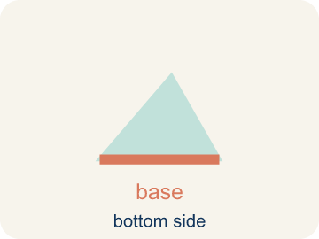 | Base Base  A side of the triangle you use to find the area.  Example: If the bottom of a triangle is 10 cm, then b = 10 cm in the formula A = ½ × b × h
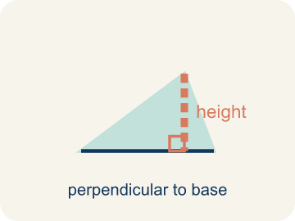 | Height Altura  The straight-up distance from the base to the top corner.  Example: A dashed vertical line from the top point straight down to the base at a 90° angle
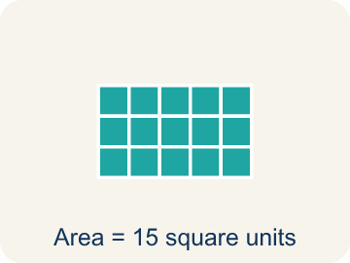 | Area Área  How much space is inside a flat shape.  Example: A triangle with b = 8 and h = 6 has area = ½ × 8 × 6 = 24 sq units
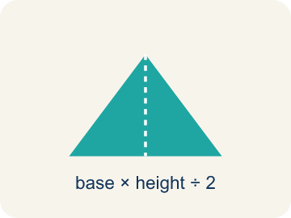 | Perpendicular Perpendicular  Two lines that meet to make a square corner (90 degrees).  Example: The corner of a book or a door frame meets at exactly 90°
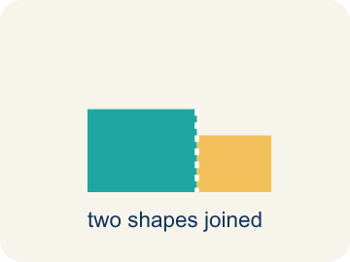 | Composite figure Figura compuesta  A shape made by putting two or more simple shapes together.  Example: A house shape = a rectangle (walls) + a triangle (roof)
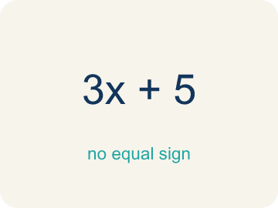 | Formula Fórmula  A math rule written with symbols.  Example: A = ½ × b × h means Area equals one-half times base times height

Worked Example

Watch & Read I Do — follow along with your teacher
Blueprint Review
Your architecture firm is designing a park with triangular garden beds. The client wants to know exactly how much soil to order, which means calculating the area of each triangular section. The first garden has a base of 12 feet and a height of 8 feet.

Think about:
• What shape are the garden beds?
• What measurements do we need to find the area?
• How is the area of a triangle related to the area of a rectangle?
• Why do we divide by 2 when finding the area of a triangle?
• Does it matter which side we call the base?

Solved Example I Do — watch each step
Problem: What is the area of a triangle with base 10 cm and height 6 cm?
A) 30 sq cm
B) 60 sq cm
C) 16 sq cm
D) 30 cm
Step 1: A = ½ × b × h = ½ × 10 × 6 = 30 square centimeters.
Answer: A. 30 sq cm

Guided Practice

Solve Together We Do — work with your class
Problem: A triangle has an area of 24 sq ft and a base of 8 ft. What is the height?
A) 6 ft
B) 3 ft
C) 16 ft
D) 12 ft
Step 1:

Step 2:

Answer:

A homeowner wants to paint one triangular wall of an A-frame cabin. The wall has a base of 20 feet and a height of 14 feet. One can of paint covers 50 square feet.
How many cans of paint does the homeowner need?

Sentence frame: The wall's area is ___ sq ft because A = 1/2 × ___ × ___. She needs ___ cans because ___ ÷ 50 = ___.

Turn & Talk discuss with a partner
1. [Launch] At the build site you survey a triangular garden bed with a base of 12 feet and a height of 8 feet. Which measurement is the height, and how is it different from the slanted side?
Start with: The height is the ___ distance from the base to the top corner.
La altura es la distancia ___ desde la base hasta la esquina de arriba.
Word bank: base, height, perpendicular, area, formula
2. [Explore] Your triangular panel (base 12, height 8) fits inside a 12 by 8 rectangle. Why do we divide by 2 to find the triangle's area before cutting the glass?
Start with: A triangle is half of a ___ with the same base and height.
Un triángulo es la mitad de un ___ con la misma base y altura.
Word bank: base, height, area, perpendicular, formula
3. [Connect] At the client review, the homeowner paints a triangular A-frame wall with base 20 ft and height 14 ft; one can covers 50 sq ft. Talk through how many cans the budget needs.
Start with: The wall's area is 1/2 times 20 times 14, which equals ___ square feet.
El área de la pared es 1/2 por 20 por 14, que es ___ pies cuadrados.
Word bank: triangle, base, height, area, formula

Independent Practice

On Your Own You Do — show your work
Solve each problem. Show your thinking in the work box.
1. What is the area of a triangle with base 14 ft and height 6 ft?
A) 42 sq ft
B) 84 sq ft
C) 20 sq ft
D) 42 ft

2. A triangular window pane has a base of 9 in and a height of 4 in. What is its area?
A) 18 sq in
B) 36 sq in
C) 13 sq in
D) 18 in

3. Which formula gives the area of a triangle with base b and height h?
A) A = ½ × b × h
B) A = b × h
C) A = b + h
D) A = 2 × b × h

4. A triangular sail has an area of 30 sq m and a height of 12 m. What is its base?
A) 5 m
B) 2.5 m
C) 18 m
D) 360 m

Write About the Math

Build Strong Sentences The Writing Revolution
I can explain my steps using the words base, height, area, and perpendicular.

1. Kernel Sentence subject + verb
Model: Area is how much space is inside a flat shape.

Write a kernel sentence about area. Use a subject and a verb.
Escribe una oración base sobre área. Usa un sujeto y un verbo.

2. Sentence Expansion because · but · so
Kernel: Area matters in math
because Area matters in math because ___.
Área importa en matemáticas porque ___.

but Area matters in math, but ___.
Área importa en matemáticas, pero ___.

so Area matters in math, so ___.
Área importa en matemáticas, entonces ___.

3. Explain Your Reasoning use a sentence starter
The height is the ___ distance from the base to the top corner.
La altura es la distancia ___ desde la base hasta la esquina de arriba.
It is different from the slanted side because ___.
Es diferente del lado inclinado porque ___.
A triangle is half of a ___ with the same base and height.
Un triángulo es la mitad de un ___ con la misma base y altura.

Exit Ticket
Answer on your own. This shows what you learned today.
★ A triangle has a base of 11 inches and a height of 8 inches. What is its area?
A) 44 sq in
B) 88 sq in
C) 19 sq in
D) 44 in

Answer Key & Teacher Guide
Teacher reference — remove or fold back before distributing to students.

Worked Notes (I Do / We Do)
I Do: A. 30 sq cm
We Do: A. 6 ft

Independent Practice
1. A) 42 sq ft — A = ½ × 14 × 6 = ½ × 84 = 42 sq ft.
2. A) 18 sq in — A = ½ × 9 × 4 = ½ × 36 = 18 square inches.
3. A) A = ½ × b × h — A triangle covers exactly half of a rectangle with the same base and height, so A = ½ × b × h.
4. A) 5 m — 30 = ½ × b × 12 → 30 = 6b → b = 5 m.

Exit Ticket
A) 44 sq in — A = 1/2 × 11 × 8 = 1/2 × 88 = 44 square inches.

Writing (TWR) — what to look for
Kernel sentence: a complete sentence needs a subject and a verb. Example: Area is how much space is inside a flat shape.
Expansion: because = reason, but = contrast/exception, so = result. Answers vary; each must keep the kernel idea.

Turn & Talk — listen for
1. Students identify the height as the perpendicular (straight-up, 90-degree) distance from the base to the opposite vertex, not the slanted side.
2. A strong answer states the triangle is half of the 12 x 8 = 96 rectangle, so the panel area is 48 sq ft, and connects the 1/2 to that halving.
3. Students compute area = 140 sq ft, then 140 / 50 = 2.8, and reason she must round up to 3 cans to cover the whole wall.

