Area of Triangles — Homework
Lesson 5-3 • Standard 6.G.1
Name: ______________________ Period: ______ Date: ____________

Today's Goals
Content: I can find the area of a triangle using the formula A = ½ × base × height.
Language: I can explain my steps using the words base, height, area, and perpendicular.

Key Words
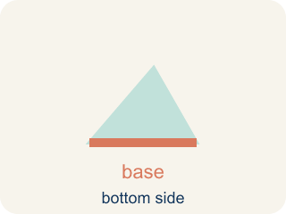
Base (Base) — A side of the triangle you use to find the area.
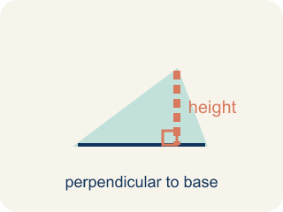
Height (Altura) — The straight-up distance from the base to the top corner.
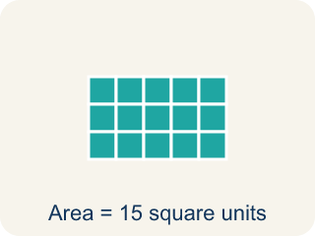
Area (Área) — How much space is inside a flat shape.
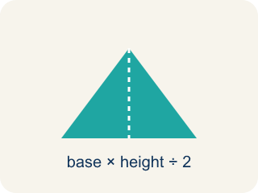
Perpendicular (Perpendicular) — Two lines that meet to make a square corner (90 degrees).
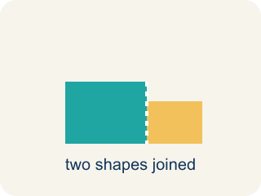
Composite figure (Figura compuesta) — A shape made by putting two or more simple shapes together.
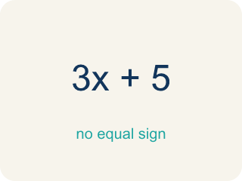
Formula (Fórmula) — A math rule written with symbols.

Practice
Show your work. Use the blank space under each problem.
1. What is the area of a triangle with base 10 cm and height 6 cm?
A. 30 sq cm
B. 60 sq cm
C. 16 sq cm
D. 30 cm
______________________________________________________________________
2. A triangle has an area of 24 sq ft and a base of 8 ft. What is the height?
A. 6 ft
B. 3 ft
C. 16 ft
D. 12 ft
______________________________________________________________________
3. Complete the table.
Triangle | Base | Height | Area
Garden A | 12 ft | 8 ft
Garden B | 9 ft |  | 27 sq ft
Garden C |  | 10 ft | 35 sq ft
Garden D | 15 ft | 4 ft
______________________________________________________________________
4. Match each shape to its area.
Item | Answer choices
____ Triangle b=8, h=6 | F. 18 sq units
____ Triangle b=10, h=8 | E. 21 sq units
____ Triangle b=12, h=5 | D. 20 sq units
____ Parallelogram b=5, h=4 | C. 30 sq units
____ Rectangle 7×3 | B. 40 sq units
____ Parallelogram b=9, h=2 | A. 24 sq units
______________________________________________________________________
5. Calculate the area of each triangle. Sort by whether the area is greater than 30 sq units or not.
Groups: Area > 30 sq units | Area ≤ 30 sq units
• b=10, h=8 → A=40 → __________________
• b=6, h=9 → A=27 → __________________
• b=14, h=5 → A=35 → __________________
• b=8, h=7 → A=28 → __________________
• b=12, h=6 → A=36 → __________________
• b=10, h=6 → A=30 → __________________
______________________________________________________________________
6. A triangle has base 10 cm and height 6 cm. What is its area?
A. 30 cm²
B. 60 cm²
C. 16 cm²
D. 15 cm²
______________________________________________________________________
7. A triangle has area 24 m² and base 8 m. What is its height?
A. 6 m
B. 3 m
C. 12 m
D. 16 m
______________________________________________________________________
8. Why does a triangle's area use ½ × base × height?
A. A triangle is half of a parallelogram with the same base and height
B. Triangles have three sides
C. The height is always half the base
D. ½ makes the number smaller
______________________________________________________________________
9. A triangular sail has base 7 ft and height 9 ft. What is its area?
A. 31.5 ft²
B. 63 ft²
C. 16 ft²
D. 30 ft²
______________________________________________________________________

Answer Key (Teacher)
1. A. 30 sq cm
A = ½ × b × h = ½ × 10 × 6 = 30 square centimeters.
2. A. 6 ft
A = ½ × b × h → 24 = ½ × 8 × h → 24 = 4h → h = 6 ft.
3. Table
Garden A — Area: 48 sq ft
Garden B — Height: 6 ft
Garden C — Base: 7 ft
Garden D — Area: 30 sq ft

4. Matches:
Triangle b=8, h=6 → 24 sq units
Triangle b=10, h=8 → 40 sq units
Triangle b=12, h=5 → 30 sq units
Parallelogram b=5, h=4 → 20 sq units
Rectangle 7×3 → 21 sq units
Parallelogram b=9, h=2 → 18 sq units

5. Correct groups:
b=10, h=8 → A=40 → Area > 30 sq units
b=6, h=9 → A=27 → Area ≤ 30 sq units
b=14, h=5 → A=35 → Area > 30 sq units
b=8, h=7 → A=28 → Area ≤ 30 sq units
b=12, h=6 → A=36 → Area > 30 sq units
b=10, h=6 → A=30 → Area ≤ 30 sq units

6. A. 30 cm²
Area = ½ × base × height = ½ × 10 × 6 = 30 cm².
7. A. 6 m
24 = ½ × 8 × h = 4h, so h = 6 m.
8. A. A triangle is half of a parallelogram with the same base and height
Two identical triangles form a parallelogram, so a triangle is half its area.
9. A. 31.5 ft²
½ × 7 × 9 = 31.5 ft².

