Area of Regular Polygons — Homework
Lesson 5-4 • Standard 6.G.1
Name: ______________________ Period: ______ Date: ____________

Today's Goals
Content: I can find the area of a regular polygon by decomposing it into triangles.
Language: I can explain my steps using the words regular polygon, decompose, triangle, and composite.

Key Words
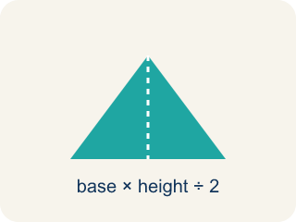
Regular Polygon (Polígono regular) — A shape where all sides and all angles are equal.
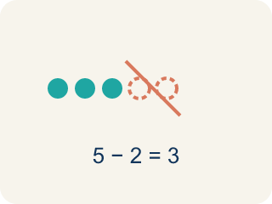
Decompose (Descomponer) — To break a shape into smaller, simpler shapes.

Triangle (Triángulo) — A shape with three sides.
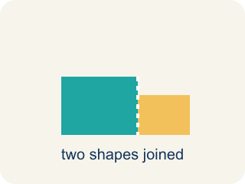
Composite (Compuesto) — Made by putting two or more simple shapes together.

Composite figure (Figura compuesta) — A shape made by putting two or more simple shapes together.
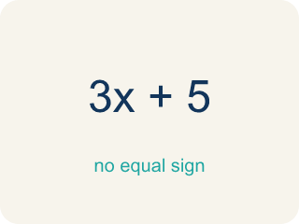
Formula (Fórmula) — A math rule written with symbols.

Practice
Show your work. Use the blank space under each problem.
1. A regular hexagon is divided into 6 equal triangles from the center. Each triangle has a base of 6 ft and a height of 5.2 ft. What is the area of one triangle?
A. 15.6 sq ft
B. 31.2 sq ft
C. 11.2 sq ft
D. 15.6 ft
______________________________________________________________________
2. Using the triangle from the previous question, what is the total area of the hexagonal skylight?
A. 93.6 sq ft
B. 15.6 sq ft
C. 187.2 sq ft
D. 62.4 sq ft
______________________________________________________________________
3. Complete the table.
Polygon | Number of Triangles | Triangle Base | Triangle Height | Area of One Triangle | Total Area
Hexagon | 6 | 6 ft | 5.2 ft
Pentagon | 5 | 8 ft | 5.5 ft
Square | 2 | 10 ft | 5 ft
Octagon | 8 | 4 ft | 4.8 ft
______________________________________________________________________
4. Match each polygon to its total area.
Item | Answer choices
____ Hexagon: 6 triangles, each ½×6×5.2 | F. 36 sq ft
____ Pentagon: 5 triangles, each ½×8×5.5 | E. 36 sq ft
____ Octagon: 8 triangles, each ½×4×4.8 | D. 50 sq ft
____ Square: 2 triangles, each ½×10×5 | C. 76.8 sq ft
____ Triangle b=12, h=6 | B. 110 sq ft
____ Parallelogram b=9, h=4 | A. 93.6 sq ft
______________________________________________________________________
5. Calculate the total area of each regular polygon, then sort from smallest to largest area.
Groups: Area ≥ 90 sq ft | Area < 90 sq ft
• Pentagon: 5 × (½×8×5.5) = 110 sq ft → __________________
• Hexagon: 6 × (½×6×5.2) = 93.6 sq ft → __________________
• Octagon: 8 × (½×4×4.8) = 76.8 sq ft → __________________
• Square: 2 × (½×10×5) = 50 sq ft → __________________
______________________________________________________________________
6. A regular hexagon has 6 equal triangles, each with area 8 cm². What is the hexagon's area?
A. 48 cm²
B. 14 cm²
C. 8 cm²
D. 24 cm²
______________________________________________________________________
7. A regular pentagon is split into 5 equal triangles. If the whole area is 60 in², what is one triangle's area?
A. 12 in²
B. 5 in²
C. 300 in²
D. 15 in²
______________________________________________________________________
8. Why can a regular polygon's area be found by splitting it into congruent triangles?
A. All the triangles are the same size, so you can multiply one triangle's area by the number of sides
B. Polygons are always squares
C. Triangles have no area
D. Each triangle is different
______________________________________________________________________
9. A regular octagon splits into 8 triangles, each with area 5.5 m². What is the total area?
A. 44 m²
B. 13.5 m²
C. 40 m²
D. 48 m²
______________________________________________________________________

Answer Key (Teacher)
1. A. 15.6 sq ft
A = ½ × b × h = ½ × 6 × 5.2 = 15.6 square feet.
2. A. 93.6 sq ft
Total area = 6 triangles × 15.6 sq ft = 93.6 square feet.
3. Table
Hexagon — Area of One Triangle: 15.6 sq ft
Hexagon — Total Area: 93.6 sq ft
Pentagon — Area of One Triangle: 22 sq ft
Pentagon — Total Area: 110 sq ft
Square — Area of One Triangle: 25 sq ft
Square — Total Area: 50 sq ft
Octagon — Area of One Triangle: 9.6 sq ft
Octagon — Total Area: 76.8 sq ft

4. Matches:
Hexagon: 6 triangles, each ½×6×5.2 → 93.6 sq ft
Pentagon: 5 triangles, each ½×8×5.5 → 110 sq ft
Octagon: 8 triangles, each ½×4×4.8 → 76.8 sq ft
Square: 2 triangles, each ½×10×5 → 50 sq ft
Triangle b=12, h=6 → 36 sq ft
Parallelogram b=9, h=4 → 36 sq ft

5. Correct groups:
Pentagon: 5 × (½×8×5.5) = 110 sq ft → Area ≥ 90 sq ft
Hexagon: 6 × (½×6×5.2) = 93.6 sq ft → Area ≥ 90 sq ft
Octagon: 8 × (½×4×4.8) = 76.8 sq ft → Area < 90 sq ft
Square: 2 × (½×10×5) = 50 sq ft → Area < 90 sq ft

6. A. 48 cm²
6 × 8 = 48 cm².
7. A. 12 in²
60 ÷ 5 = 12 in² per triangle.
8. A. All the triangles are the same size, so you can multiply one triangle's area by the number of sides
A regular polygon divides into equal triangles, so total area = (one triangle) × (number of triangles).
9. A. 44 m²
8 × 5.5 = 44 m².

