Area of Composite Figures — Homework
Lesson 5-5 • Standard 6.G.1
Name: ______________________ Period: ______ Date: ____________

Today's Goals
Content: I can find the area of a composite figure by adding or subtracting the areas of basic shapes.
Language: I can explain my steps using the words composite figure, decompose, add, and subtract.

Key Words
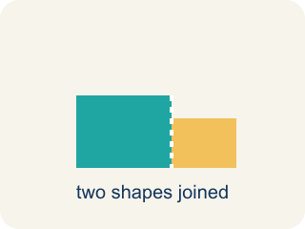
Composite Figure (Figura compuesta) — A shape made by putting two or more simple shapes together.
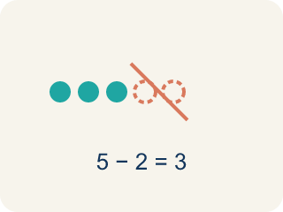
Decompose (Descomponer) — To break a shape into smaller, simpler shapes.
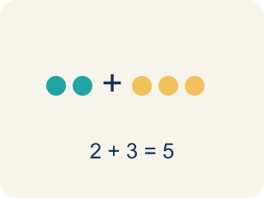
Add (Sumar) — Add up the areas of the smaller shapes to get the total.

Subtract (Restar) — Take away the area of a missing piece from a bigger shape.
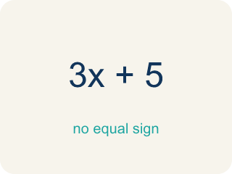
Formula (Fórmula) — A math rule written with symbols.

Practice
Show your work. Use the blank space under each problem.
1. An L-shaped room is made of two rectangles: 10 ft × 6 ft and 4 ft × 3 ft. What is the total area?
A. 72 sq ft
B. 60 sq ft
C. 12 sq ft
D. 72 ft
______________________________________________________________________
2. A rectangular patio is 15 ft × 10 ft with a 5 ft × 4 ft rectangular flower bed cut out. What is the remaining area?
A. 130 sq ft
B. 150 sq ft
C. 20 sq ft
D. 170 sq ft
______________________________________________________________________
3. Complete the table.
Figure | Shape 1 Area | Shape 2 Area | Operation | Total Area
L-shaped deck | 48 sq ft | 20 sq ft | Add
Floor with alcove | 90 sq ft | 15 sq ft | Add
Wall with window cutout | 120 sq ft | 18 sq ft | Subtract
Courtyard with fountain cutout | 200 sq ft | 36 sq ft | Subtract
______________________________________________________________________
4. Match each composite figure to its total area.
Item | Answer choices
____ L-shape: 10×6 + 4×3 | F. 90 sq ft
____ T-shape: 14×4 + 6×10 | E. 58 sq ft
____ Wall 15×10 minus window 5×4 | D. 116 sq ft
____ Pool 14×10 minus cutout 6×4 | C. 130 sq ft
____ L-shape: 8×5 + 3×6 | B. 116 sq ft
____ Floor 12×8 minus vent 2×3 | A. 72 sq ft
______________________________________________________________________
5. Calculate each composite figure's area. Sort by whether the area is more than 100 sq ft or not.
Groups: Area > 100 sq ft | Area ≤ 100 sq ft
• L-shape: 12×8 + 6×5 = 126 sq ft → __________________
• T-shape: 10×3 + 4×7 = 58 sq ft → __________________
• Wall 15×10 − window 5×4 = 130 sq ft → __________________
• L-shape: 9×7 + 3×4 = 75 sq ft → __________________
• Floor 20×8 − vent 6×3 = 142 sq ft → __________________
• U-shape: 10×8 − 4×3 = 68 sq ft → __________________
______________________________________________________________________
6. A figure is a 6×4 rectangle with a 2×2 square added on. What is the total area?
A. 28 sq units
B. 24 sq units
C. 20 sq units
D. 32 sq units
______________________________________________________________________
7. A composite shape is a 10×8 rectangle with a 3×4 rectangle cut out. What is the area?
A. 68 sq units
B. 80 sq units
C. 92 sq units
D. 12 sq units
______________________________________________________________________
8. What is the best first step to find the area of a composite figure?
A. Break it into simple shapes like rectangles and triangles
B. Measure only one side
C. Add all the side lengths
D. Multiply the two longest sides
______________________________________________________________________
9. A garden is a 12×5 rectangle plus a triangle with base 12 and height 4 on top. What is the total area?
A. 84 sq units
B. 60 sq units
C. 24 sq units
D. 72 sq units
______________________________________________________________________

Answer Key (Teacher)
1. A. 72 sq ft
Area 1 = 10 × 6 = 60 sq ft. Area 2 = 4 × 3 = 12 sq ft. Total = 60 + 12 = 72 sq ft.
2. A. 130 sq ft
Patio = 15 × 10 = 150 sq ft. Cutout = 5 × 4 = 20 sq ft. Remaining = 150 − 20 = 130 sq ft.
3. Table
L-shaped deck — Total Area: 68 sq ft
Floor with alcove — Total Area: 105 sq ft
Wall with window cutout — Total Area: 102 sq ft
Courtyard with fountain cutout — Total Area: 164 sq ft

4. Matches:
L-shape: 10×6 + 4×3 → 72 sq ft
T-shape: 14×4 + 6×10 → 116 sq ft
Wall 15×10 minus window 5×4 → 130 sq ft
Pool 14×10 minus cutout 6×4 → 116 sq ft
L-shape: 8×5 + 3×6 → 58 sq ft
Floor 12×8 minus vent 2×3 → 90 sq ft

5. Correct groups:
L-shape: 12×8 + 6×5 = 126 sq ft → Area > 100 sq ft
T-shape: 10×3 + 4×7 = 58 sq ft → Area ≤ 100 sq ft
Wall 15×10 − window 5×4 = 130 sq ft → Area > 100 sq ft
L-shape: 9×7 + 3×4 = 75 sq ft → Area ≤ 100 sq ft
Floor 20×8 − vent 6×3 = 142 sq ft → Area > 100 sq ft
U-shape: 10×8 − 4×3 = 68 sq ft → Area ≤ 100 sq ft

6. A. 28 sq units
Rectangle 6 × 4 = 24, plus square 2 × 2 = 4. Total = 28 sq units.
7. A. 68 sq units
80 − 12 = 68 sq units.
8. A. Break it into simple shapes like rectangles and triangles
Decompose the figure into simple shapes, find each area, then add or subtract.
9. A. 84 sq units
Rectangle 12 × 5 = 60; triangle ½ × 12 × 4 = 24. Total = 84 sq units.

