Powers and Exponents — Homework
Lesson 6-1 • Standard 6.EE.1
Name: ______________________ Period: ______ Date: ____________

Today's Goals
Content: I can write and evaluate numbers in exponent form using a base and a power.
Language: I can explain my work using the words exponent, base, power, and evaluate.

Key Words
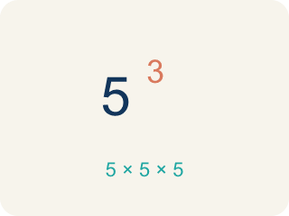
Exponent (Exponente) — A small number that tells how many times to multiply the number by itself.
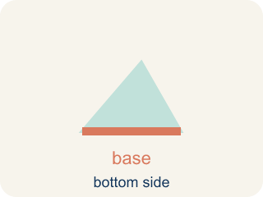
Base (Base) — The number that gets multiplied by itself.

Power (Potencia) — A number written with a base and an exponent, like 2³.
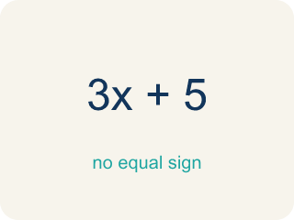
Evaluate (Evaluar) — To find the value of an expression.
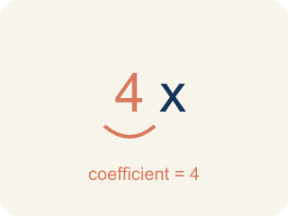
Coefficient (Coeficiente) — The number in front of a letter, like the 3 in 3x.
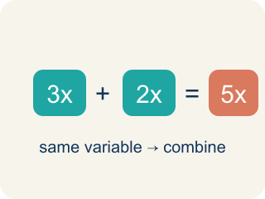
Like terms (Términos semejantes) — Terms with the same letter, like 2x and 5x.

Practice
Show your work. Use the blank space under each problem.
1. What is the value of 4³?
A. 64
B. 12
C. 43
D. 7
______________________________________________________________________
2. What is the value of 6²?
A. 36
B. 12
C. 62
D. 8
______________________________________________________________________
3. Evaluate each exponential expression. Show the repeated multiplication and the final value.
Power | Repeated Multiplication | Value
4³ | 4 × 4 × 4
2⁶ | 2 × 2 × 2 × 2 × 2 × 2
5³ | 5 × 5 × 5
10⁴ | 10 × 10 × 10 × 10
______________________________________________________________________
4. Sort each power by whether its value is greater than 50 or not.
Groups: Value > 50 | Value ≤ 50
• 2⁵ = 32 → __________________
• 3⁴ = 81 → __________________
• 7² = 49 → __________________
• 10² = 100 → __________________
• 5³ = 125 → __________________
• 4² = 16 → __________________
______________________________________________________________________
5. Match each power to its value.
Item | Answer choices
____ 2⁵ | F. 128
____ 3³ | E. 25
____ 4³ | D. 1000
____ 10³ | C. 64
____ 5² | B. 27
____ 2⁷ | A. 32
______________________________________________________________________
6. What is the value of 2⁵?
A. 32
B. 10
C. 25
D. 16
______________________________________________________________________
7. What is 10⁴?
A. 10,000
B. 40
C. 1,000
D. 100
______________________________________________________________________
8. Which expression equals 81?
A. 3⁴
B. 3³
C. 2⁶
D. 4³
______________________________________________________________________
9. What is 5³?
A. 125
B. 15
C. 25
D. 8
______________________________________________________________________

Answer Key (Teacher)
1. A. 64
4³ = 4 × 4 × 4 = 64.
2. A. 36
6² = 6 × 6 = 36.
3. Evaluate each exponential expression. Show the repeated multiplication and the final value.
4³ — Value: 64
2⁶ — Value: 64
5³ — Value: 125
10⁴ — Value: 10000

4. Correct groups:
2⁵ = 32 → Value ≤ 50
3⁴ = 81 → Value > 50
7² = 49 → Value ≤ 50
10² = 100 → Value > 50
5³ = 125 → Value > 50
4² = 16 → Value ≤ 50

5. Matches:
2⁵ → 32
3³ → 27
4³ → 64
10³ → 1000
5² → 25
2⁷ → 128

6. A. 32
2⁵ = 2 × 2 × 2 × 2 × 2 = 32.
7. A. 10,000
10⁴ = 10 × 10 × 10 × 10 = 10,000.
8. A. 3⁴
3⁴ = 3 × 3 × 3 × 3 = 81. 3³ = 27, 2⁶ = 64, and 4³ = 64.
9. A. 125
5³ = 5 × 5 × 5 = 125.

