Evaluate Expressions — Homework
Lesson 6-2 • Standard 6.EE.2c
Name: ______________________ Period: ______ Date: ____________

Today's Goals
Content: I can evaluate algebraic expressions by substituting values for the variables.
Language: I can explain my steps using the words variable, expression, evaluate, and substitute.

Key Words
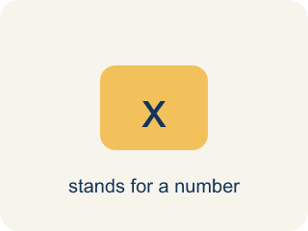
Variable (Variable) — A letter that stands for an unknown number.
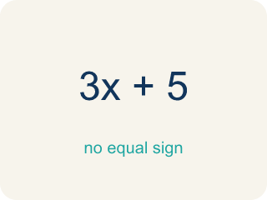
Expression (Expresión) — A math phrase with numbers and letters, but no equal sign.

Evaluate (Evaluar) — To find the value by putting numbers in for the letters.
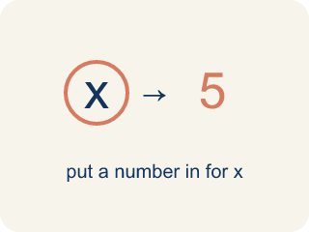
Substitute (Sustituir) — To put a number in place of a letter.
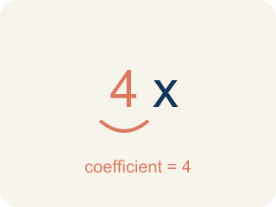
Coefficient (Coeficiente) — The number in front of a letter, like the 3 in 3x.
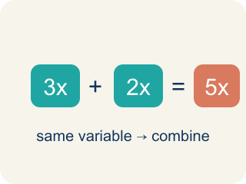
Like terms (Términos semejantes) — Terms with the same letter, like 2x and 5x.

Practice
Show your work. Use the blank space under each problem.
1. Evaluate 3x + 7 when x = 4.
A. 19
B. 34
C. 12
D. 14
______________________________________________________________________
2. Evaluate 20 − 2n when n = 6.
A. 8
B. 14
C. 32
D. 12
______________________________________________________________________
3. Evaluate each expression for the given value of the variable.
Expression | Variable Value | Substitution | Result
5n − 3 | n = 6 | 5(6) − 3
n² + 4 | n = 3 | 3² + 4
2(n + 8) | n = 5 | 2(5 + 8)
40 − 3n | n = 7 | 40 − 3(7)
______________________________________________________________________
4. Evaluate each expression when a = 3. Sort by whether the result is greater than 15 or not.
Groups: Greater than 15 | 15 or less
• 5a + 2 = 17 → __________________
• 6a = 18 → __________________
• a² + 7 = 16 → __________________
• 4a − 1 = 11 → __________________
• 2a + 5 = 11 → __________________
• 10 − a = 7 → __________________
______________________________________________________________________
5. Match each expression to its value.
Item | Answer choices
____ 3x when x=4 | F. 10
____ x² when x=5 | E. 5
____ 2x+1 when x=3 | D. 5
____ x/2 when x=10 | C. 7
____ 4x−3 when x=2 | B. 25
____ x²+1 when x=3 | A. 12
______________________________________________________________________
6. Evaluate 3 + 4 × 2².
A. 19
B. 28
C. 56
D. 14
______________________________________________________________________
7. Evaluate (8 − 3)² + 6.
A. 31
B. 19
C. 61
D. 25
______________________________________________________________________
8. If a = 4, what is 2a + 5?
A. 13
B. 9
C. 20
D. 11
______________________________________________________________________
9. Evaluate 24 ÷ (2 + 4) × 3.
A. 12
B. 1.33
C. 4
D. 18
______________________________________________________________________

Answer Key (Teacher)
1. A. 19
3(4) + 7 = 12 + 7 = 19.
2. A. 8
20 − 2(6) = 20 − 12 = 8.
3. Evaluate each expression for the given value of the variable.
5n − 3 — Result: 27
n² + 4 — Result: 13
2(n + 8) — Result: 26
40 − 3n — Result: 19

4. Correct groups:
5a + 2 = 17 → Greater than 15
6a = 18 → Greater than 15
a² + 7 = 16 → Greater than 15
4a − 1 = 11 → 15 or less
2a + 5 = 11 → 15 or less
10 − a = 7 → 15 or less

5. Matches:
3x when x=4 → 12
x² when x=5 → 25
2x+1 when x=3 → 7
x/2 when x=10 → 5
4x−3 when x=2 → 5
x²+1 when x=3 → 10

6. A. 19
Order of operations: 2² = 4, then 4 × 4 = 16, then 3 + 16 = 19.
7. A. 31
(8 − 3)² = 5² = 25, then 25 + 6 = 31.
8. A. 13
2 × 4 + 5 = 8 + 5 = 13.
9. A. 12
2 + 4 = 6; 24 ÷ 6 = 4; 4 × 3 = 12.

