Write Algebraic Expressions — Homework
Lesson 6-3 • Standard 6.EE.2a
Name: ______________________ Period: ______ Date: ____________

Today's Goals
Content: I can write algebraic expressions from words and real-world situations.
Language: I can explain my expression using the words variable, coefficient, constant, and algebraic expression.

Key Words
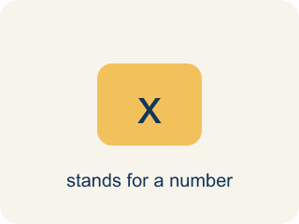
Variable (Variable) — A letter that stands for a number that is unknown or can change.
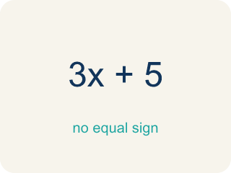
Algebraic Expression (Expresión algebraica) — A math phrase that has at least one letter.
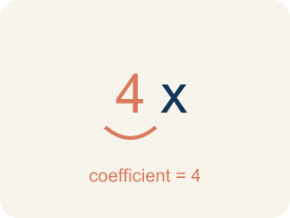
Coefficient (Coeficiente) — The number in front of a letter, like the 3 in 3x.
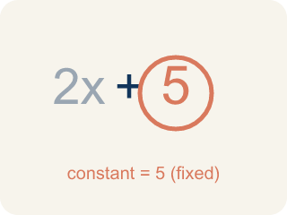
Constant (Constante) — A number on its own that does not change.
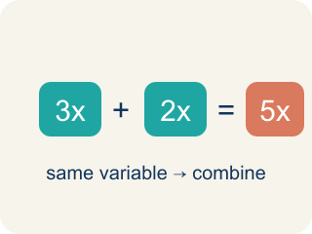
Like terms (Términos semejantes) — Terms with the same letter, like 2x and 5x.

Practice
Show your work. Use the blank space under each problem.
1. Which expression represents 'the product of 6 and a number n'?
A. 6n
B. 6 + n
C. n − 6
D. n ÷ 6
______________________________________________________________________
2. Which expression represents '9 less than a number y'?
A. y − 9
B. 9 − y
C. y + 9
D. 9y
______________________________________________________________________
3. Match each word phrase to its correct algebraic expression.
Groups: Correctly Matched
• twice a number k → 2k → __________________
• a number b divided by 5 → b ÷ 5 → __________________
• the sum of a number d and 15 → d + 15 → __________________
• 10 decreased by a number r → 10 − r → __________________
• 4 more than triple a number c → 3c + 4 → __________________
• half of a number h → h ÷ 2 → __________________
______________________________________________________________________
4. Match each word phrase to its algebraic expression.
Item | Answer choices
____ the product of 5 and n | F. z + 7
____ 8 less than a number w | E. y ÷ 4
____ a number p increased by 12 | D. 2x + 3
____ twice a number x, plus 3 | C. p + 12
____ a number y divided by 4 | B. w − 8
____ 7 more than a number z | A. 5n
______________________________________________________________________
5. Write an algebraic expression for each real-world situation.
Situation | Variable | Expression
Movie tickets cost $12 each | t = number of tickets
You had $50 and spent some money | s = dollars spent
Each student gets 3 pencils plus 2 erasers | n = number of students
A pizza is split equally among friends | f = number of friends, pizza = 24 slices
______________________________________________________________________
6. Which expression means '5 more than a number n'?
A. n + 5
B. 5n
C. n − 5
D. 5 − n
______________________________________________________________________
7. Which expression means 'the product of 7 and a number x'?
A. 7x
B. 7 + x
C. x − 7
D. x ÷ 7
______________________________________________________________________
8. Write 'a number y divided by 4' as an expression.
A. y/4
B. 4y
C. y − 4
D. 4 − y
______________________________________________________________________
9. Which expression means '3 less than twice a number m'?
A. 2m − 3
B. 3 − 2m
C. 2(m − 3)
D. 3m − 2
______________________________________________________________________

Answer Key (Teacher)
1. A. 6n
'Product' means multiplication, so the product of 6 and n is 6n.
2. A. y − 9
'Less than' means subtract from the number, so it's y − 9.
3. Correct groups:
twice a number k → 2k → Correctly Matched
a number b divided by 5 → b ÷ 5 → Correctly Matched
the sum of a number d and 15 → d + 15 → Correctly Matched
10 decreased by a number r → 10 − r → Correctly Matched
4 more than triple a number c → 3c + 4 → Correctly Matched
half of a number h → h ÷ 2 → Correctly Matched

4. Matches:
the product of 5 and n → 5n
8 less than a number w → w − 8
a number p increased by 12 → p + 12
twice a number x, plus 3 → 2x + 3
a number y divided by 4 → y ÷ 4
7 more than a number z → z + 7

5. Write an algebraic expression for each real-world situation.
Movie tickets cost $12 each — Expression: 12t
You had $50 and spent some money — Expression: 50 − s
Each student gets 3 pencils plus 2 erasers — Expression: 3n + 2n or 5n
A pizza is split equally among friends — Expression: 24 ÷ f

6. A. n + 5
'More than' means addition: n + 5.
7. A. 7x
'Product' means multiplication: 7x.
8. A. y/4
'Divided by 4' means y/4.
9. A. 2m − 3
Twice a number is 2m; '3 less' subtracts 3: 2m − 3.

