Properties of Operations — Homework
Lesson 6-4 • Standard 6.EE.3
Name: ______________________ Period: ______ Date: ____________

Today's Goals
Content: I can use the commutative, associative, and identity properties to rewrite expressions.
Language: I can explain my reasoning using the words commutative property, associative property, and identity property.

Key Words
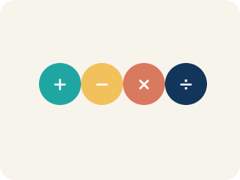
Commutative Property (Propiedad conmutativa) — You can change the order and get the same answer.

Associative Property (Propiedad asociativa) — You can change the grouping and get the same answer.

Identity Property (Propiedad de identidad) — Adding 0 or multiplying by 1 keeps the same value.

Property (Propiedad) — A rule that is always true in math.
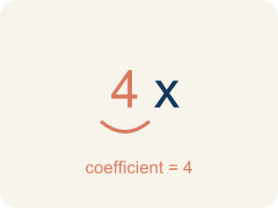
Coefficient (Coeficiente) — The number in front of a letter, like the 3 in 3x.
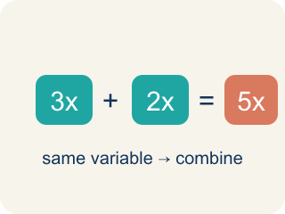
Like terms (Términos semejantes) — Terms with the same letter, like 2x and 5x.

Practice
Show your work. Use the blank space under each problem.
1. Which property is shown? 5 + 13 = 13 + 5
A. Commutative Property
B. Associative Property
C. Identity Property
D. Distributive Property
______________________________________________________________________
2. Which property is shown? (6 × 3) × 2 = 6 × (3 × 2)
A. Associative Property
B. Commutative Property
C. Identity Property
D. Distributive Property
______________________________________________________________________
3. Match each equation with the property it demonstrates.
Groups: Commutative | Associative | Identity
• a + b = b + a → __________________
• x × 1 = x → __________________
• (m + n) + p = m + (n + p) → __________________
• c × d = d × c → __________________
• y + 0 = y → __________________
• (a × b) × c = a × (b × c) → __________________
______________________________________________________________________
4. Match each equation to its property.
Item | Answer choices
____ 7 + 9 = 9 + 7 | F. Associative (Add)
____ (2 × 5) × 3 = 2 × (5 × 3) | E. Commutative (Mult)
____ 15 × 1 = 15 | D. Identity (Add)
____ 0 + 23 = 23 | C. Identity (Mult)
____ 6 × 4 = 4 × 6 | B. Associative (Mult)
____ (8 + 3) + 7 = 8 + (3 + 7) | A. Commutative (Add)
______________________________________________________________________
5. Use properties to rewrite each expression in a way that makes mental math easier. Then calculate.
Original | Rearranged (using properties) | Value
25 × 7 × 4 | 25 × 4 × 7 = 100 × 7
19 + 36 + 1 | 19 + 1 + 36 = 20 + 36
50 × 9 × 2 | 50 × 2 × 9 = 100 × 9
______________________________________________________________________
6. Which property is shown by 4 + 7 = 7 + 4?
A. Commutative Property of Addition
B. Associative Property
C. Distributive Property
D. Identity Property
______________________________________________________________________
7. Which property is shown by (2 × 3) × 5 = 2 × (3 × 5)?
A. Associative Property of Multiplication
B. Commutative Property
C. Distributive Property
D. Identity Property
______________________________________________________________________
8. What number completes the Identity Property: 9 × ___ = 9?
A. 1
B. 0
C. 9
D. 81
______________________________________________________________________
9. Which equation shows the Distributive Property?
A. 3(x + 2) = 3x + 6
B. 3 + x = x + 3
C. (3x)y = 3(xy)
D. x + 0 = x
______________________________________________________________________

Answer Key (Teacher)
1. A. Commutative Property
The order of the addends changed, so this is the Commutative Property of Addition.
2. A. Associative Property
The grouping (parentheses) changed but the order stayed the same, so this is the Associative Property of Multiplication.
3. Correct groups:
a + b = b + a → Commutative
x × 1 = x → Identity
(m + n) + p = m + (n + p) → Associative
c × d = d × c → Commutative
y + 0 = y → Identity
(a × b) × c = a × (b × c) → Associative

4. Matches:
7 + 9 = 9 + 7 → Commutative (Add)
(2 × 5) × 3 = 2 × (5 × 3) → Associative (Mult)
15 × 1 = 15 → Identity (Mult)
0 + 23 = 23 → Identity (Add)
6 × 4 = 4 × 6 → Commutative (Mult)
(8 + 3) + 7 = 8 + (3 + 7) → Associative (Add)

5. Use properties to rewrite each expression in a way that makes mental math easier. Then calculate.
25 × 7 × 4 — Value: 700
19 + 36 + 1 — Value: 56
50 × 9 × 2 — Value: 900

6. A. Commutative Property of Addition
Changing the order of addends shows the Commutative Property.
7. A. Associative Property of Multiplication
Changing the grouping shows the Associative Property.
8. A. 1
Multiplying by 1 keeps the value the same.
9. A. 3(x + 2) = 3x + 6
Distributing 3 over (x + 2) gives 3x + 6.

