The Distributive Property — Homework
Lesson 6-5 • Standard 6.EE.3
Name: ______________________ Period: ______ Date: ____________

Today's Goals
Content: I can use the distributive property to expand and factor expressions.
Language: I can explain my steps using the words distributive property, factor, expand, and equivalent.

Key Words
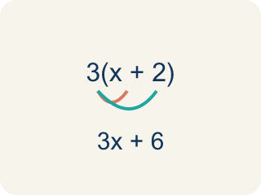
Distributive Property (Propiedad distributiva) — Multiplying a number by everything inside the parentheses: a(b + c) = ab + ac.
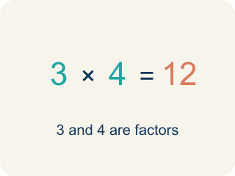
Factor (Factor) — A number that gets multiplied by another number.

Expand (Desarrollar) — To multiply out the parentheses in an expression.
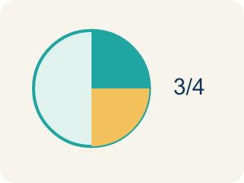
Equivalent (Equivalente) — Expressions that always have the same value.
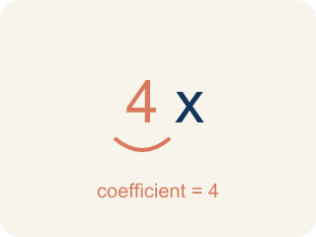
Coefficient (Coeficiente) — The number in front of a letter, like the 3 in 3x.
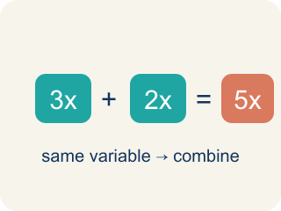
Like terms (Términos semejantes) — Terms with the same letter, like 2x and 5x.

Practice
Show your work. Use the blank space under each problem.
1. Expand 6(n + 3) using the distributive property.
A. 6n + 18
B. 6n + 3
C. n + 18
D. 6n + 9
______________________________________________________________________
2. Expand 4(5 − 2) using the distributive property.
A. 12
B. 20 − 2
C. 9
D. 22
______________________________________________________________________
3. Use the distributive property to expand each expression.
Factored Form | Expanded Form
3(2x + 5)
7(a − 4)
2(3m + 8)
5(6 − y)
______________________________________________________________________
4. Match each factored form to its expanded form.
Item | Answer choices
____ 2(x + 9) | F. 8x − 24
____ 5(3n − 2) | E. 12m + 6
____ 4(a + 6) | D. 21 − 3y
____ 3(7 − y) | C. 4a + 24
____ 6(2m + 1) | B. 15n − 10
____ 8(x − 3) | A. 2x + 18
______________________________________________________________________
5. Expand each expression, then sort by whether the expanded form has a constant greater than 15 or not.
Groups: Constant > 15 | Constant ≤ 15
• 3(x + 7) = 3x + 21 → __________________
• 2(n + 5) = 2n + 10 → __________________
• 5(a + 4) = 5a + 20 → __________________
• 4(y − 2) = 4y − 8 → __________________
• 6(m + 3) = 6m + 18 → __________________
• 2(3x + 1) = 6x + 2 → __________________
______________________________________________________________________
6. Use the Distributive Property: 4(x + 3) = ?
A. 4x + 12
B. 4x + 3
C. x + 12
D. 4x + 7
______________________________________________________________________
7. Use the Distributive Property: 5(2x − 1) = ?
A. 10x − 5
B. 10x − 1
C. 7x − 5
D. 10x + 5
______________________________________________________________________
8. Which expression is equal to 6x + 18 using a common factor?
A. 6(x + 3)
B. 6(x + 18)
C. x(6 + 18)
D. 6(x + 12)
______________________________________________________________________
9. Use the Distributive Property to compute 7 × 104.
A. 728
B. 700
C. 98
D. 742
______________________________________________________________________

Answer Key (Teacher)
1. A. 6n + 18
6(n + 3) = 6 × n + 6 × 3 = 6n + 18.
2. A. 12
4(5 − 2) = 4 × 5 − 4 × 2 = 20 − 8 = 12.
3. Use the distributive property to expand each expression.
3(2x + 5) — Expanded Form: 6x + 15
7(a − 4) — Expanded Form: 7a − 28
2(3m + 8) — Expanded Form: 6m + 16
5(6 − y) — Expanded Form: 30 − 5y

4. Matches:
2(x + 9) → 2x + 18
5(3n − 2) → 15n − 10
4(a + 6) → 4a + 24
3(7 − y) → 21 − 3y
6(2m + 1) → 12m + 6
8(x − 3) → 8x − 24

5. Correct groups:
3(x + 7) = 3x + 21 → Constant > 15
2(n + 5) = 2n + 10 → Constant ≤ 15
5(a + 4) = 5a + 20 → Constant > 15
4(y − 2) = 4y − 8 → Constant ≤ 15
6(m + 3) = 6m + 18 → Constant > 15
2(3x + 1) = 6x + 2 → Constant ≤ 15

6. A. 4x + 12
4 × x + 4 × 3 = 4x + 12.
7. A. 10x − 5
5 × 2x − 5 × 1 = 10x − 5.
8. A. 6(x + 3)
The GCF of 6x and 18 is 6: 6(x + 3).
9. A. 728
7 × 104 = 7 × 100 + 7 × 4 = 700 + 28 = 728.

