UNIT 6 · LESSON 6 STANDARD 6.EE.4

Equivalent Expressions
Student Notes Packet
Name: ______________________ Date: ____________ Period: ________

Today's Goals
Content: I can show that two expressions are equivalent by simplifying and combining like terms.
Language: I can explain my work using the words equivalent, simplify, like terms, and combine.

Key Vocabulary
Look at the picture, read the word, then read what it means.
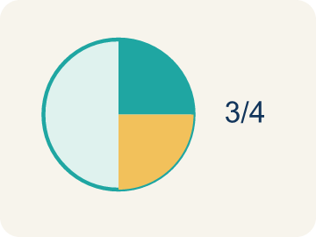 | Equivalent Equivalente  Expressions that always have the same value.  Example: 2x + 4 and 2(x + 2): when x = 3, both = 10; when x = 7, both = 18 — always the same
 | Simplify Simplificar  To write an expression in a shorter, simpler way.  Example: 3x + 2x + 5 simplifies to 5x + 5 — fewer terms, same value
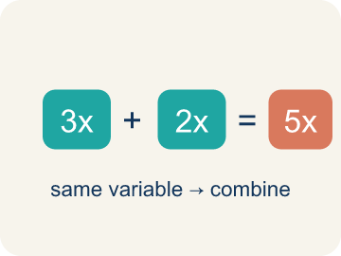 | Like Terms Términos semejantes  Terms with the same letter, like 2x and 5x.  Example: 3x and 7x are like terms (both x); 3x and 3y are NOT (x vs y); 3x and 3x² are NOT (x vs x²)
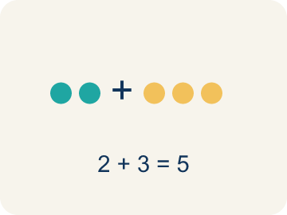 | Combine Combinar  To add or subtract terms with the same letter.  Example: 4n + 3n = 7n — add the coefficients (4 + 3 = 7) and keep the variable (n)
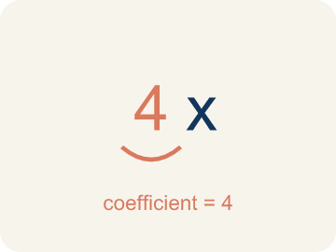 | Coefficient Coeficiente  The number in front of a letter, like the 3 in 3x.  Example: In 5x + 3, the coefficient of x is 5 — when x = 2, the 5x part equals 10

Worked Example

Watch & Read I Do — follow along with your teacher
Remix Studio
At the music studio, two producers wrote formulas for the cost of renting equipment. Producer A wrote 3x + 2x + 10, and Producer B wrote 5x + 10. They look different, but are they really? Let's check: if x = 4, Producer A gets 3(4) + 2(4) + 10 = 30, and Producer B gets 5(4) + 10 = 30. Same result — they're equivalent expressions!

Think about:
• Why did both formulas give the same answer?
• What did Producer B do differently from Producer A?
• Would they still match if x = 10?
• Can two expressions look completely different but always give the same answer?
• Is there always a 'simplest' way to write an expression?

Solved Example I Do — watch each step
Problem: Which expression is equivalent to 4x + 3x?
A) 7x
B) 12x
C) 7x²
D) 43x
Step 1: 4x + 3x = 7x.
Step 2: Combine the coefficients: 4 + 3 = 7.
Answer: A. 7x

Guided Practice

Solve Together We Do — work with your class
Problem: Which expression is equivalent to 2(m + 5)?
A) 2m + 10
B) 2m + 5
C) m + 10
D) 7m
Step 1:

Step 2:

Answer:

A music studio charges different clients using different formulas. Client A pays 4h + 2h + 30 for h hours. Client B pays 6h + 30. A new client asks if the pricing is fair.
Are these expressions equivalent? How can you prove it?

Sentence frame: The expressions ___ equivalent because when I simplify 4h + 2h + 30, I get ___. I can prove it by substituting h = ___: both expressions equal ___.

Turn & Talk discuss with a partner
1. [Launch] Producer A wrote 3x + 2x + 10 and Producer B wrote 5x + 10. They look different but both give 30 when x = 4. Why are they equivalent?
Start with: These expressions are equivalent because 3x + 2x ___.
Estas expresiones son equivalentes porque 3x + 2x ___.
Word bank: Equivalent, Simplify, Like Terms, Combine
2. [Explore] How can you prove 2(n + 4) and 2n + 8 are equivalent? What two strategies could you use?
Start with: They are equivalent because distributing 2(n + 4) gives ___.
Son equivalentes porque distribuir 2(n + 4) da ___.
Word bank: Equivalent, Simplify, Combine, Like Terms
3. [Connect] Client A pays 4h + 2h + 30 and Client B pays 6h + 30. Is the pricing fair (equivalent)? How can you prove it?
Start with: The expressions ___ equivalent because 4h + 2h = ___.
Las expresiones ___ equivalentes porque 4h + 2h = ___.
Word bank: Equivalent, Simplify, Combine, Like Terms

Independent Practice

On Your Own You Do — show your work
Solve each problem. Show your thinking in the work box.
1. Which property is shown: 3(x + 7) = 3x + 21?
A) Distributive
B) Commutative
C) Associative
D) Identity

2. Simplify: 5n + 2n
A) 7n
B) 10n
C) 7n²
D) 52n

3. Which expression is equivalent to 3x + 3x?
A) 6x
B) 9x
C) 3x²
D) x + 6

4. Which expression is equivalent to 2(x + 4)?
A) 2x + 8
B) 2x + 4
C) x + 8
D) 2x + 6

Write About the Math

Build Strong Sentences The Writing Revolution
I can explain my work using the words equivalent, simplify, like terms, and combine.

1. Kernel Sentence subject + verb
Model: Equivalent is expressions that always have the same value.

Write a kernel sentence about equivalent. Use a subject and a verb.
Escribe una oración base sobre equivalente. Usa un sujeto y un verbo.

2. Sentence Expansion because · but · so
Kernel: Equivalent matters in math
because Equivalent matters in math because ___.
Equivalente importa en matemáticas porque ___.

but Equivalent matters in math, but ___.
Equivalente importa en matemáticas, pero ___.

so Equivalent matters in math, so ___.
Equivalente importa en matemáticas, entonces ___.

3. Explain Your Reasoning use a sentence starter
These expressions are equivalent because 3x + 2x ___.
Estas expresiones son equivalentes porque 3x + 2x ___.
I checked by substituting x = ___ and getting ___ both ways.
Lo comprobé sustituyendo x = ___ y obteniendo ___ en ambas.
They are equivalent because distributing 2(n + 4) gives ___.
Son equivalentes porque distribuir 2(n + 4) da ___.

Exit Ticket
Answer on your own. This shows what you learned today.
★ Which expression is equivalent to 6n + 4 + 3n − 1?
A) 9n + 3
B) 9n + 5
C) 63n
D) 18n + 4

Answer Key & Teacher Guide
Teacher reference — remove or fold back before distributing to students.

Worked Notes (I Do / We Do)
I Do: A. 7x
We Do: A. 2m + 10

Independent Practice
1. A) Distributive — Multiplying 3 by each term inside the parentheses is the distributive property.
2. A) 7n — 5n + 2n = 7n. Add the coefficients: 5 + 2 = 7. The variable stays as n.
3. A) 6x — Adding like terms: 3x + 3x = 6x.
4. A) 2x + 8 — Distribute: 2x + 8.

Exit Ticket
A) 9n + 3 — 6n + 3n = 9n and 4 − 1 = 3, so the simplified expression is 9n + 3.

Writing (TWR) — what to look for
Kernel sentence: a complete sentence needs a subject and a verb. Example: Equivalent is expressions that always have the same value.
Expansion: because = reason, but = contrast/exception, so = result. Answers vary; each must keep the kernel idea.

Turn & Talk — listen for
1. Students explain 3x + 2x = 5x (combining like terms), so both equal 5x + 10, and verify by substituting a value like x = 4 to get 30 both ways.
2. A strong answer uses the distributive property (2(n + 4) = 2n + 8) and/or substitutes a value into both to confirm equal results.
3. Students simplify 4h + 2h + 30 to 6h + 30, conclude the pricing is fair/equivalent, and verify by substituting a value of h.

