Equivalent Expressions — Homework
Lesson 6-6 • Standard 6.EE.4
Name: ______________________ Period: ______ Date: ____________

Today's Goals
Content: I can show that two expressions are equivalent by simplifying and combining like terms.
Language: I can explain my work using the words equivalent, simplify, like terms, and combine.

Key Words
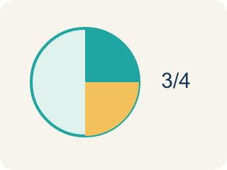
Equivalent (Equivalente) — Expressions that always have the same value.

Simplify (Simplificar) — To write an expression in a shorter, simpler way.
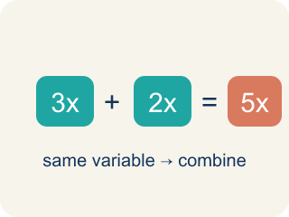
Like Terms (Términos semejantes) — Terms with the same letter, like 2x and 5x.
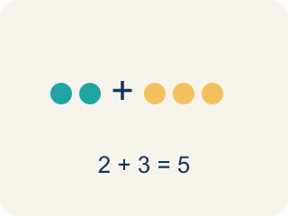
Combine (Combinar) — To add or subtract terms with the same letter.
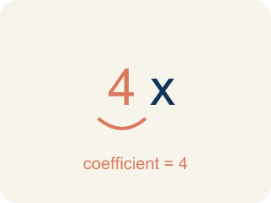
Coefficient (Coeficiente) — The number in front of a letter, like the 3 in 3x.

Practice
Show your work. Use the blank space under each problem.
1. Which expression is equivalent to 4x + 3x?
A. 7x
B. 12x
C. 7x²
D. 43x
______________________________________________________________________
2. Which expression is equivalent to 2(m + 5)?
A. 2m + 10
B. 2m + 5
C. m + 10
D. 7m
______________________________________________________________________
3. Match each expression with its simplified form.
Groups: Correctly Matched
• 8y + 2y → 10y → __________________
• 3(a + 6) → 3a + 18 → __________________
• 5n + 4 + 2n → 7n + 4 → __________________
• 9p − 3p → 6p → __________________
• 4(2x − 1) → 8x − 4 → __________________
• 6t + t → 7t → __________________
______________________________________________________________________
4. Match each expression to its simplified equivalent.
Item | Answer choices
____ 6x + 2x | F. 5x + 10
____ 3(n + 5) | E. 6m + 1
____ 4a + 7 + a | D. 6y − 8
____ 2(3y − 4) | C. 5a + 7
____ 10m − 4m + 1 | B. 3n + 15
____ 5(x + 2) | A. 8x
______________________________________________________________________
5. Simplify each expression. Then evaluate both the original and simplified form when x = 3 to verify they are equivalent.
Original | Simplified | Value when x = 3
2x + 5x + 1
4(x + 2)
3x + 4 + x − 1
______________________________________________________________________
6. Which expression is equivalent to 3x + 3x?
A. 6x
B. 9x
C. 3x²
D. x + 6
______________________________________________________________________
7. Which expression is equivalent to 2(x + 4)?
A. 2x + 8
B. 2x + 4
C. x + 8
D. 2x + 6
______________________________________________________________________
8. Are 4x + 2 and 2(2x + 1) equivalent?
A. Yes, they are equal for every value of x
B. No, never
C. Only when x = 0
D. Only when x = 1
______________________________________________________________________
9. Which expression is NOT equivalent to 5x + 10?
A. 5x + 5
B. 5(x + 2)
C. 10 + 5x
D. x·5 + 10
______________________________________________________________________

Answer Key (Teacher)
1. A. 7x
4x + 3x = 7x. Combine the coefficients: 4 + 3 = 7.
2. A. 2m + 10
2(m + 5) = 2m + 10 using the distributive property.
3. Correct groups:
8y + 2y → 10y → Correctly Matched
3(a + 6) → 3a + 18 → Correctly Matched
5n + 4 + 2n → 7n + 4 → Correctly Matched
9p − 3p → 6p → Correctly Matched
4(2x − 1) → 8x − 4 → Correctly Matched
6t + t → 7t → Correctly Matched

4. Matches:
6x + 2x → 8x
3(n + 5) → 3n + 15
4a + 7 + a → 5a + 7
2(3y − 4) → 6y − 8
10m − 4m + 1 → 6m + 1
5(x + 2) → 5x + 10

5. Simplify each expression. Then evaluate both the original and simplified form when x = 3 to verify they are equivalent.
2x + 5x + 1 — Simplified: 7x + 1
2x + 5x + 1 — Value when x = 3: 22
4(x + 2) — Simplified: 4x + 8
4(x + 2) — Value when x = 3: 20
3x + 4 + x − 1 — Simplified: 4x + 3
3x + 4 + x − 1 — Value when x = 3: 15

6. A. 6x
Adding like terms: 3x + 3x = 6x.
7. A. 2x + 8
Distribute: 2x + 8.
8. A. Yes, they are equal for every value of x
2(2x + 1) = 4x + 2, so they are equivalent for all x.
9. A. 5x + 5
5x + 5 is different; the others all equal 5x + 10.

