Simplify Algebraic Expressions — Homework
Lesson 6-7 • Standard 6.EE.3
Name: ______________________ Period: ______ Date: ____________

Today's Goals
Content: I can simplify algebraic expressions by combining like terms.
Language: I can explain my steps using the words like terms, combine, simplify, and coefficient.

Key Words
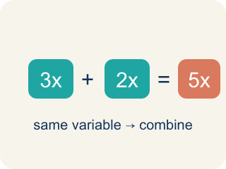
Like Terms (Términos semejantes) — Terms with the same letter, like 2x and 5x.
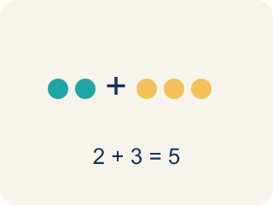
Combine (Combinar) — To add or subtract terms with the same letter into one.
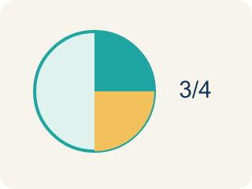
Simplify (Simplificar) — To write an expression in its shortest form.
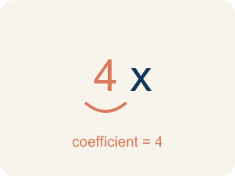
Coefficient (Coeficiente) — The number in front of a letter, like the 3 in 3x.
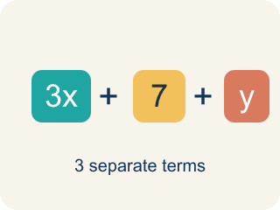
Term (Término) — A single number, variable, or product of them, separated by + or − signs.
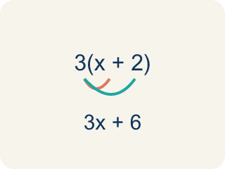
Distributive property (Propiedad distributiva) — Multiplying a sum by a number means multiplying each part by that number.

Practice
Show your work. Use the blank space under each problem.
1. Simplify 7x + 3x.
A. 10x
B. 10x²
C. 21x
D. 73x
______________________________________________________________________
2. Simplify 9n + 4 + 2n.
A. 11n + 4
B. 15n
C. 11n² + 4
D. 92n + 4
______________________________________________________________________
3. Simplify each expression by combining like terms.
Expression | Like Terms Combined | Simplified
3a + 5a + 2 | 3a + 5a = 8a
6x + 4 + 2x + 7
10m − 3m + 5
4y + 3 + y + 9
______________________________________________________________________
4. Match each expression to its simplified form.
Item | Answer choices
____ 8x + 3x + 1 | F. 6p + 1
____ 5a − 2a + 7 | E. 7m + 10
____ 4n + n + 6 | D. 7y
____ 12y − 5y | C. 5n + 6
____ 3m + 8 + 4m + 2 | B. 3a + 7
____ 9p + 1 − 3p | A. 11x + 1
______________________________________________________________________
5. Simplify each expression, then sort by whether the simplified coefficient of the variable is greater than 6 or not.
Groups: Coefficient > 6 | Coefficient ≤ 6
• 4x + 5x = 9x → coefficient 9 → __________________
• 8n − 3n = 5n → coefficient 5 → __________________
• 3a + a + 4a = 8a → coefficient 8 → __________________
• 10m − 7m = 3m → coefficient 3 → __________________
• 2y + 5y = 7y → coefficient 7 → __________________
• 6p − p = 5p → coefficient 5 → __________________
______________________________________________________________________
6. Simplify: 4x + 3 + 2x.
A. 6x + 3
B. 9x
C. 6x + 5
D. 4x + 5
______________________________________________________________________
7. Simplify: 7y − 2y + 5.
A. 5y + 5
B. 9y + 5
C. 5y − 5
D. 10y
______________________________________________________________________
8. Simplify: 3(x + 2) + 4x.
A. 7x + 6
B. 3x + 6
C. 7x + 2
D. 12x
______________________________________________________________________
9. Simplify: 8a + 4 − 3a − 1.
A. 5a + 3
B. 5a + 5
C. 11a + 3
D. 5a − 3
______________________________________________________________________

Answer Key (Teacher)
1. A. 10x
7x + 3x = 10x. Add the coefficients: 7 + 3 = 10.
2. A. 11n + 4
9n + 2n = 11n. The constant 4 has no like term, so it stays. Result: 11n + 4.
3. Simplify each expression by combining like terms.
3a + 5a + 2 — Simplified: 8a + 2
6x + 4 + 2x + 7 — Like Terms Combined: 6x + 2x = 8x, 4 + 7 = 11
6x + 4 + 2x + 7 — Simplified: 8x + 11
10m − 3m + 5 — Like Terms Combined: 10m − 3m = 7m
10m − 3m + 5 — Simplified: 7m + 5
4y + 3 + y + 9 — Like Terms Combined: 4y + y = 5y, 3 + 9 = 12
4y + 3 + y + 9 — Simplified: 5y + 12

4. Matches:
8x + 3x + 1 → 11x + 1
5a − 2a + 7 → 3a + 7
4n + n + 6 → 5n + 6
12y − 5y → 7y
3m + 8 + 4m + 2 → 7m + 10
9p + 1 − 3p → 6p + 1

5. Correct groups:
4x + 5x = 9x → coefficient 9 → Coefficient > 6
8n − 3n = 5n → coefficient 5 → Coefficient ≤ 6
3a + a + 4a = 8a → coefficient 8 → Coefficient > 6
10m − 7m = 3m → coefficient 3 → Coefficient ≤ 6
2y + 5y = 7y → coefficient 7 → Coefficient > 6
6p − p = 5p → coefficient 5 → Coefficient ≤ 6

6. A. 6x + 3
Combine like terms 4x + 2x = 6x, then add 3: 6x + 3.
7. A. 5y + 5
7y − 2y = 5y, so 5y + 5.
8. A. 7x + 6
3x + 6 + 4x = 7x + 6.
9. A. 5a + 3
8a − 3a = 5a; 4 − 1 = 3; result 5a + 3.

