Write Equations — Homework
Lesson 7-1-flagship • Standard 6.EE.6
Name: ______________________ Period: ______ Date: ____________

Today's Goals
Content: I can write an equation to represent a real-world situation.
Language: I can explain my equation using the words equation, variable, equal sign, and expression.

Key Words
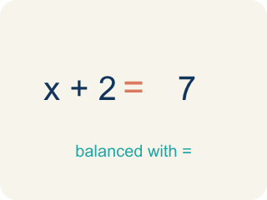
Equation (Ecuación) — A math sentence with an equal sign showing both sides are the same.
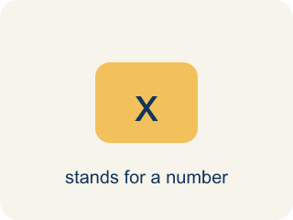
Variable (Variable) — A letter that stands for an unknown number.

Equal sign (Signo igual) — The = sign, showing both sides are the same.
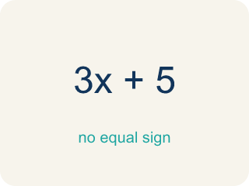
Expression (Expresión) — A math phrase with numbers and letters, but no equal sign.

Practice
Show your work. Use the blank space under each problem.
1. Which equation represents: 'A number plus 12 equals 30'?
A. n + 12 = 30
B. n − 12 = 30
C. 12n = 30
D. n / 12 = 30
______________________________________________________________________
2. Which equation represents: 'Seven less than a number is 18'?
A. n − 7 = 18
B. 7 − n = 18
C. n + 7 = 18
D. n / 7 = 18
______________________________________________________________________
3. For each situation, identify what the variable represents and write the equation.
Situation | Variable Represents | Equation
A box holds some files. After removing 5, there are 13 left. | Number of files in the box | n − 5 = 13
A detective split 48 photos equally into folders. Each folder has 6 photos. | Number of folders | 48 / n = 6
______________________________________________________________________
4. A detective found some fingerprints on Monday and 14 more on Tuesday, for a total of 30. Which equation represents this?
A. f + 14 = 30
B. f − 14 = 30
C. 14f = 30
D. f / 14 = 30
______________________________________________________________________

Answer Key (Teacher)
1. A. n + 12 = 30
'Plus' means addition, so the equation is n + 12 = 30.
2. A. n − 7 = 18
'Seven less than a number' means start with the number and subtract 7: n − 7 = 18.
3. For each situation, identify what the variable represents and write the equation.
(See completed table.)

4. A. f + 14 = 30
The detective's Monday fingerprints (f) plus 14 more equals 30: f + 14 = 30.

