Solve Multiplication and Division Equations — Homework
Lesson 7-3 • Standard 6.EE.7
Name: ______________________ Period: ______ Date: ____________

Today's Goals
Content: I can solve one-step multiplication and division equations using inverse operations.
Language: I can explain my steps using the words inverse operation, multiply, divide, and isolate.

Key Words
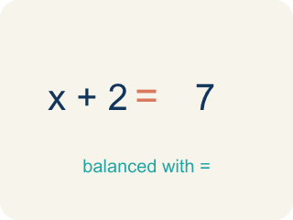
Inverse operation (Operación inversa) — Two math actions that undo each other, like × and ÷.
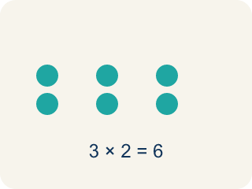
Multiply (Multiplicar) — To add equal groups again and again.
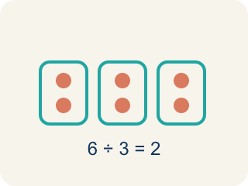
Divide (Dividir) — To split into equal groups.

Isolate (Despejar) — To get the letter by itself on one side.
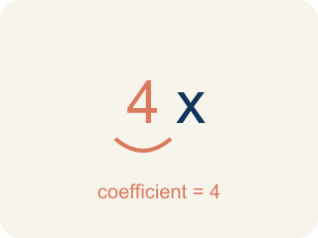
Coefficient (Coeficiente) — The number multiplied by a variable.

Solution (Solución) — The value of the variable that makes the equation true.

Practice
Show your work. Use the blank space under each problem.
1. Solve: 6x = 42
A. x = 7
B. x = 48
C. x = 36
D. x = 252
______________________________________________________________________
2. Solve: n / 3 = 8
A. n = 24
B. n = 11
C. n = 5
D. n = 3
______________________________________________________________________
3. Solve each equation, show your work, and check.
Equation | Work | Solution | Check
8m = 56 | 56 ÷ 8 | m = 7 | 8 × 7 = 56 ✓
y / 6 = 11 | 11 × 6 | y = 66 | 66 / 6 = 11 ✓
12k = 96 | 96 ÷ 12 | k = 8 | 12 × 8 = 96 ✓
______________________________________________________________________
4. A detective splits 54 clues equally among 9 case files. The equation 9c = 54 represents this. What is c?
A. c = 6
B. c = 63
C. c = 45
D. c = 9
______________________________________________________________________
5. Solve: 6x = 54.
A. x = 9
B. x = 60
C. x = 48
D. x = 324
______________________________________________________________________
6. Solve: x/4 = 7.
A. x = 28
B. x = 1.75
C. x = 11
D. x = 3
______________________________________________________________________
7. Solve: 8n = 2.
A. n = 0.25
B. n = 16
C. n = 4
D. n = 10
______________________________________________________________________
8. Five friends split a bill equally and each pays $12. Which equation finds the total t?
A. t/5 = 12
B. 5t = 12
C. t − 5 = 12
D. t + 5 = 12
______________________________________________________________________

Answer Key (Teacher)
1. A. x = 7
Divide both sides by 6: x = 42 ÷ 6 = 7. Check: 6 × 7 = 42 ✓
2. A. n = 24
Multiply both sides by 3: n = 8 × 3 = 24. Check: 24 / 3 = 8 ✓
3. Solve each equation, show your work, and check.
(See completed table.)

4. A. c = 6
Divide both sides by 9: c = 54 ÷ 9 = 6 clues per file.
5. A. x = 9
Divide both sides by 6: x = 54 ÷ 6 = 9.
6. A. x = 28
Multiply both sides by 4: x = 28.
7. A. n = 0.25
n = 2 ÷ 8 = 0.25.
8. A. t/5 = 12
Total divided by 5 equals 12, so t = 60.

