Write Inequalities — Homework
Lesson 7-4 • Standard 6.EE.8
Name: ______________________ Period: ______ Date: ____________

Today's Goals
Content: I can write inequalities to represent real-world situations.
Language: I can explain my inequality using the words inequality, greater than, less than, and at least / at most.

Key Words
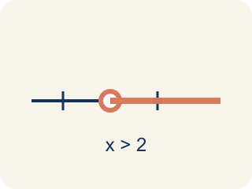
Inequality (Desigualdad) — A math sentence that compares two sides with <, >, ≤, or ≥.

Greater than (Mayor que) — The > sign, showing one number is bigger.

Less than (Menor que) — The < sign, showing one number is smaller.

At least / At most (Al menos / A lo más) — 'At least' means ≥. 'At most' means ≤.
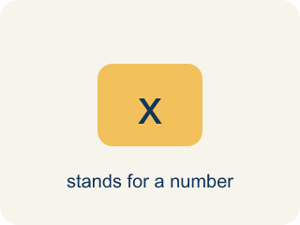
Variable (Variable) — A letter that stands for an unknown number.
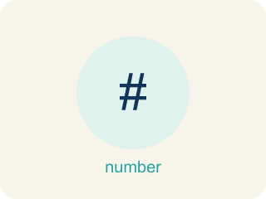
No more than (No más de) — A phrase meaning less than or equal to (≤).

Practice
Show your work. Use the blank space under each problem.
1. Which inequality represents: 'The temperature is less than 40 degrees'?
A. t < 40
B. t > 40
C. t ≤ 40
D. t = 40
______________________________________________________________________
2. Which inequality represents: 'You must be at least 48 inches tall to ride'?
A. h ≥ 48
B. h > 48
C. h < 48
D. h ≤ 48
______________________________________________________________________
3. Identify the key phrase, symbol, and write the inequality for each situation.
Situation | Key Phrase | Symbol | Inequality
A package weighs less than 50 pounds. | less than | < | w < 50
You need at least $25 to buy the game. | at least | ≥ | m ≥ 25
No more than 30 students can join the club. | no more than | ≤ | s ≤ 30
______________________________________________________________________
4. Sort each inequality into whether x = 10 is a solution.
Groups: x = 10 IS a solution | x = 10 is NOT a solution
______________________________________________________________________
5. A parking garage charges if your stay is more than 2 hours. Which inequality represents times t that are charged?
A. t > 2
B. t ≥ 2
C. t < 2
D. t ≤ 2
______________________________________________________________________
6. Which inequality means 'a number x is at least 10'?
A. x ≥ 10
B. x > 10
C. x ≤ 10
D. x < 10
______________________________________________________________________
7. Which inequality means 'you must be more than 5 feet tall to ride'?
A. h > 5
B. h ≥ 5
C. h < 5
D. h ≤ 5
______________________________________________________________________
8. A bus holds at most 40 people. Which inequality shows the number p of people allowed?
A. p ≤ 40
B. p ≥ 40
C. p > 40
D. p < 40
______________________________________________________________________
9. Which inequality means 'a number n is less than 8'?
A. n < 8
B. n ≤ 8
C. n > 8
D. n ≥ 8
______________________________________________________________________

Answer Key (Teacher)
1. A. t < 40
'Less than' means <, so the inequality is t < 40.
2. A. h ≥ 48
'At least' means greater than or equal to, so h ≥ 48.
3. Identify the key phrase, symbol, and write the inequality for each situation.
(See completed table.)

4. Correct groups:

5. A. t > 2
'More than 2 hours' means strictly greater than: t > 2. Exactly 2 hours is not charged.
6. A. x ≥ 10
'At least 10' means 10 or more: x ≥ 10.
7. A. h > 5
'More than 5' is h > 5.
8. A. p ≤ 40
'At most 40' means 40 or fewer: p ≤ 40.
9. A. n < 8
'Less than 8' is n < 8.

