Graph Inequalities — Homework
Lesson 7-5 • Standard 6.EE.8
Name: ______________________ Period: ______ Date: ____________

Today's Goals
Content: I can graph the solutions of an inequality on a number line.
Language: I can explain my graph using the words number line, open circle, closed circle, and solution set.

Key Words
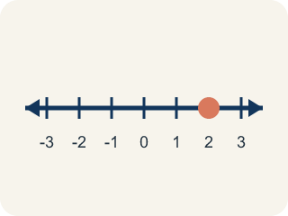
Number line (Recta numérica) — A line with numbers in order. You use it to show answers.
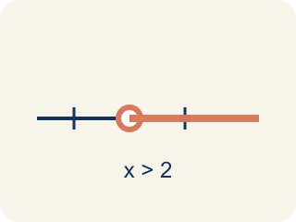
Open circle (Círculo abierto) — An empty circle showing a number is NOT included.

Closed circle (Círculo cerrado) — A filled-in circle showing a number IS included.

Solution set (Conjunto solución) — All the numbers that make the inequality true.

Inequality (Desigualdad) — A math sentence comparing two amounts with <, >, ≤, or ≥.
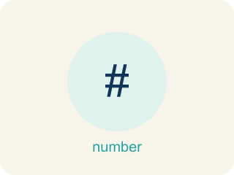
Boundary point (Punto límite) — The number on the number line where the solution set starts.

Practice
Show your work. Use the blank space under each problem.
1. Which graph represents x < 5?
A. Open circle at 5, shaded left
B. Closed circle at 5, shaded left
C. Open circle at 5, shaded right
D. Closed circle at 5, shaded right
______________________________________________________________________
2. Which graph represents x ≥ 3?
A. Closed circle at 3, shaded right
B. Open circle at 3, shaded right
C. Closed circle at 3, shaded left
D. Open circle at 3, shaded left
______________________________________________________________________
3. A number line shows a closed circle at 8 and is shaded to the left. Which inequality does this represent?
A. x ≤ 8
B. x < 8
C. x ≥ 8
D. x > 8
______________________________________________________________________
4. Complete the table comparing how different symbols affect the graph.
Inequality | Circle Type | Shade Direction | Is x = boundary a solution?
x > 6 | Open | Right | No — 6 > 6 is false
x ≥ 6 | Closed | Right | Yes — 6 ≥ 6 is true
x ≤ 6 | Closed | Left | Yes — 6 ≤ 6 is true
______________________________________________________________________
5. On a number line, x > 3 is shown with...
A. An open circle at 3, shaded to the right
B. A closed circle at 3, shaded left
C. A closed circle at 3, shaded right
D. An open circle at 3, shaded left
______________________________________________________________________
6. Which inequality has a closed (filled) circle on its graph?
A. x ≤ 5
B. x < 5
C. x > 5
D. x ≠ 5
______________________________________________________________________
7. A graph shows a closed circle at -2 shaded to the right. Which inequality is it?
A. x ≥ -2
B. x > -2
C. x ≤ -2
D. x < -2
______________________________________________________________________
8. Which value is a solution to x < 4?
A. 3
B. 4
C. 5
D. 6
______________________________________________________________________

Answer Key (Teacher)
1. A. Open circle at 5, shaded left
x < 5 means 5 is NOT included (open circle) and values less than 5 are shaded (left).
2. A. Closed circle at 3, shaded right
x ≥ 3 means 3 IS included (closed circle) and values greater than or equal to 3 are shaded (right).
3. A. x ≤ 8
Closed circle means the value is included (≤ or ≥). Shaded left means less than or equal to: x ≤ 8.
4. Complete the table comparing how different symbols affect the graph.
(See completed table.)

5. A. An open circle at 3, shaded to the right
'Greater than' uses an open circle and shades right (larger values).
6. A. x ≤ 5
'Less than or equal to' includes the endpoint, shown by a closed circle.
7. A. x ≥ -2
Closed circle means 'or equal to'; shaded right means greater: x ≥ -2.
8. A. 3
Only 3 is less than 4.

