Solve and Graph Inequalities — Homework
Lesson 7-6 • Standard 6.EE.5
Name: ______________________ Period: ______ Date: ____________

Today's Goals
Content: I can solve an inequality and graph its solution set on a number line.
Language: I can explain my work using the words solve, graph, solution, and substitute.

Key Words
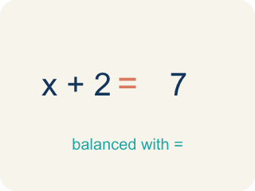
Solve (Resolver) — To find the number that makes it true.

Graph (Graficar) — To show answers on a number line with circles and shading.

Solution (Solución) — A number that makes the equation or inequality true.
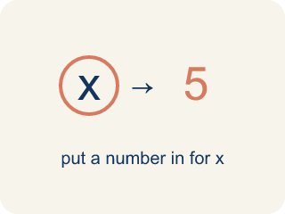
Substitute (Sustituir) — To put a number in for the letter to check if it works.
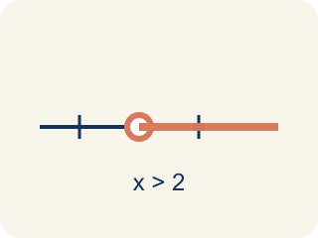
Solution set (Conjunto solución) — All of the values that make an inequality true.

Inverse operation (Operación inversa) — An operation that undoes another, used to isolate the variable.

Practice
Show your work. Use the blank space under each problem.
1. Solve: x + 6 > 14
A. x > 8
B. x > 20
C. x < 8
D. x = 8
______________________________________________________________________
2. Solve: x − 9 ≤ 3
A. x ≤ 12
B. x ≤ 6
C. x ≥ 12
D. x = 12
______________________________________________________________________
3. Solve each inequality, describe the inverse operation, and describe the graph.
Inequality | Inverse Operation | Solution | Graph Description
x + 11 ≥ 20 | Subtract 11 | x ≥ 9 | Closed circle at 9, shade right
x − 3 < 7 | Add 3 | x < 10 | Open circle at 10, shade left
x + 8 ≤ 20 | Subtract 8 | x ≤ 12 | Closed circle at 12, shade left
______________________________________________________________________
4. Is x = 5 a solution to x + 4 > 12?
A. No, because 5 + 4 = 9, and 9 is not greater than 12
B. Yes, because 5 + 4 = 9
C. Yes, because 5 > 4
D. No, because 5 < 12
______________________________________________________________________
5. Solve each inequality first, then sort by whether x = 10 is a solution.
Groups: x = 10 IS a solution | x = 10 is NOT a solution
______________________________________________________________________
6. Solve and choose the solution: x + 3 < 9.
A. x < 6
B. x > 6
C. x < 12
D. x > 12
______________________________________________________________________
7. Solve: 2x ≥ 10.
A. x ≥ 5
B. x ≤ 5
C. x ≥ 20
D. x ≥ 8
______________________________________________________________________
8. A rider must be at least 48 inches tall. Which inequality and a valid height fit?
A. h ≥ 48; 50 inches works
B. h > 48; 48 works
C. h ≤ 48; 50 works
D. h < 48; 48 works
______________________________________________________________________
9. Which value is NOT a solution of x ≤ 7?
A. 8
B. 7
C. 6
D. 0
______________________________________________________________________

Answer Key (Teacher)
1. A. x > 8
Subtract 6 from both sides: x > 14 − 6 = 8. Graph: open circle at 8, shade right.
2. A. x ≤ 12
Add 9 to both sides: x ≤ 3 + 9 = 12. Graph: closed circle at 12, shade left.
3. Solve each inequality, describe the inverse operation, and describe the graph.
(See completed table.)

4. A. No, because 5 + 4 = 9, and 9 is not greater than 12
Substitute: 5 + 4 = 9. Since 9 > 12 is false, x = 5 is NOT a solution.
5. Correct groups:

6. A. x < 6
Subtract 3 from both sides: x < 6.
7. A. x ≥ 5
Divide both sides by 2: x ≥ 5.
8. A. h ≥ 48; 50 inches works
'At least 48' is h ≥ 48, and 50 satisfies it.
9. A. 8
8 is greater than 7, so it is not a solution.

