Statistical Questions and Data — Homework
Lesson 8-1-flagship • Standard 6.SP.1
Name: ______________________ Period: ______ Date: ____________

Today's Goals
Content: I can tell the difference between a statistical question and a non-statistical question.
Language: I can explain my reasoning using the words statistical question, data, variability, and survey.

Key Words
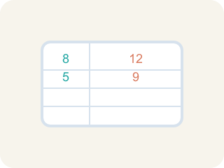
Statistical Question (Pregunta estadística) — A question where the answers will be different for different people.

Data (Datos) — Facts and numbers you collect, like answers to a survey.
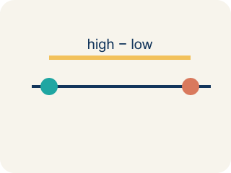
Variability (Variabilidad) — How spread out the numbers are.

Survey (Encuesta) — Collecting facts by asking people questions.
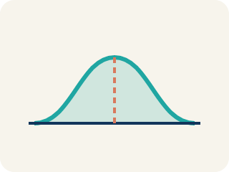
Data distribution (Distribución de datos) — How the data looks: where it sits and how spread out it is.

Practice
Show your work. Use the blank space under each problem.
1. Which of the following is a statistical question?
A. How many points did each player score this season?
B. How many points are scored for a free throw?
C. What sport does this team play?
D. How many halves are in a soccer game?
______________________________________________________________________
2. Which question is NOT a statistical question?
A. How many innings are in a baseball game?
B. How many home runs did each player hit this year?
C. How many miles does each runner train per week?
D. How tall is each player on the basketball team?
______________________________________________________________________
3. A coach asks: "How many hours does each athlete on the track team sleep the night before a meet?" Why is this a statistical question?
A. Because the answers will vary from athlete to athlete
B. Because it is about sports
C. Because it has a numerical answer
D. Because the coach asked it
______________________________________________________________________
4. Decide if each question is statistical and explain why.
Question | Statistical? | Why?
How many push-ups can each student do in one minute? | Yes | Different students can do different amounts — there is variability.
How many sides does a basketball court have? | No | There is one fixed answer (4 sides) — no variability.
How far does each player kick the ball? | Yes | Different players kick different distances — the data varies.
______________________________________________________________________
5. Each non-statistical question below has been rewritten to become statistical. Match the original to its rewritten version.
Groups: Original: 'How many students are in 6th grade?' | Original: 'What time does school start?'
______________________________________________________________________

Answer Key (Teacher)
1. A. How many points did each player score this season?
"How many points did each player score?" is statistical because different players will have different scores — there is variability in the data.
2. A. How many innings are in a baseball game?
"How many innings are in a baseball game?" has one fixed answer (9) — no variability. The other questions all produce different answers for different people.
3. A. Because the answers will vary from athlete to athlete
A statistical question anticipates variability. Different athletes sleep different amounts, so the data collected will vary.
4. Decide if each question is statistical and explain why.
(See completed table.)

5. Correct groups:

