Statistical Questions and Data — Homework
Lesson 8-1 • Standard 6.SP.1
Name: ______________________ Period: ______ Date: ____________

Today's Goals
Content: I can tell the difference between a statistical question and a non-statistical question.
Language: I can explain my reasoning using the words statistical question, data, variability, and survey.

Key Words
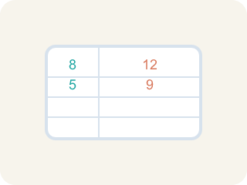
Statistical Question (Pregunta estadística) — A question where the answers will be different for different people.

Data (Datos) — Facts and numbers you collect, like answers to a survey.
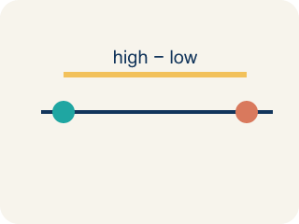
Variability (Variabilidad) — How spread out the numbers are.

Survey (Encuesta) — Collecting facts by asking people questions.
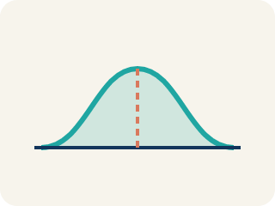
Data distribution (Distribución de datos) — How the data looks: where it sits and how spread out it is.

Practice
Show your work. Use the blank space under each problem.
1. Which of the following is a statistical question?
A. How many points did each player score this season?
B. How many points are scored for a free throw?
C. What sport does this team play?
D. How many halves are in a soccer game?
______________________________________________________________________
2. Which question is NOT a statistical question?
A. How many innings are in a baseball game?
B. How many home runs did each player hit this year?
C. How many miles does each runner train per week?
D. How tall is each player on the basketball team?
______________________________________________________________________
3. A coach asks: "How many hours does each athlete on the track team sleep the night before a meet?" Why is this a statistical question?
A. Because the answers will vary from athlete to athlete
B. Because it is about sports
C. Because it has a numerical answer
D. Because the coach asked it
______________________________________________________________________
4. Decide if each question is statistical and explain why.
Question | Statistical? | Why?
How many push-ups can each student do in one minute? | Yes | Different students can do different amounts — there is variability.
How many sides does a basketball court have? | No | There is one fixed answer (4 sides) — no variability.
How far does each player kick the ball? | Yes | Different players kick different distances — the data varies.
______________________________________________________________________
5. Each non-statistical question below has been rewritten to become statistical. Match the original to its rewritten version.
Groups: Original: 'How many students are in 6th grade?' | Original: 'What time does school start?'
______________________________________________________________________
6. Which is a statistical question?
A. How tall are the students in our class?
B. How tall is the teacher?
C. What is my height?
D. Is the door open?
______________________________________________________________________
7. Which question is NOT statistical?
A. What time did the bus arrive today?
B. How many minutes do students sleep each night?
C. How long do people wait at the store?
D. What ages are the players on the team?
______________________________________________________________________
8. Why do statistical questions expect different answers?
A. Because the data values vary from one case to another
B. Because they are always about numbers
C. Because they cannot be answered
D. Because they only have one answer
______________________________________________________________________
9. Which rewrite makes 'How old am I?' a statistical question?
A. How old are the students in this school?
B. How old is my best friend?
C. When is my birthday?
D. Am I older than 12?
______________________________________________________________________

Answer Key (Teacher)
1. A. How many points did each player score this season?
"How many points did each player score?" is statistical because different players will have different scores — there is variability in the data.
2. A. How many innings are in a baseball game?
"How many innings are in a baseball game?" has one fixed answer (9) — no variability. The other questions all produce different answers for different people.
3. A. Because the answers will vary from athlete to athlete
A statistical question anticipates variability. Different athletes sleep different amounts, so the data collected will vary.
4. Decide if each question is statistical and explain why.
(See completed table.)

5. Correct groups:

6. A. How tall are the students in our class?
A statistical question anticipates variability — heights vary across students.
7. A. What time did the bus arrive today?
A single bus arrival time has one answer, so it is not statistical.
8. A. Because the data values vary from one case to another
Statistical questions anticipate variability in the data.
9. A. How old are the students in this school?
Asking about many students produces data that varies.

