Mean, Median, and Mode — Homework
Lesson 8-2 • Standard 6.SP.3
Name: ______________________ Period: ______ Date: ____________

Today's Goals
Content: I can find the mean, median, and mode of a data set.
Language: I can explain my reasoning using the words mean, median, mode, and outlier.

Key Words
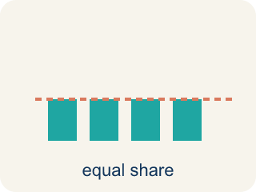
Mean (Media) — The average. Add all the numbers, then divide by how many there are.
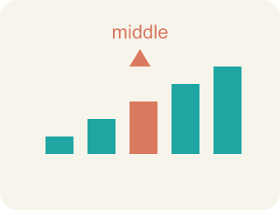
Median (Mediana) — The middle number when you put them in order.
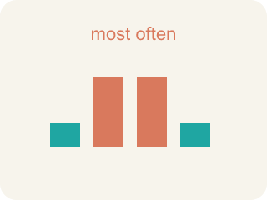
Mode (Moda) — The number that shows up most often.
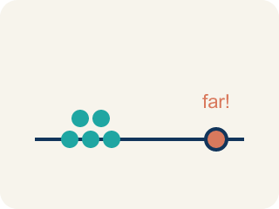
Outlier (Valor atípico) — A number that is much bigger or smaller than the rest.
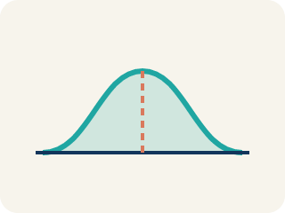
Data distribution (Distribución de datos) — How the data looks: where it sits and how spread out it is.
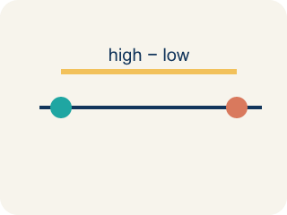
Variability (Variabilidad) — How spread out the numbers are.

Practice
Show your work. Use the blank space under each problem.
1. Find the mean of: 10, 14, 8, 12, 16
A. 12
B. 14
C. 10
D. 60
______________________________________________________________________
2. Find the median of: 3, 7, 2, 9, 5
A. 5
B. 3
C. 7
D. 5.2
______________________________________________________________________
3. Complete the table.
Data Set | Mean | Median | Mode
5, 8, 8, 10, 14
20, 25, 25, 30, 25, 35
100, 110, 90, 100, 115, 95
______________________________________________________________________
4. Match each measure to its definition.
Item | Answer choices
____ Mean | D. Max − Min
____ Median | C. Most frequent
____ Mode | B. Middle value
____ Range | A. Sum ÷ Count
______________________________________________________________________
5. Data set: 4, 6, 6, 8, 10, 12. What is the median?
A. 7
B. 6
C. 8
D. 7.67
______________________________________________________________________
6. What is the mean of 4, 6, 8, 10, 12?
A. 8
B. 10
C. 40
D. 6
______________________________________________________________________
7. What is the median of 3, 7, 9, 12, 15?
A. 9
B. 7
C. 12
D. 46
______________________________________________________________________
8. What is the mode of 2, 5, 5, 7, 9, 5?
A. 5
B. 7
C. 2
D. 9
______________________________________________________________________
9. What is the median of 4, 8, 10, 14?
A. 9
B. 10
C. 8
D. 12
______________________________________________________________________

Answer Key (Teacher)
1. A. 12
Sum = 10 + 14 + 8 + 12 + 16 = 60. Mean = 60 ÷ 5 = 12.
2. A. 5
Ordered: 2, 3, 5, 7, 9. The middle value is 5.
3. Table
5, 8, 8, 10, 14 — Mean: 9
5, 8, 8, 10, 14 — Median: 8
5, 8, 8, 10, 14 — Mode: 8
20, 25, 25, 30, 25, 35 — Mean: 26.67
20, 25, 25, 30, 25, 35 — Median: 25
20, 25, 25, 30, 25, 35 — Mode: 25
100, 110, 90, 100, 115, 95 — Mean: 101.67
100, 110, 90, 100, 115, 95 — Median: 100
100, 110, 90, 100, 115, 95 — Mode: 100

4. Matches:
Mean → Sum ÷ Count
Median → Middle value
Mode → Most frequent
Range → Max − Min

5. A. 7
With 6 values, the median is the average of the 3rd and 4th values: (6 + 8) ÷ 2 = 7.
6. A. 8
Sum = 40; 40 ÷ 5 = 8.
7. A. 9
The middle value of five ordered numbers is the third one: 9.
8. A. 5
5 appears most often (three times).
9. A. 9
With four values, average the middle two: (8 + 10) ÷ 2 = 9.

