Mean Absolute Deviation — Homework
Lesson 8-3 • Standard 6.SP.5c
Name: ______________________ Period: ______ Date: ____________

Today's Goals
Content: I can find the mean absolute deviation (MAD) to describe how spread out data is.
Language: I can explain my work using the words mean absolute deviation, deviation, absolute value, and spread.

Key Words
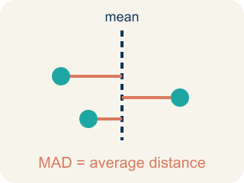
Mean Absolute Deviation (Desviación media absoluta) — The average distance of each number from the mean.

Deviation (Desviación) — How far a number is from the mean.
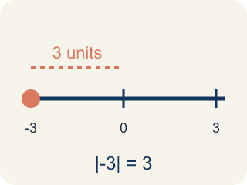
Absolute Value (Valor absoluto) — How far a number is from zero. It is always positive.
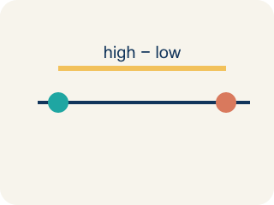
Spread (Dispersión) — How far apart the numbers are.
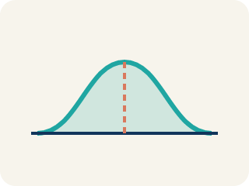
Data distribution (Distribución de datos) — How the data looks: where it sits and how spread out it is.

Variability (Variabilidad) — How spread out the numbers are.

Practice
Show your work. Use the blank space under each problem.
1. The mean of a data set is 15. One value is 11. What is the absolute deviation of that value from the mean?
A. 4
B. −4
C. 26
D. 11
______________________________________________________________________
2. A data set has absolute deviations of 3, 1, 5, 2, 4. What is the MAD?
A. 3
B. 5
C. 15
D. 1
______________________________________________________________________
3. Complete the table.
Score | Deviation (Score − Mean) | Absolute Deviation
12
8
10
14
6
______________________________________________________________________
4. Match each MAD value to what it tells you about the data.
Item | Answer choices
____ MAD = 1.5 | D. Moderate spread
____ MAD = 8.0 | C. All values are identical
____ MAD = 0 | B. Very spread out data
____ MAD = 4.2 | A. Very consistent data
______________________________________________________________________
5. Sort these data sets from LEAST spread out (lowest MAD) to MOST spread out (highest MAD).
Groups: Least to most spread out
______________________________________________________________________
6. Two runners have the same average time of 60 seconds. Runner A's MAD is 1.2 seconds. Runner B's MAD is 5.8 seconds. Which runner is the coach more likely to pick for a relay race that needs a reliable time?
A. Runner A — lower MAD means more consistent times
B. Runner B — higher MAD means faster potential
C. Either — they have the same average
D. Neither — MAD doesn't matter for relay races
______________________________________________________________________
7. The data 5, 7, 9 has mean 7. What is the mean absolute deviation (MAD)?
A. 1.33
B. 2
C. 7
D. 21
______________________________________________________________________
8. What does a larger MAD tell you about a data set?
A. The values are more spread out from the mean
B. The mean is larger
C. There are more values
D. The data has no mode
______________________________________________________________________
9. The data 10, 10, 10, 10 has what MAD?
A. 0
B. 10
C. 2.5
D. 40
______________________________________________________________________
10. For the data 2, 4, 6 (mean 4), what is the MAD?
A. 1.33
B. 2
C. 4
D. 12
______________________________________________________________________

Answer Key (Teacher)
1. A. 4
Deviation = 11 − 15 = −4. Absolute deviation = |−4| = 4.
2. A. 3
Sum of absolute deviations = 3 + 1 + 5 + 2 + 4 = 15. MAD = 15 ÷ 5 = 3.
3. Table
12 — Deviation (Score − Mean): 2
12 — Absolute Deviation: 2
8 — Deviation (Score − Mean): -2
8 — Absolute Deviation: 2
10 — Deviation (Score − Mean): 0
10 — Absolute Deviation: 0
14 — Deviation (Score − Mean): 4
14 — Absolute Deviation: 4
6 — Deviation (Score − Mean): -4
6 — Absolute Deviation: 4

4. Matches:
MAD = 1.5 → Very consistent data
MAD = 8.0 → Very spread out data
MAD = 0 → All values are identical
MAD = 4.2 → Moderate spread

5. Correct groups:

6. A. Runner A — lower MAD means more consistent times
Runner A's MAD of 1.2 means times are usually within 1.2 seconds of 60. Runner B's times vary more widely. For reliability, pick Runner A.
7. A. 1.33
Distances from 7 are 2, 0, 2; mean = 4 ÷ 3 ≈ 1.33.
8. A. The values are more spread out from the mean
MAD measures average distance from the mean; larger MAD means more spread.
9. A. 0
Every value equals the mean, so each distance is 0 and MAD = 0.
10. A. 1.33
Distances are 2, 0, 2; mean = 4 ÷ 3 ≈ 1.33.

