Appropriate Measures — Homework
Lesson 8-4 • Standard 6.SP.5d
Name: ______________________ Period: ______ Date: ____________

Today's Goals
Content: I can choose the best measure of center for a data set based on its shape.
Language: I can explain my choice using the words mean, median, outlier, and skewed.

Key Words
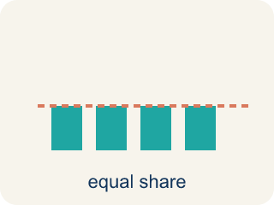
Mean (Media) — The average. Add all the numbers, then divide by how many there are.
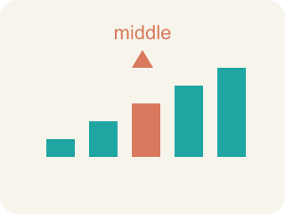
Median (Mediana) — The middle number when you put them in order.
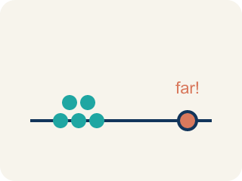
Outlier (Valor atípico) — A number that is much bigger or smaller than the rest.
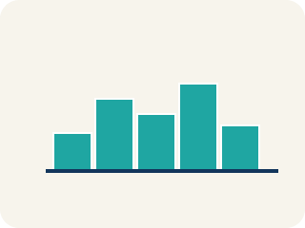
Skewed (Sesgado) — When most data sits on one side with a tail on the other.
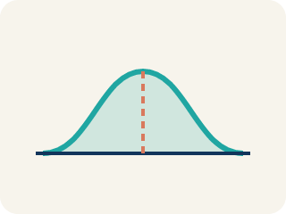
Data distribution (Distribución de datos) — How the data looks: where it sits and how spread out it is.
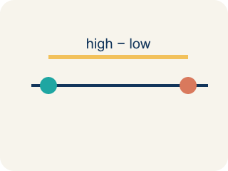
Variability (Variabilidad) — How spread out the numbers are.

Practice
Show your work. Use the blank space under each problem.
1. A gymnast's scores are: 8.5, 8.8, 8.7, 8.6, 8.9. There are no outliers. Which measure best represents a typical score?
A. Mean
B. Median
C. Neither — the data is too small
D. Both are equally bad
______________________________________________________________________
2. A runner's mile times are: 7:10, 7:15, 7:12, 7:20, 12:00. The 12:00 was due to a cramp. Which measure best represents a typical mile?
A. Median — the outlier 12:00 pulls the mean too high
B. Mean — it uses all the data
C. Mode — it shows the most common time
D. Neither measure works
______________________________________________________________________
3. A baseball player's batting averages over 6 seasons are: .280, .295, .290, .285, .300, .110. The .110 was an injury-shortened season. Which measure better represents the player's typical batting average?
A. Median, because the .110 outlier pulls the mean down
B. Mean, because it uses all the data
C. Mean, because .110 is a real season
D. Neither measure works
______________________________________________________________________
4. Complete the table.
Data Set | Mean | Median | Outlier? | Best Measure
15, 18, 16, 17, 15
15, 18, 16, 17, 72
______________________________________________________________________
5. A data set has an extreme outlier. Which measure of center is usually best?
A. Median
B. Mean
C. Range
D. Mode only
______________________________________________________________________
6. Which measure of spread pairs naturally with the mean?
A. Mean absolute deviation
B. Median
C. Mode
D. Range only
______________________________________________________________________
7. Test scores are 80, 82, 85, 88, 12. Why is the median better than the mean here?
A. The score of 12 is an outlier that pulls the mean down
B. The mean is always wrong
C. There are too few scores
D. The data has no median
______________________________________________________________________
8. For data with no outliers and a symmetric shape, which center is appropriate?
A. Mean
B. Only mode
C. Only range
D. Neither mean nor median
______________________________________________________________________

Answer Key (Teacher)
1. A. Mean
The data is symmetric with no outliers, so the mean (8.7) best represents the typical score.
2. A. Median — the outlier 12:00 pulls the mean too high
The 12:00 is an outlier that pulls the mean up. The median (7:15) better represents the runner's typical time.
3. A. Median, because the .110 outlier pulls the mean down
The .110 is an outlier that pulls the mean down to .260. The median (.2875) better represents typical performance because it isn't affected by the extreme value.
4. Table
15, 18, 16, 17, 15 — Mean: 16.2
15, 18, 16, 17, 15 — Median: 16
15, 18, 16, 17, 15 — Outlier?: No
15, 18, 16, 17, 15 — Best Measure: Mean (no outlier, data is clustered)
15, 18, 16, 17, 72 — Mean: 27.6
15, 18, 16, 17, 72 — Median: 17
15, 18, 16, 17, 72 — Outlier?: Yes (72)
15, 18, 16, 17, 72 — Best Measure: Median (72 pulls the mean to 27.6, higher than 4 of 5 values)

5. A. Median
The median is resistant to outliers, so it better represents typical values.
6. A. Mean absolute deviation
MAD measures spread around the mean.
7. A. The score of 12 is an outlier that pulls the mean down
The outlier 12 lowers the mean a lot, but the median stays near the typical scores.
8. A. Mean
With no outliers, the mean represents the data well.

