Display Data: Box Plots — Homework
Lesson 8-5 • Standard 6.SP.4
Name: ______________________ Period: ______ Date: ____________

Today's Goals
Content: I can make and read a box plot to summarize a data set.
Language: I can explain my box plot using the words box plot, median, quartile, and interquartile range.

Key Words
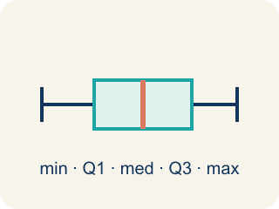
Box Plot (Diagrama de caja) — A graph that shows how data is spread using five key numbers.
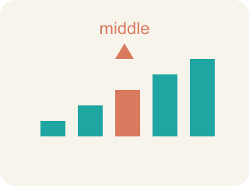
Median (Mediana) — The middle number that splits the data in half.
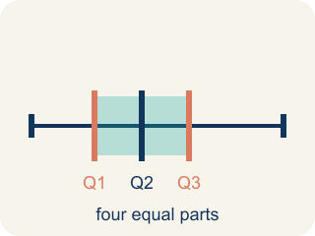
Quartile (Cuartil) — Numbers that split the data into four equal parts.
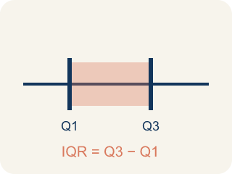
Interquartile Range (Rango intercuartílico) — The spread of the middle half of the data (Q3 − Q1).
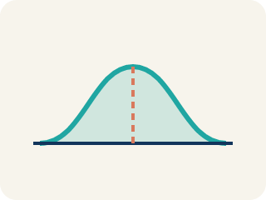
Data distribution (Distribución de datos) — How the data looks: where it sits and how spread out it is.
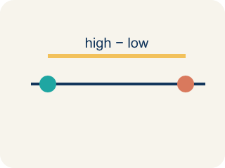
Variability (Variabilidad) — How spread out the numbers are.

Practice
Show your work. Use the blank space under each problem.
1. A box plot shows: Min = 10, Q1 = 15, Median = 20, Q3 = 28, Max = 35. What is the interquartile range (IQR)?
A. 13
B. 25
C. 10
D. 20
______________________________________________________________________
2. On a box plot, what does the line inside the box represent?
A. The median
B. The mean
C. The mode
D. The range
______________________________________________________________________
3. Complete the table.
Measure | Value
Data: 5, 8, 12, 15, 18, 20, 25, 30, 35
Minimum
Q1 (median of lower half: 5, 8, 12, 15)
Median
Q3 (median of upper half: 20, 25, 30, 35)
Maximum
IQR (Q3 − Q1)
______________________________________________________________________
4. Match each box plot term to its meaning.
Item | Answer choices
____ Minimum | F. Largest value in the data set
____ Q1 | E. Q3 − Q1 (spread of middle 50%)
____ Median | D. Median of the upper half
____ Q3 | C. Middle value of the entire data set
____ IQR | B. Median of the lower half
____ Maximum | A. Smallest value in the data set
______________________________________________________________________
5. Two box plots show: Team A has IQR = 8, Team B has IQR = 22. What does this tell you?
A. Team A's middle 50% is more consistent; Team B's is more spread out
B. Team B is a better team
C. Team A has a higher median
D. The IQRs don't tell you about consistency
______________________________________________________________________
6. In a box plot, the line inside the box represents the...
A. Median
B. Mean
C. Maximum
D. Range
______________________________________________________________________
7. A box plot has Q1 = 20 and Q3 = 35. What is the interquartile range (IQR)?
A. 15
B. 55
C. 27.5
D. 20
______________________________________________________________________
8. What does the box (between Q1 and Q3) of a box plot represent?
A. The middle 50% of the data
B. All of the data
C. The mean
D. Only the largest values
______________________________________________________________________
9. A data set has minimum 5 and maximum 45. What is the range?
A. 40
B. 50
C. 25
D. 9
______________________________________________________________________

Answer Key (Teacher)
1. A. 13
IQR = Q3 − Q1 = 28 − 15 = 13.
2. A. The median
The line inside the box of a box plot always represents the median.
3. Table
Minimum — Value: 5
Q1 (median of lower half: 5, 8, 12, 15) — Value: 10
Median — Value: 18
Q3 (median of upper half: 20, 25, 30, 35) — Value: 27.5
Maximum — Value: 35
IQR (Q3 − Q1) — Value: 17.5

4. Matches:
Minimum → Smallest value in the data set
Q1 → Median of the lower half
Median → Middle value of the entire data set
Q3 → Median of the upper half
IQR → Q3 − Q1 (spread of middle 50%)
Maximum → Largest value in the data set

5. A. Team A's middle 50% is more consistent; Team B's is more spread out
A smaller IQR means the middle 50% of data is more tightly clustered. Team A's scoring is more consistent in the middle range.
6. A. Median
The middle line of a box plot marks the median.
7. A. 15
IQR = Q3 − Q1 = 35 − 20 = 15.
8. A. The middle 50% of the data
The box spans Q1 to Q3, holding the middle half of the data.
9. A. 40
Range = maximum − minimum = 45 − 5 = 40.

