Display Data: Histograms — Homework
Lesson 8-6 • Standard 6.SP.4
Name: ______________________ Period: ______ Date: ____________

Today's Goals
Content: I can make and read a histogram to display data in intervals.
Language: I can explain my histogram using the words histogram, frequency, interval, and distribution.

Key Words
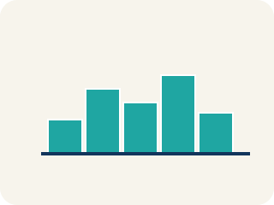
Histogram (Histograma) — A bar graph that groups data into equal ranges. The bars touch.
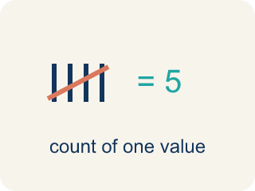
Frequency (Frecuencia) — How many times a value shows up.

Interval (Intervalo) — A range of numbers used to group data.
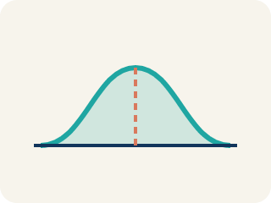
Distribution (Distribución) — How the data is spread out.

Data distribution (Distribución de datos) — How the data looks: where it sits and how spread out it is.
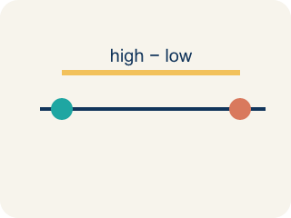
Variability (Variabilidad) — How spread out the numbers are.

Practice
Show your work. Use the blank space under each problem.
1. A histogram shows these frequencies: 0–4: 3 players, 5–9: 8 players, 10–14: 12 players, 15–19: 5 players. How many players are represented in total?
A. 28
B. 12
C. 20
D. 15
______________________________________________________________________
2. In a histogram, what does the height of each bar represent?
A. The frequency (count) of data in that interval
B. The average of the data in that interval
C. The range of the interval
D. The median of the data
______________________________________________________________________
3. Complete the table.
Interval (Yards) | Frequency
Player rushing yards per game: 0, 5, 12, 15, 18, 22, 25, 28, 31, 35, 40, 45
0–9
10–19
20–29
30–39
40–49
______________________________________________________________________
4. A histogram of test scores shows: 50–59: 2, 60–69: 5, 70–79: 10, 80–89: 8, 90–99: 3. Which interval has the most students?
A. 70–79 with 10 students
B. 80–89 with 8 students
C. 60–69 with 5 students
D. 90–99 with 3 students
______________________________________________________________________
5. Match each term to its description.
Item | Answer choices
____ Histogram | D. Range of values grouped together
____ Bar graph | C. Count of values in an interval
____ Frequency | B. Bars separated, shows categories
____ Interval | A. Bars touch, shows frequency by interval
______________________________________________________________________
6. Based on the histogram frequencies below, sort the intervals from most players to fewest: 0–9: 4, 10–19: 11, 20–29: 7, 30–39: 2.
Groups: Most to fewest players
______________________________________________________________________
7. A histogram differs from a bar graph because...
A. It groups numeric data into equal intervals with no gaps
B. It uses pictures
C. It only shows one value
D. It cannot show frequency
______________________________________________________________________
8. A histogram bin for 10–19 has a bar height of 6. What does 6 represent?
A. 6 data values fall in that interval
B. The value 6 only
C. 6 intervals
D. The mean is 6
______________________________________________________________________
9. Histogram bins are 0–9, 10–19, 20–29 with heights 4, 9, 2. How many data values total?
A. 15
B. 9
C. 6
D. 45
______________________________________________________________________
10. Why should histogram intervals be equal in width?
A. So the bars fairly compare how many values fall in each range
B. To make the graph colorful
C. Because data must be negative
D. So there are no numbers
______________________________________________________________________

Answer Key (Teacher)
1. A. 28
Add all frequencies: 3 + 8 + 12 + 5 = 28 players.
2. A. The frequency (count) of data in that interval
Each bar's height shows the frequency — how many data values fall within that interval.
3. Table
0–9 — Frequency: 2
10–19 — Frequency: 3
20–29 — Frequency: 3
30–39 — Frequency: 2
40–49 — Frequency: 2

4. A. 70–79 with 10 students
The 70–79 interval has the highest frequency of 10 students.
5. Matches:
Histogram → Bars touch, shows frequency by interval
Bar graph → Bars separated, shows categories
Frequency → Count of values in an interval
Interval → Range of values grouped together

6. Correct groups:

7. A. It groups numeric data into equal intervals with no gaps
Histograms display continuous numeric data in intervals (bins) with bars touching.
8. A. 6 data values fall in that interval
The bar height is the frequency — how many values fall in that bin.
9. A. 15
4 + 9 + 2 = 15 data values.
10. A. So the bars fairly compare how many values fall in each range
Equal widths make frequency comparisons fair across bins.

