Shape of Data Distributions — Homework
Lesson 8-7 • Standard 6.SP.2
Name: ______________________ Period: ______ Date: ____________

Today's Goals
Content: I can describe the shape of a data distribution as symmetric, skewed, or having clusters and gaps.
Language: I can explain my description using the words symmetric, skewed, cluster, and gap.

Key Words
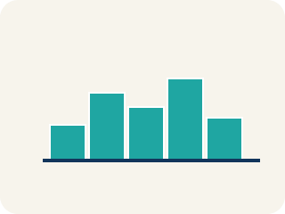
Symmetric (Simétrico) — Data that looks about the same on the left and right.

Skewed (Sesgado) — Data bunched on one side with a tail on the other.
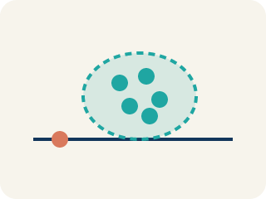
Cluster (Agrupamiento) — A group of numbers that are close together.

Gap (Hueco (espacio)) — A big empty space where there is no data.
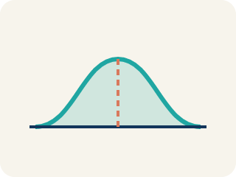
Data distribution (Distribución de datos) — How the data looks: where it sits and how spread out it is.
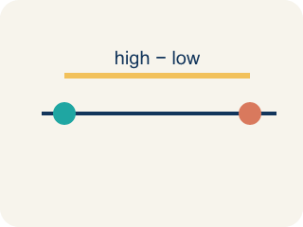
Variability (Variabilidad) — How spread out the numbers are.

Practice
Show your work. Use the blank space under each problem.
1. A histogram of basketball players' ages shows: most players are 22–28, with a long tail of older players up to age 40. What is the shape of this distribution?
A. Skewed right
B. Symmetric
C. Skewed left
D. Uniform
______________________________________________________________________
2. A data set is symmetric. What is likely true about the mean and median?
A. They are approximately equal
B. The mean is much higher than the median
C. The median is much higher than the mean
D. They are always exactly the same
______________________________________________________________________
3. A dot plot of goals scored per game shows: 0(5 dots), 1(7 dots), 2(4 dots), 3(2 dots), 4(1 dot). What is the shape?
A. Skewed right — most values at the low end with a tail to the right
B. Symmetric — equal on both sides
C. Skewed left — most values at the high end
D. Uniform — all bars the same height
______________________________________________________________________
4. Complete the table: how does distribution shape affect the relationship between mean and median?
(table)
______________________________________________________________________
5. For each data set, decide: is it symmetric, skewed right, or skewed left?
Groups: Symmetric | Skewed Right | Skewed Left
______________________________________________________________________
6. A distribution with a long tail stretching to the right is called...
A. Skewed right
B. Skewed left
C. Symmetric
D. Uniform
______________________________________________________________________
7. A data set that is roughly the same on both sides of the center is...
A. Symmetric
B. Skewed right
C. Skewed left
D. Bimodal only
______________________________________________________________________
8. In a right-skewed distribution, how does the mean compare to the median?
A. The mean is usually greater than the median
B. They are always equal
C. The mean is always 0
D. The median is always larger by 10
______________________________________________________________________
9. A distribution with two clear peaks is described as...
A. Bimodal
B. Symmetric only
C. Uniform
D. Skewed left
______________________________________________________________________

Answer Key (Teacher)
1. A. Skewed right
Most data is on the left (younger ages) with a tail stretching right (older ages). This is skewed right.
2. A. They are approximately equal
In a symmetric distribution, the mean and median are approximately equal because the data is balanced on both sides.
3. A. Skewed right — most values at the low end with a tail to the right
The data peaks at 0–1 goals and tails off toward 4. Most data is on the left with fewer values stretching right — this is skewed right.
4. Complete the table: how does distribution shape affect the relationship between mean and median?
(See completed table.)

5. Correct groups:

6. A. Skewed right
A tail pulling toward larger values means it is skewed right.
7. A. Symmetric
If both sides mirror each other, the distribution is symmetric.
8. A. The mean is usually greater than the median
The long right tail pulls the mean above the median.
9. A. Bimodal
Two peaks means the distribution is bimodal.

